Achieving a Surviving and Thriving Future
Future Focus for Political Science

Gary A. Christopherson
Former United States Federal Senior Executive
Founder, Thrive! – Building a Thriving Future
August 6, 2014

Abstract

Much of political science focuses on pieces of past and future. Can it focus on the whole future and go beyond studies to build a whole and better future? This paper suggests political science is relevant and essential to building a thriving future for whole communities, countries and world. The underlying theory is humans, as a person and as people, need to survive and want to thrive. This drives their and public organization behavior. Three next generation methods can help build a better future. They are 1) strategic and operational planning, management and execution, 2) Behavioral Effectiveness Model and 3) Thrive model. This theory and these methods were applied successfully. This paper describes how to apply them to community, country and world. At a tipping point when our future is most endangered and we are most capable, helping build a thriving future should be political science’s mission and greatest achievement.

Achieving a Surviving and Thriving Future
Future Focus for Political Science

Summary

Much of political science today focuses on one or more of the many pieces of our past and future. But is that enough? Is it not time for political science to focus on the whole future? But is political science even capable of focusing on the whole future? If yes, is it capable of going beyond studies and actually helping build and sustain a whole future that is much better than our past? This paper suggests a path for political science that makes it relevant and maybe essential to building the future in which whole communities, whole countries and the whole world not only survive but thrive.
The underlying theory for this better future is that humans, as a person and as a people need to survive and want to thrive. This drives their behavior and the behavior of their public and private organizations. However, achieving and sustaining surviving and thriving will occur only if people commit to “me and all of us”, “today, the short term future and the long term future”, and “survive and thrive”.
Three next generation methods can help build a much better future. Strategic and operational planning, management and execution provides the framework for public policy and public administration development and execution. The Behavioral Effectiveness Model (BEM) provides the model for understanding and determining future behavior for a person and a people. The Thrive model provides the framework for what is surviving and thriving and what public policy is needed to build, achieve and sustain a surviving and thriving future.
This theory and these methods have been applied successfully at local and national levels. This paper describes how they can be applied to three settings – community, country and world.
We are at a “tipping point” when our future is most endangered and we are most capable. It is only people, joined together, that can create the large, positive and timely change for building a thriving future. This can and should be the political science’s future mission. This can be its greatest achievement.

Achieving a Surviving and Thriving Future
Future Focus for Political Science

Much of political science today focuses on one or more of the many pieces of our past and future. But is that enough? Is it not time for political science to focus on the whole future? But is political science even capable of focusing on the whole future? If yes, is it capable of going beyond studies and actually helping build and sustain a whole future that is much better than our past? This paper suggests a path for political science that makes it relevant and maybe essential to building the future in which whole communities, whole countries and the whole world not only survive but thrive.
The underlying theory is humans, as a person and as a people, need to survive and want to thrive. This drives their and their public organization behavior. Three next generation methods can help build a better future. They are 1) strategic and operational planning, management and execution, 2) the Behavioral Effectiveness Model and 3) the Thrive model. This theory and these methods were applied successfully at the local and national levels. This paper describes how to apply them to community, country and world.
At a tipping point when our future is most endangered and we are most capable, helping build a surviving and thriving future should be political science’s mission and greatest achievement.

The Underlying Thrive Political Theory
The underlying Thrive political theory for this better future is that a person and a people need to survive and wants to thrive in the current world and a sustainable future world. This is built on the underlying assumption that a person needs to survive and want to thrive. This drives their behavior and the behavior of their public and private organizations. However, achieving and sustaining surviving and thriving will occur only if people commit to “me and all of us”, “today, the short term future and the long term future”, and “survive and thrive”.
Thriving for a person, a people and the world is the human endeavor and the ideal. As the ultimate ideal, thriving is a person, a people and the world surviving and thriving together.
As the human endeavor, thriving is the lifelong (a person) and neverending (a people and the world) striving to survive and thrive in the current world and a survivable and thriving future world.
Ideally, the person and the rest of the world are continuously and simultaneously striving with the best combination of independence and interdependence in joint pursuit of survival and thriving.
This theory is designed to be defensible, understandable, usable, sustainable and valuable for a person and a people for today and the future. It addresses the following key elements:
- Our nature, as a person and a people, is our need to survive and desire to thrive in the current world and a sustainable future world.
- Our actions are driven by our need to survive and desire to thrive but influenced by a) other persons and the surrounding world and b) the need and desire for a long term, sustainable future.
- Our relationship with other persons and the surrounding world is driven and governed by our need to survive and desire to thrive in the current world and a sustainable future world.
What are its underlying assumptions and argument? The theory is built on the underlying assumption that a person needs to survive and wants to thrive. With that underlying assumption are made two more assumptions:
- a person depends on other persons (a people) for survival and thriving, and
- a person’s future survival and thriving depends on there being a future world.
If these three assumptions are true, then:
- a person and a people both need to survive and desire to thrive,
- this need and desire applies to both the current and future world, and
- the future world must be sustainable and sustained to fully meet the need and desire.
What are the human endeavor and the ideal? As the human endeavor, thriving is the lifelong (a person) and neverending (a people and the world) striving to survive and thrive in the current world and a survivable and thriving future world. A person and a people strive for and can achieve a high level of motivation and ability (including knowledge). This striving and increasing ability is evident in overall human development to date. It can be argued that a people will achieve that high level of ability over time. That achievement is the foundation for striving for and achieving even higher levels of ability and motivation and even higher levels of survival and thriving.
A person’s and a people’s striving for a survivable and thriving future is motivated by needs and wants and enabled by experience, knowledge, and thinking (for example, creativity and reasoning).
During the striving, there are successes and failures. There are progress and regress. All contribute to achieving and continuing thriving. Over time and as a person and a people strives and grows, successes should exceed failures and progress should exceed regress.
Striving follows a nonlinear path through a complex world toward the ideal. The nonlinear path makes life more challenging and more interesting. But there is a negative risk during the nonlinear progression toward the ideal. A particular regression can be so severe as to end progression. The risk is that in the progression toward the ideal, a regression (for example, loss of natural resources, death of a people and/or the world) may be so severe as to end the progression. Human existence, for all practical purposes, can end before the ideal can be reached.
Ideally, the person and the rest of the world are continuously and simultaneously striving with the best combination of independence and interdependence in joint pursuit of survival and thriving. This is also true for a people.
The ultimate aspiration and ideal is thriving, the achievement of a survivable and thriving future for a whole person, a whole people and the whole world.
What are key elements and questions? The theory’s key elements and related questions are as follows:
- What is the nature of being and the world? The nature of human being (and becoming) is that a person (and a people) needs to survive and wants to thrive in the current world and a sustainable future world. These are life’s drivers. Through successes and failures and progress and regress, these drivers produce a desired nonlinear progression of a person, a people and the world toward a survivable and thriving future. However necessary and desirable, achieving a survivable and thriving future is not inevitable. The aspiration is reached when what a person is and is becoming are in harmony at very high levels and a person is still moving to higher and higher levels. This is also true for a people.
- How should a person and a people act? A person’s actions are driven by one’s need to survive and desire to thrive but are influenced by a) the surrounding world and b) the need and desire for a sustainable future. This sustainability applies to one’s self. This also applies to the people (for example, family and friends) and the world (for example, plants and animals) with which a person has a personal bond. This also applies to the people and world on which a person depends for survival and thriving. Though striving to survive and thrive has the potential to become selfish and destructive, it becomes constructive when there is recognition of the personal bond with other persons and the world. It also becomes constructive when there is recognition that survival and thriving depend on other persons and the world. This is especially true when moving beyond the short term future to a sustainable, long term future. This governs much of how a person and a people should and will act.
- What is the relationship of a person and a people to other persons and the state? A person’s relationship with other persons (including family, community, country) and the rest of the world is driven and governed by a person’s need to survive and desire to thrive in the current world and a sustainable future world. This is affected by a) a person’s current and future personal bond with other persons and the world and b) a person’s current and future dependency on other persons and the rest of the world for surviving and thriving. The government’s relationship to its people is driven and governed by the people’s need to survive and desire to thrive in the current world and a sustainable future world. The government’s relationship is also affected by its current and future dependency on the rest of the world its and its people’s survival and thriving.
What is the theory’s value? To meet the full need and provide the full value, it must be understandable to, usable by, sustainable for and valuable to essentially all persons.
Is it understandable? The first test of ‘real life’ understandability is whether or not a person who creates, teaches, or analyzes such theories finds it understandable. This is the expert. The second and more important test of real life understandability is whether or not a person who wants to use this in real life finds it understandable. This is the general public.
In real life, the theory is understandable because it is what a person lives and understands every day. From the moment that a person awakes in the morning and throughout most of each day, ensuring survival drives a person’s life. A person eats, drinks and practices hygiene to survive. A person works or otherwise obtains resources (for example, income) to acquire the basic survival necessities such as food, shelter, knowledge, and health. A person acquires these basic survival necessities throughout most of their life. The exceptions are very young children and older persons with very limited cognitive ability. A person acquires and develops relationships with other persons in order to gain survival necessities. This may be related to social needs, resource acquisition needs, and/or survival necessities. A person acquires and develops relationships with the surrounding world (for example, the state) as the person strives to survive. This might be to a) get a driver’s, vehicle or a professional license, b) obtain a permit to build or renovate shelter, c) buy food and clothing, d) obtain health care, or e) meet societal/legal obligations (for example, pay taxes).
Unless survival is all consuming, a person also wants to thrive in the current world and a sustainable future world. A person wants a better, preferably thriving life. This may be better food, health, knowledge/skills, recreation, shelter and/or relationships. The latter may take on the form of a better relationship with existing family (for example, parents and siblings) or acquiring a family (for example, a spouse and children). This desire to thrive can take on a longer term perspective because a person generally does not want life to end and wants a sustainable, thriving future. A person may want a family line, a people and/or a state to continue into the future. The strength of the desire for a sustainable thriving future by a person, a people, a community or a country (or all countries together) will determine the strength of the drive to build a sustainable, thriving future.
This is not new or difficult to understand. It is essentially what a person and a people know and live.
Is it usable? The theory can be used to help a person understand one’s self, other persons and the world as the person survives and progresses through life. To successfully survive and progress through life, it is critical to understand the power of the need to survive for one’s self and for other persons. Until and unless that survival need is ensured, a person (or a people) is highly unlikely to a) relate well to other persons (even those upon whom the person (or people) depends for survival), b) think about or act on the long term future, or c) think about or act on moving beyond surviving to thriving. Until basic, real and physical necessities are ensured, it is difficult to impossible for the person and other persons to focus on and strive toward a sustainable, thriving future. If and when a person does focus on and strive toward a sustainable, thriving future, this theory can help a person understand how the desire to thrive drives self behavior and other persons’ behavior.
It can be used to better understand and manage the nonlinear (progress and regress) nature of life and a person’s own needs (survive) and wants (thrive), and a person’s own aspirations and ideals. If a person understands that life is nonlinear and will likely include many instances of progress (good things; going forward toward meeting needs and wants) and regress (bad things; going backward on meeting needs and wants), the person has context in which to think and act. Consistent with needs, wants, aspirations and ideals, a person can think through and act to avoid, stop, minimize and/or manage bad things and regress. Similarly, a person can think through and act to seek, start, maximize and/or manage good things and progress. These thoughts and actions help produce a better outcome (for example, less negative impact from regress, more positive impact from progress, and greater knowledge). Very importantly, it helps produce more knowledge for future thought and action. A basic model for such future thought and action is depicted in the following figure, ‘Thrive Model - Building a Thriving Future’.

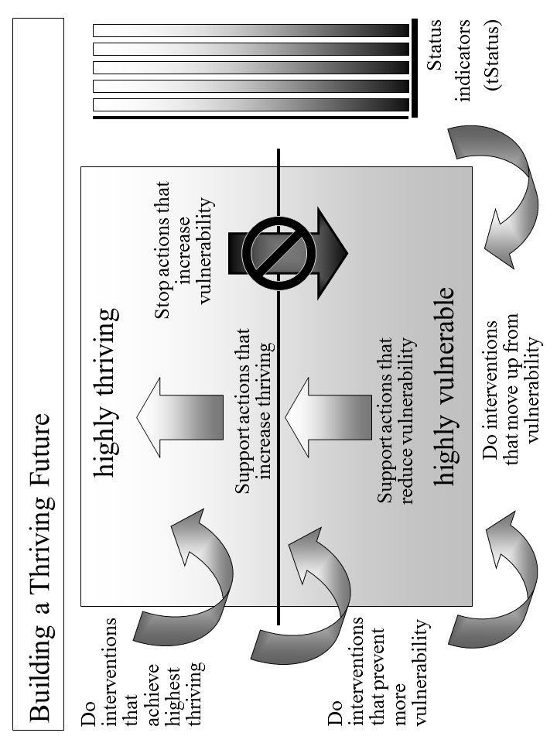
Figure 1. Thrive Model - Building a Thriving Future.

It can be used to design and manage a person’s own path through an ever changing life. A person can better design and manage a more positive path once the person a) better understands the need to survive and desire to thrive, b) better understands other persons and the surrounding world, c) better recognizes and accepts a changing world, and d) better understands the desire for a sustainable thriving future. A person can better use the needs, wants, aspirations and ideals to design the future path. A person’s future path should ensure survival in a changing world and, at the same time, strive toward a thriving future. The path should be flexible to adapt to a nonlinear world and the changing future. The path should adjust as a person’s needs and wants change. The path should be adjusted or a new and better path created if and when the world changes and/or when a path does not seem to be on track. While on the path, there should be ongoing scanning of other persons and the surrounding world for changes affecting the path.
It can be used to understand and manage a person’s relationship with those with whom there is a personal bond (for example, friends and family). Once a person understands that a person with whom there is a personal bond has thoughts and behaviors driven by the need to survive and desire to thrive, the relationship with the other person is more understandable. Relating to the other person is easier, more positive and more likely to succeed. There is also the opportunity to jointly and cooperatively act in ways that are more likely to be successful and produce better outcomes for both.
It can be used to understand and manage relationships with that upon which a person depends for surviving and thriving. That includes other persons (for example, family, friends, co-workers, employers, government, educators, health care providers, food suppliers) and the world. Once a person understands that a person upon whom the person depends for one’s own success has thoughts and behaviors driven by the need to survive and desire to thrive, the relationship with the other person is more understandable. Relating to the other person is easier, more positive and more likely to succeed. There is also the opportunity to jointly and cooperatively act in ways that are more likely to be successful and produce better outcomes for both. Similarly, a person needs to understand that the world (for example, plants, animals, and natural resources) upon which the person depends also needs to survive and is better if it thrives. With that understanding, the person’s relationship with the surrounding world can be more mutually beneficial.
It can help a person understand and deal with today and the near and long term future. It helps a person understand the strong driving force of a person’s needs today and in the near term, foreseeable future. It helps a person understand that the failure to successfully address today’s and near term needs is likely to result in the failure to address the long term future and build a sustainable, thriving future. Recognizing this, one option is to build a sustainable, thriving future that includes survival for today and the foreseeable future. Short term survival actions should never be at the expense of long term survival and thriving.
It can help a person understand and help build a sustainable, thriving future for one’s self, other persons and the world. A person can better understand how to create more effective paths to a survivable future and, preferably, a sustainable, thriving future. A person understands better what drives one’s own and other persons’ thoughts and behavior. As a person better understands a) one’s own needs and wants, b) other persons’ needs and wants and c) the surrounding world, a person is more able to build one’s own sustainable, thriving future. Likewise, a person is more able and motivated to jointly build a survivable and sustainable, thriving future for a people and the surrounding world.
Is it sustainable? The theory is designed specifically to be sustainable. It should have a high probability of being sustainable because it is defensible, understandable, usable, sustainable and valuable for a person, a people and the world for today and a sustainable, thriving future. It is defensible in that it builds upon preceding work and experience and builds upon the basic nature of a person and a person’s need to survive and desire to thrive on a sustained basis.
It adaptable in that it recognizes that the world changes and that it must retain defensibility, understandability, usability, sustainability and value throughout those changes. Change is inherent to the theory. Striving to survive and thrive by a changing person among a changing people in a changing world is inherent to the theory.
Is it valuable? The theory is valuable because it can help improve life for a person, a people and/or the world. It is most valuable when it is applied synergistically to all three. It does that. In real life, it can provide a better understanding of life’s driving forces and how those forces affect near and long term behavior. It can provide a better understanding of how to use those driving forces to improve human behavior and improve human behavior’s outcome - an improved life for a person, a people and the world.
It is more valuable because it can help a person, a people and/or the world survive together on a sustained basis. In real life, it can help a person and a people better understand the need to survive. It can help with understanding real need to survive versus perceived (but not real) need versus desire to thrive. It can help with understanding the conditions necessary to survival. It can help create and effectively execute an adaptable path to near and long term survival in an ever changing world.
It is most valuable because it can help a person, a people and/or the world thrive on a sustained basis. In real life, it can help a person and a people better understand the desire to thrive. It can help with understanding the desire to thrive on a sustained basis. It can help with understanding the conditions necessary to a sustainable, thriving future. It can help create and effectively execute an adaptable path to achieving a sustainable, thriving future in an ever changing world.

Next Generation Methods
Three next generation methods can help build a much better future. Strategic and operational planning, management and execution provides the framework for public policy and public administration development and execution. The Behavioral Effectiveness Model (BEM) provides the model for understanding and determining future behavior for a person and a people. The Thrive model provides the framework for what is surviving and thriving and what public policy is needed to build, achieve and sustain a surviving and thriving future. All were used successfully in the past at the local and national levels.
Strategic and Operational Planning, Management and Execution. This next generation approach to strategic and operational planning, management and execution builds upon and is better than past approaches because:
- First, it focuses on individual “persons” -- individuals with unique abilities, motivation, and behaviors uniquely affected by and affecting their “environment.” “Person” aspects are addressed by the Behavioral Effectiveness Model (BEM) and the “Person-centered Model”. They have been used to help improve health and health care.
- Second, it is designed to be more effective at addressing issue areas, especially large, complex ones. Large, complex issue areas (e.g., health) have been addressed with them.
- Third, it is designed to effectively handle the cross-cutting issues of a highly interactive and interdependent world. Cross-cutting issue areas, including health and vulnerability, have been explored with the full via strategy core set.
- Fourth, it is designed to tackle issues as a system (e.g. a health system) interacting with other systems and within larger systems (e.g. communities, nations, broader areas). Systems (personal health, health care delivery systems, and public health) have been addressed with the full via strategy core set, including the “system” models.
- Fifth, it is designed to effectively handle “whole” systems, including whole communities, whole nations, and whole broader areas. Systems have been addressed (e.g., health system for America in context of America and the world) or explored (e.g., vulnerability, community, a nation) with the full via strategy core set.
- Sixth, it is designed to effectively handle the future in terms of sustaining whatever progress we make and adjusting to a changing future. Sustainable, future-adaptive systems have been addressed (e.g., personal health, large health care delivery systems) or explored (e.g., vulnerability, community, nation) with the full via strategy core set, including the predictive aspects of the core set’s models.
Overall Strategy Model. The overall Overall Strategy is to effectively use a set of integrated, coordinated components to produce the necessary knowledge and an effective overall strategy with supportive strategies. By using the full core set, we can better identify and understand the targeted system (e.g., community, country), decide what we want to achieve on a sustained basis, understand and select the target behaviors, design and select what interventions we need, and develop the overall strategy and supportive strategies to achieve the desired state.
Though the steps in Table 1 imply their sequential application that is not always the case. Step 1 is important in our understanding what is the current system, its status, its projected actions, and its projected people and population behaviors. Step 1c helps us organize that thinking of how we might get from the current situation to the desired status for the targeted system. Step 2 helps us work through what needs to be changed and how we might make that change. Step 3 pulls all this together to help us create and execute the overall strategy and supportive strategies. Step 4 is to make sure we evaluate how we are doing and provide input for changes in strategy. Step 5 focuses on the successful execution of the overall strategy and supportive strategies. Step 6 makes sure we understand that strategy is not static and needs to adjust to unanticipated input and environmental changes, and the strategy needs to be executed successfully on an ongoing basis.

Table 1. Overall Strategy - Building a Better Future
- Assess current and projected state of target issue area, or “whole”.
  - Use Systems Model (including “Ideal Systems”) to understand targeted system (e.g. health system, community, nation, broader area) today.
  - Use Status Model to identify current status for “whole” (e.g., community, country, broader areas), issue areas (e.g., health, education), or cross-cutting issue area (e.g., vulnerability, climate, habitat) targeted for positive, large scale change.
  - Use Thrive Model to analyze the positive/negative actions currently impacting or projected to impact issue area, cross-cutting issue, or “whole”.
  - Use Person Model to identify what individual people are likely to do in future.
  - Use Population Model to identify what populations are likely to do in future.
  - Use Behavioral Effectiveness Model (BEM) to assess projected people behaviors.
- Design strategy to achieve desired status for target issue area, cross-cutting issue, or “whole”.
  - Use Systems Model (incl. “Ideal Systems”) to identify desired future system state.
  - Use Status Model to identify desired status for targeted system.
  - Use Performance Improvement Model to identify changes, including behavior, needed to progress from current status and achieve desired status for targeted system.
  - Use Thrive Model to identify potential interventions for creating and sustaining desired positive, large scale change.
  - Use Person Model to identify what individual people should do to help achieve the desired positive, large scale change.
  - Use Population Model to identify what populations of people should do to help achieve the desired positive, large scale change.
  - Use BEM to identify ability, motivation and desired behaviors that help achieve desired change and to develop supportive strategies to achieve desired behaviors.
  - Use Strategy and Supportive Strategies Model to identify and assess and organize supportive strategies (sets of interventions) for creating/sustaining desired change.
- With above inputs, develop overall, self-perpetuating strategy for creating and sustaining desired positive, large scale change across target system.
- Apply evaluation methodology for assessing strategies’ and interventions’ impact on near and long term status and for implications for future interventions and strategies.
- Execute overall strategy and supportive strategies successfully.
- Adjust and execute overall strategy and supportive strategies to meet changing inputs and environment.
The Overall Strategy was used for several large scale changes, including systems such as the $15+ billion Military Health System (Department of Defense), the $1+ billion HealtheVet VistA health information system (Veterans Health Administration), the draft Strategic and Operational Plan for the $500+ billion Centers for Medicare and Medicaid Services.
In 2006, the Centers for Medicare and Medicaid Services (CMS) used the combination for drafting a strategic and operational plan for 2007-12. Essentially, the whole strategy was used, working with the CMS staff, to develop a strategic plan covering six years for the $500+ billion agency and its programs. The desired health status and outcome measures were identified. The “ideal” system was identified. The performance improvement model was developed as the framework. Evaluation measures were developed. The strategy addressed “person”, “population” and behavioral issues and how to address them. The end result was a comprehensive draft strategic and operational plan that was developed with the staff. The plan remains available for future CMS use.
An important example of the combination’s use in the early 2000s, was to create and sustain positive change to the Veterans Health Administration (VHA) health information system, a nationwide system covering over 1000 sites of care and with an annual budget of over $1 billion. The desired change was to build upon and expand the capability of VHA’s existing VistA health information system by creating a sustainable next generation system named HealtheVet VistA. The new system was approved by VHA, the Department of Veterans Affairs and the Office of Management and budget and received increased funding of about $125 million annually. Much of the new system is already in place and operating successfully.
The combination’s application to whole communities, nations and broader areas is also being explored as a total system interacting with other systems.. In this case, the focus is on the whole population and its individual whole persons. It also addresses animals, plants and other natural resources in the context of the community, nation or broader area. The full range of significant issue areas within the target community, nation or broader area is explored, including their interaction and interdependency. Status indicators to assess current and desired future state are being developed. The intended result is an overall, sustainable, executable strategy for improving the status of a community, a country or a broader area.
Performance Improvement Model. The Performance Improvement Model lays out the process by which a desired performance or status (e.g. minimized vulnerability and maximized thriving, high health status, sustainable and good human and animal habitat, sustainable energy) is set and compared to the current status. Based on that, a strategy is developed that makes the necessary changes to achieve the desired performance or status. [See Figure 2.]

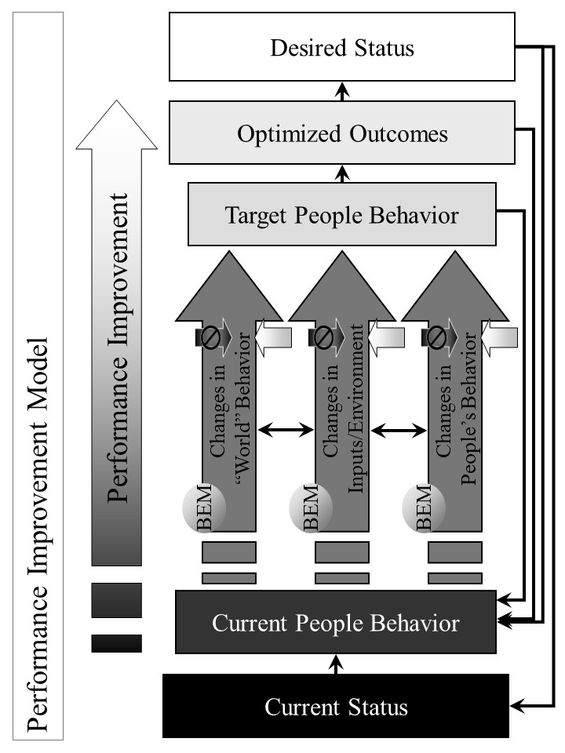

Figure 2. Performance Improvement Model - Strategies for Improving Performance to Achieve Desired Status.
Based on an understanding of the system that is to be improved and its current status or performance level, a desired level of status or performance is chosen. The model is designed to help determine what it will take to achieve that performance or status level. [See Table 2.]

Table 2. Performance Improvement Model –

Strategies for Improving Performance to Achieve Desired Status

The overall strategy for improving performance is as follows:
- Based on an understanding of the system that is to be improved, assess its current status or performance level.
- Determine what should be the desired level of status or performance.
- Assess what is the delta (difference) between those two levels.
- Determine what outcomes need to be produced in order to achieve the desired level of status or performance.
- Determine what people’s current behaviors are.
- Determine what people’s target behaviors should be.
- Assess what is the delta between those two sets of behavior and what behavior changes are desired.
- Determine how “world”, input/environment, and people behavior already occurring or projected to occur affect people behaviors. “World” behaviors are changes in people behaviors that are outside the system being changed. “Inputs/Environment” changes are non-people behaviors such as climate change, and plant and animal change.
- Determine the set of strategies and interventions needed to change people behaviors by using other models, including the Behavioral Effectiveness Model (BEM), the via model, and the Person and Population models. These strategies and interventions may be applied to any or all of “world”, input/environment and people behavior already occurring or projected to occur.
- Measure the effect that these strategies and interventions are having on changing people’s behavior, the outcomes and the status.
- Feed the strategies and interventions into the Overall Strategy and Supporting Strategies.
- Determine how changes in status, outcomes and behavior create a new level of “current” status, outcomes and behavior and rerun the Performance Improvement Model on an ongoing basis.

The Performance Improvement Model’s primary use to date has been for improving health care quality, outcomes and status. Its potential use is being explored in creating an overall strategy for reducing vulnerability and improving the status of a community, nation or broader area.
At the Centers for Medicare and Medicaid Services (CMS), the model was used in 2006 to design an overall strategy for national quality improvement for health care, including but not limited to care funded by Medicare and Medicaid. The desired outcome was health status based on the best knowledge on how much health status can be improved through health care. The current status was based on the best available information on current health status. The model helped identify what outcomes, properly optimized, could best produce the desired health status. Further, it helped identify what target people (persons, health care personnel) behaviors could best produce those optimized outcomes. The Person Model was used to understand how individual persons do and should behave over time. The Population Model was used to understand how populations do and should behave over time. The BEM Model was used to determine what interventions would likely produce the desired behavior change. The via Model was used to determine how to apply those interventions as a coordinated, ongoing strategy. These strategies and interventions were used to enhance the overall quality improvement program for CMS.
Thrive Model. [See separate section below.]
Behavioral Effectiveness Model (BEM). [See separate section below.]
Person Model. The Person Model helps us to understand that each person goes through several life stages depending on how long they live. If status (e.g. health, income, performance) is to be improved, it is seldom a one-time intervention and generally should be done across the life span. As a result, the Person Model works by applying the Behavioral Effectiveness Model over an individual person’s time and life stages. [See Figure 3.]

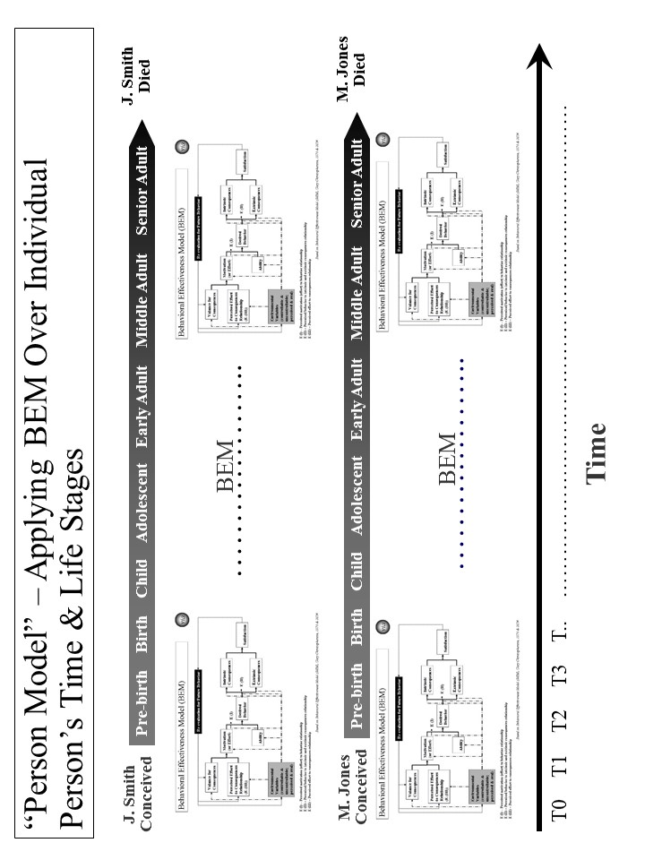
Figure 3. “Person Model” – Applying BEM Over Each Person’s Time and Life Stages.

The Person Model, with BEM as the underlying model, recognizes that each person is different at the beginning, throughout the life stages, and near the end. For status to be improved, the strategy needs to be both specific to each person across the life span and effective for all persons across the life span. [See Table 3.]

Table 3. Person Model – Applying BEM Over Each Person’s Time and Life Stages

The Person Model use for achieving desired behavior is as follows:
- Identify the person or population whose behavior is targeted.
- Decide what is the time frame or life stage(s) to be addressed. The preferred time frame is the whole life.
- Decide what is the desired behavior or behaviors over time and through life stages.
- Apply BEM model as a recurring model (running the model as many times as necessary) adjusting to changes in motivation, ability and environmental variables.
- Assess what interventions will best move projected behavior to desired behavior for the covered time and life stage(s).
- Apply the interventions and assess their effect on an ongoing basis.
- Adjust the interventions as needed over time and based on result.
- Feed the interventions into the Overall Strategy and Supporting Strategies.

To date, the Person Model’s primary use has been for improving health. Its potential use is being explored for creating an overall strategy for reducing vulnerability and improving the status of a community, nation or broader area.
At the Centers for Medicare and Medicaid Services (CMS), the model was used in 2005 to enhance the overall strategy for national quality improvement for health care. The desired behavior was of health care providers over time and their careers. The model helped identify what target health care personnel behaviors, on an ongoing basis, could produce the best outcomes. Based on that, an approach was laid out using current and new interventions to improve health care provider behavior in a way that would produce improved outcomes and health status for the foreseeable future and over the health care providers’ careers (life stages). These interventions were used to improve the overall quality improvement program for CMS.
The model was used in the early 2000s to create a new model called “person-centered health”. The Person-Centered Health Model has been used to refine the programs of the Veterans Health Administration, including overall care, care in the community and the VHA health information system (electronic health record and personal health record systems). It was also used at the Centers for Medicare and Medicaid Services to help with the draft strategic and operational plan.
Population Model. The Population Model addresses status from the perspective of what is happening at any point in time and the effect on a diverse or non-diverse population. Again, BEM is the underlying model for adjusting strategy to address points in time across persons and their life stages. This model also applies to other differences (e.g., racial, ethnic, income, vulnerability) in the target population [See Figure 4.]

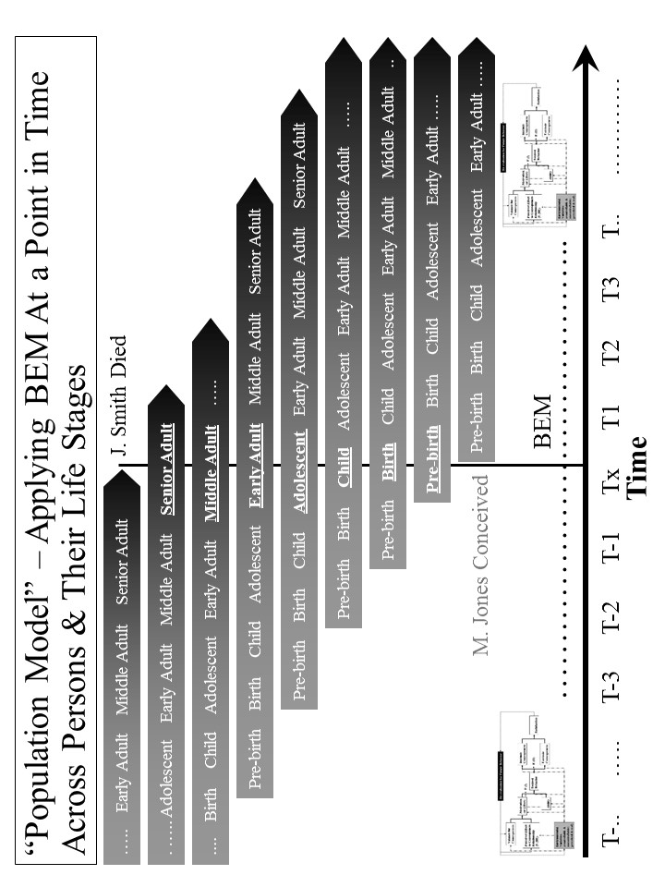

Figure 4. “Population Model” – Applying BEM at a Point in Time Across Persons and Their Life Stages
The Population Model, with BEM as the underlying model, recognizes that strategy, at any point in time, must be both specific to each applicable person across the life span and effective across all persons across the life span. [See Table 4.] Taking a time slice, the model recognizes that at any specific time, the target population likely includes persons from all different stages of life (pre-birth, birth, child, adolescent, early adult, middle adult and senior adult). At that time, each person has different status levels, different factors affecting status, and different responses to efforts at improving status. This can be seen in how major disasters (e.g., tsunamis, earthquakes, disease outbreaks, crop failures, drought) affect people differently. This can be seen in how program interventions (e.g. education, housing programs, financial assistance, health insurance programs, heating assistance, taxes) affect people differently.

Table 4. Population Model –

Applying BEM at a Point in Time Across Persons and Their Life Stages

The Population Model use for achieving desired behavior is as follows:
- Identify the population whose behavior is targeted.
- Decide what are the point(s) in time and life stage(s) to be addressed.
- Decide what is the desired behavior or behaviors at different points in time across persons and their life stages.
- Apply the BEM model across time and across populations and their life stages taking into account their differing motivation, ability and environmental variables.
- Assess what interventions will best move projected behavior to desired behavior across time and across populations and their life stages.
- Apply the interventions and assess their effect on a population on an ongoing basis.
- Adjust the interventions as needed over time and based on result.
- Feed the interventions into the Overall Strategy and Supporting Strategies.

The Population Model’s primary use to date has been for improving health. Its potential use is being explored for creating an overall strategy for reducing vulnerability and improving the status of a community, nation or broader area.
At the Centers for Medicare and Medicaid Services (CMS), the model was used in 2006 to design the draft CMS Strategic and Operational Plan for 2007-12. It was used to address CMS’s disparate beneficiary population and the timing and design of program interventions. The plan was designed to address the needs of both younger and older Medicaid beneficiaries, beneficiaries with disabilities, and healthier and severely ill Medicare beneficiaries. It also addressed the populations that are pre-Medicaid and pre-Medicare. The plan recognized that over time, these populations change as new age cohorts moved into the program. These Population Model interventions were then used to develop the draft overall Strategic and Operational Plan for CMS.
For the DoD Military Health System (MHS), the model was used in the 1990s to work with pre-military, active service, Guard and Reserve, veterans, retirees and their families. All are the responsibility of the MHS. Key points in time greatly affect how the health programs work and their effect. Earlier wars (and their effects) such as the two World Wars and the Korean War are very different than the Vietnam War than the first Iraq War, as well as the second Iraq War and then the Afghanistan operations. They are all likely to be different than future wars and other military actions. All of these factors were built into the overall strategy for the future Military Health System that was re-engineered to improve performance, adopted as a force health protection program, and was made more flexible to adjust to different futures.
System(s) Model (Including “Ideal” Systems). The System(s) Model views the world as a system of systems. When a strategy is being designed, it is important to determine what the target system is, what larger system it is part of, what its subsystems are, and what other systems it relates to. A system can be a community, a nation, or a broader area. It can be an issue area system such a health system, an education system, or an ecological system. The Ideal Systems Model, developed by people such as industrial engineers (e.g. Gerald Nadler) decades ago, is another key model for looking at how well a system could perform and how to achieve the highest performance for that system. [See Figure 5.]

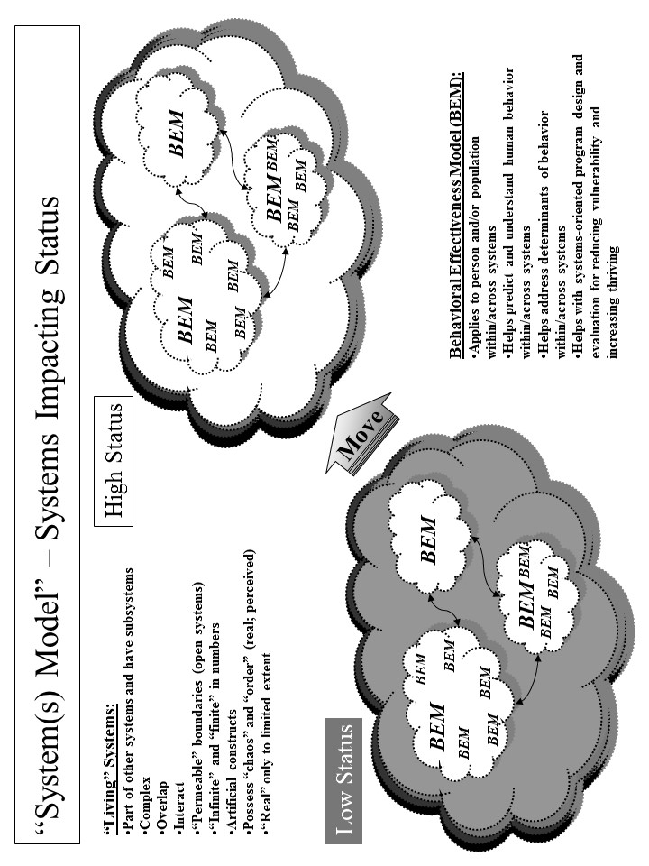

Figure 5. Systems Model – Systems Impacting Status

For efforts to improve status to be successful and sustainable, the strategy and its execution need to be systematic and positively change a system (a whole community, a whole nation or a whole broader area) of systems (e.g., health, education, employment/income, housing, habitat, climate) on a sustained basis. [See Table 5.]

Table 5. Systems Model – Systems Impacting Status

The Systems Model use for achieving desired status is as follows:
- Identify the target system within which status is to be improved.
- Identify other systems that are related and might either be impacted or have an impact.
- Identify the status (lower than desired) for the current system and key characteristics of the current system.
- Identify the desired status and characteristics for the future system using the Ideal Systems Model.
- Identify the key behaviors in the current systems and what they need to be in the future system.
- Determine what changes need to be made to the current system to move it to the desired system.
- Assess what interventions will best change the current system into the desired future system.
- Apply the interventions and assess their effect on behavior change and on status.
- Adjust the interventions as needed over time and based on result.
- Feed the interventions into the Overall Strategy and Supporting Strategies.

In a systems model, there is recognition that systems are “living”. They change internally, impact other systems and are impacted by other systems. Systems are part of other systems and they have subsystems themselves. They are usually complex. They often overlap with other systems. They interact with other systems, sometimes fairly predictably and sometimes not. They often have permeable borders that are not always understood or constant. They may be nearly infinite in number. Often we apply an artificial construct to them to help us understand and work with them. Some systems are formal constructs (e.g., the British National Health Service system, the Kaiser Permanente system, the Military Health System, the veterans health system) and some are informal constructs (e.g. the American “health system”). They may be or appear to be “chaotic” or “ordered”. They may be or appear to be “real”.
To positively change a system (e.g. the American “health system”) on a sustained basis, we need to understand the impact that existing and future systems will have on each person’s or a population’s status. We need to understand the impact of systems that we create, change or delete will have on other systems and, ultimately, on each person’s status.
Within “human” systems are real people (individual persons, populations of persons) and organizations (made up of persons) whose behaviors collectively help determine the behavior of the system. The Behavioral Effectiveness Model (BEM) helps us understand the behaviors and their determinants (ability, motivation, environmental factors) on an individual level and on a population of individuals level. In the systems model used here, there is recognition that moving from low status to high status requires moving individual behavior on a massive scale if it is a large system like the American “health system”. This movement includes the persons we want to move to higher status and the persons that help or hinder that movement.
As shown in Figure 6, the Ideal Systems Model helps determine the desired system. It starts out by assessing the current system. It then sets what is the theoretical ideal system assuming there are no costs or constraints preventing us from reaching that system. The theoretical ideal is a guide but is not reachable in the real world for the foreseeable future. Then the model helps us think through the options between the current system and the theoretical ideal system. The ultimate ideal system is one which imposes no constrains but is not yet feasible due to the “means” not yet being available. The feasible ideal system is one where the constraints are removed or reduced and the “means” are available. Finally, the recommended system is the best given the constraints and available means and is on the glide path to the ultimate ideal. The Thrive Model helps design and assess these different systems.

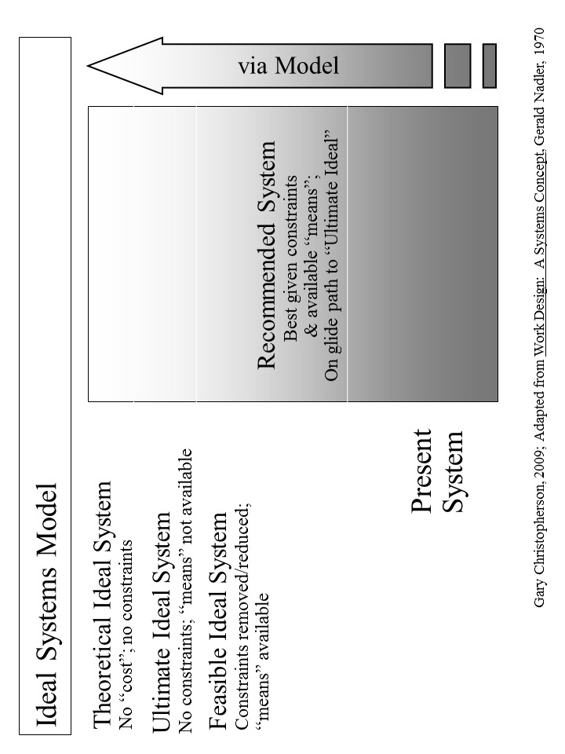
Figure 6. Ideal Systems Model

The primary use of the System Model (this adapted version) to date has been for improving health. Its potential use is being explored in creating an overall strategy for reducing vulnerability and improving the status of a community, nation or broader area.
One of its earliest uses was in the late 1970s to design and execute an inner city health system for Milwaukee, Wisconsin. The result was a new public/private multi-clinic system providing preventive services, primary care, maternal and infant care, mental health care, dental care, and social services for the community poorest and highest risk people. The total system also included hospital services from public and private hospitals. The system operated successfully for over 30 years and has been viewed as a successful model for improving inner city health care.
At the Centers for Medicare and Medicaid Services (CMS), the Systems Model was used in 2006 to design the draft CMS Strategic and Operational Plan for 2007-12. Rather than approaching the plan as a program by program plan or a CMS only plan, the whole American “health system” was used as the framework. The plan was designed using the Ideal Systems Model to improve health across the total American population using the entire American “health system”. The CMS plan strategies were built on how best to move to high health status by using both CMS programs focused on Medicare and Medicaid beneficiaries and programs with broader scope. The plan was designed to address the needs of both younger and older Medicaid beneficiaries, beneficiaries with disabilities, and healthier and severely ill Medicare beneficiaries. It also addressed the populations that are pre-Medicaid and pre-Medicare. These Systems Model interventions were then used to develop the draft overall strategic and operational plan for CMS.
For the Department of Defense (DoD) Military Health System (MHS), the model was used in the middle 1990s to work with full set of DoD health-related programs. The Military Health System was treated as a system that encompassed health care for 1) service members when not engaged in military action, 2) service members (including the Guard and Reserve) when engaged in military action, and 3) family members, retirees, Guard and Reserve in non-active status, veterans served by other providers (e.g., Veterans Health Administration and private providers). It also encompassed preventive services for service members, and force health protection (including protective tools when deployed). The overall MHS strategy was built using the Ideal Systems Model coupled with other “futures” models. It included the health of all of these people. The strategy included all the services needed to protect and improve their health. It included working with other entities, including the Veterans Health Administration and the Centers for Disease Control. All of this was built into the overall strategy for the future Military Health System that was re-engineered, adopted a force health protection program, was more effective and efficient, and was more flexible to adjust to different futures.
The model’s application is being explored for whole communities, nations and broader areas where these are treated as total systems interacting with other systems outside. Building an appropriate set of status indicators is a critical step given the breadth of such systems and the need to assess current and desired future status. The focus is on the whole human population (as well as its individual whole persons), and on animals, plants and natural resources within the targeted community, nation or broader area. The full range of significant issue areas within the target community, nation or broader areas is explored, including their interaction and interdependency. The Ideal Systems model is used to both set the vision and design the recommended systems for now and for the future. The intended result is an overall, sustainable, executable strategy for improving the status of a community, a nation or a broader area.
Strategy Model. The Strategy Model builds on the above groundwork and brings this all together to develop and execute stainable, effective strategies for improving status. It includes the model for building the strategies as well as the framework into which the strategies fit. The model includes both the overall strategy and supportive strategies and the actual interventions supporting the strategies. [See Figure 7.]
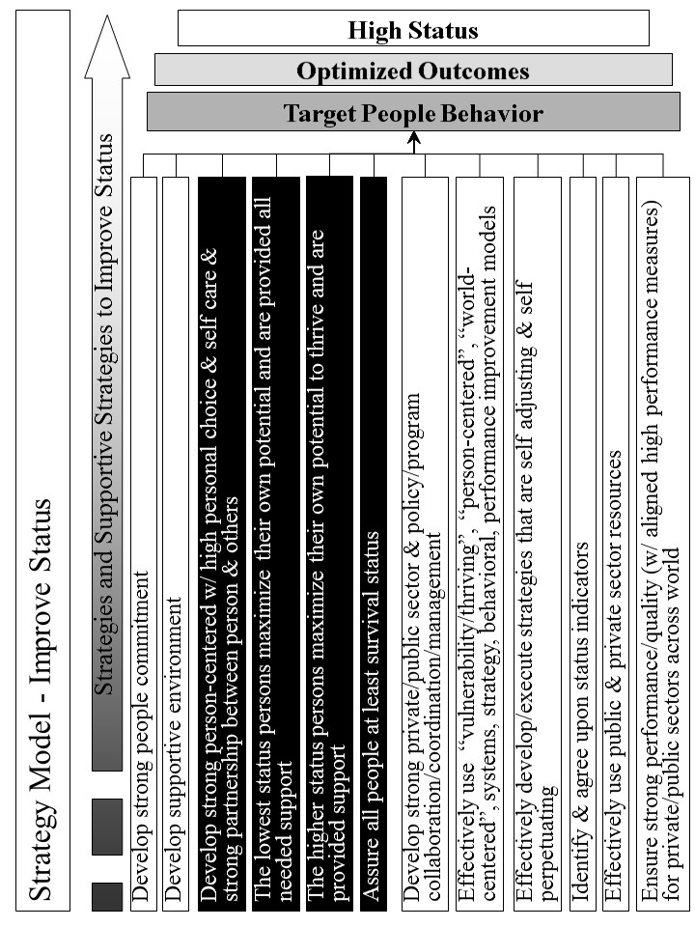
Figure 7. “Strategy Model” – Improve Status

The model brings together all the previous information into an overall strategy and supportive strategies to improve status (e.g. health, income, vulnerability, habitat, climate). [See Table 6.]

Table 6. Strategy Model – Improve Status

The Strategy Model use for achieving desired status incorporates previous work from the other models and input and is as follows:
- Load the desired status and the associated indicators.
- Load the optimized outcomes that will best produce high status.
- Load the target behaviors that will best produce the optimized outcomes.
- Use pathways to connect how the supportive strategies will best produce the target behavior. The pathways are customized to the issue area or “whole”.
- Identify the specific supportive strategies that, working through the pathways will best produce the target behaviors.
- Execute the strategy and its supportive strategies effectively.
- Assess the progress on improving status. Assess the effectiveness of the strategy and its supportive strategies.
- Revise strategy and supportive strategies as needed to be effective and sustained over time.

The Strategy Model’s primary use to date has been for improving health. Its potential use for creating an overall strategy for reducing vulnerability and improving the status of a community, nation or broader area is being explored.
At the Centers for Medicare and Medicaid Services (CMS), the Strategy Model was used in 2006 to design the draft CMS Strategic and Operational Plan for 2007-12. For each of the supportive strategies, a set of specific interventions were developed to make the plan fully operational. With respect to quality improvement for CMS, a more in-depth strategy was developed using the Strategy Model.
Similarly, it is being used to build an overall strategic approach, Building a Better Future, addressing whole communities, nations and broader areas.
Status Model. The Status Model is used to identify the desired and current status for “whole” systems (e.g., a non-geographic population, a community, a nation, a broader area), issue areas (e.g., health, education) or cross-cutting issue areas (e.g., vulnerability, climate, habitat) that are targeted for positive, large scale change. It also includes the status indicators and their supportive measures such as those shown in Figure 8.
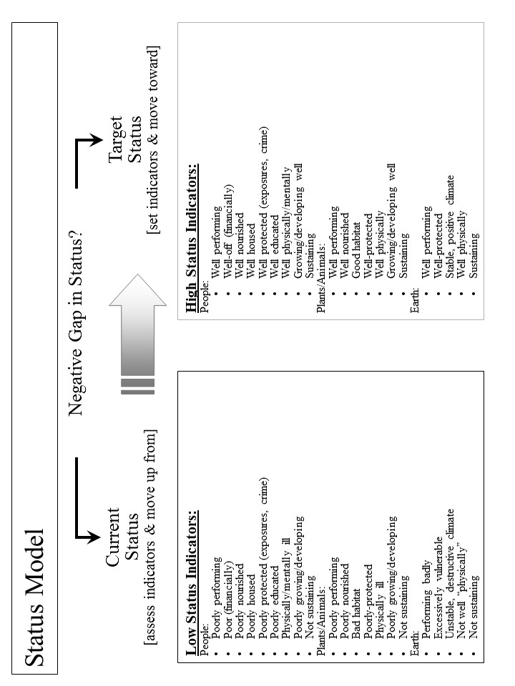
Figure 8. Status Model

For efforts to create and sustain positive systems to be successful, we need to determine how we are doing today, how we are doing as we progress to the desired system and how we are doing when we achieve and work to sustain the desired system. The Status Model helps do that as shown in Table 7.

Table 7. Status Model

The Status Model is as follows:
- Determine what is the issue area, cross-cutting area or “whole” system for which the strategy is targeted and status indicators are needed.
- Decide how high, in general, is the desired status. Is it optimal? If not, how close can we get to optimal?
- Identify all of the indicators that, as a set, indicate the desired high status. These are the “Target Status” set of indicators.
- Decide what each indicator’s level should be to match the desired high status.
- Decide what each indicator’s level is to describe low status.
- To the extent needed, identify more detailed measures for each indicator.
- Assess the “Current Status”, i.e., the current level of indicators for the target population.
- Assess the “Negative Gap” between the current status and the desired target status. This is the gap to be closed with the overall strategy.
- Execute the status model effectively and measure progress.
- Assess the effectiveness of the status indicators.
- Revise status indicators, individually and as a set, as needed to be effective.
The Status Model’s primary use has been for improving health. Its potential use is being explored in creating an overall strategy for reducing vulnerability and improving the status of a community, nation or broader area.
In both the draft CMS Strategic and Operational Plan (2006) and the work being done on how to “achieve a healthy America”, the model’s applications are similar. Both include status indicators that apply across America. Both depend on more detailed measures to support and add depth to the indicators. The CMS approach focused a bit more on CMS beneficiaries but did include all Americans. The “healthy America” approach uses status indicators that apply to all Americans. The health status indicators address the person’s ability and motivation to achieve high health status. The same is true for health care providers. These are more process indicators. The status indicators include outcomes of various treatments and other health interventions. The status indicators go further and include what most consider as “health status” indicators such as low morbidity and mortality, high quality of life, high satisfaction, and low future risk for adverse events. Current status is assessed as well as the negative gap between the desired future high
For the broader work on communities, nations and broader areas, the full set of status indicators is very large but can be grouped into high level categories with supportive measures. They should encompass all the significant indicators covering the full breadth of the target area. On the highest level, they must be meaningful enough to provide guidance on improving the whole target area as a whole system. They must be supported by clearly defined measures that can be measured by data that is available into the future. Further, the status indicators must be flexible enough to adjust to changing future conditions. With these status indicators, a strategy can be developed and its progress assessed.

Behavioral Effectiveness Model (BEM). The Behavioral Effectiveness Model (BEM) is built upon several related models from expectancy theory, instrumentality theory, theory of reasoned action, contingency theory, system theory, social cognitive theory, behavioral theory, etc. that have been in use and refined over 30-40 years. This overall approach is built upon the premise that a person or a population’s behavior is key to what creates and sustains positive change. [See Figure ?.]
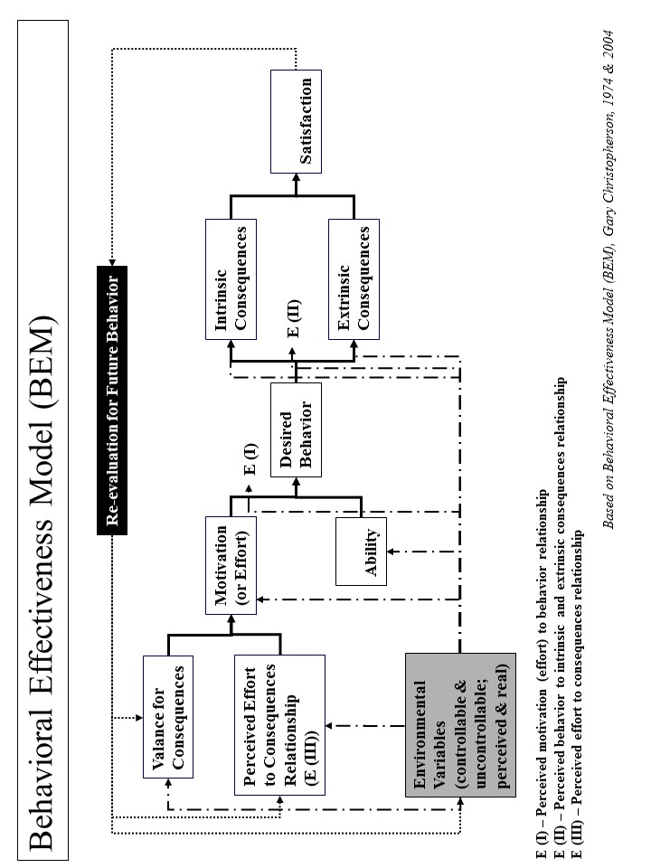
Figure ?. “Behavioral Effectiveness Model (BEM) - Improving Personal Behavior/Performance
BEM’s value lies in 1) being relatively parsimonious, 2) incorporating key aspects of other behavioral models, 3) being “computable” (i.e., it can use databases (personal and environmental characteristics, desired behaviors and tailored interventions)), 4) tailoring applicability to more than one person simultaneously by using individual characteristics and desired behavior(s) and 5) using evidence-based interventions that can be tailored to those characteristics and the desired behavior.
As shown in Table ?, the BEM model is designed to 1) apply interventions that help achieve the desired target behavior, 2) learn more about the person or population involved, 3) learn more about interventions and 4) learn more about the “system” in which intervention are used. It can also be used for prediction, analysis and program development and evaluation. The model can be applied to 1) an individual person, 2) populations whose characteristics are sufficiently the same, and/or 3) populations of individuals for which each individual gets a personalized and tailored intervention. The model can be linked to a database so that it can use and produce information and support personalized and tailored interventions:
- For any number of individuals and over any period of time
- For one-time behaviors and behavior over time
- For change in a single behavior and multiple behaviors.

Table ?. “Behavioral Effectiveness Model (BEM)” –

Improving Personal Behavior/Performance

The BEM Model use for achieving desired behavior is as follows:
- Identify the person or population whose behavior is targeted.
- Decide what is the desired behavior or behaviors. Note that some behavior is one-time and some is recurring.
- Assess motivation in terms of its current and future characteristics.
- Assess ability in terms of its current and future characteristics.
- Assess environmental variables, both controllable and uncontrollable and both perceived and real.
- Assess how motivation, ability and environmental variables are likely to affect future behavior without further intervention.
- Assess what are likely to be the intrinsic (internal to the person or population) and extrinsic (external to the person or population) consequences of projected behavior and what is likely to be the person or population’s satisfaction.
- Assess how consequences and satisfaction are likely to affect future behavior
- Assess how projected behavior, without further intervention, matches to desired behavior.
- Assess what interventions will best move projected behavior to desired behavior for the near and long term.
- Apply the interventions and assess their effect.
- Adjust the interventions as needed over time and based on result.
- Feed the interventions into the Overall Strategy and Supporting Strategies.

The Behavioral Effectiveness Model’s primary use to date has been for improving health. Its potential use is being explored in creating an overall strategy for reducing vulnerability and improving the status of a non-geographic population, a community, a nation or a broader area.
Its earliest use was in the middle 1970’s, helping develop a high blood pressure control program in Milwaukee, Wisconsin. The desired behavior was adherence to methods for controlling high blood pressure. These methods could be medication use and/or life style change (e.g., diet, exercise, stress reduction). Through the use of BEM, the program was better able to get people to get their blood pressures checked and controlled and to determine the likely success of particular methods with a specific person and with persons with similar characteristics. The blood pressure control program was seen as a national model for community blood pressure control.
With respect to communities, nations or broader areas, BEM is used for addressing the full breadth of issue areas and of people, animals/plants, and other natural resources. Here it helps identify what behaviors are associated with the relevant status indicators. It helps identify what ability and motivational factors are and would be determinants of improving status. The model determines what interventions could improve the motivation and ability factors and, as a result, improve status. Based on these, a strategy is being created for improving status for a whole population, in this case America as a whole.
Thrive Model. The Thrive Model serves as a basic framework for interventions that improve the status of an issue area (e.g., health, vulnerability, environment) or a “whole” (e.g., a non-geographic population, a community, a country, or a broader area). [See Figure ?.] As detailed in Table ?, the Thrive Model includes what it is we want to achieve and avoid, how to work through interventions and actions that affect that achievement, and how to measure progress.

Table ?. Thrive Model

The Thrive Model use for interventions improving status is as follows:
- Decide what issue area or “whole” needs status improvement.
- Decide what status indicators will be used to measure current and desired status.
- Identify current and projected actions that affect status in one of the following ways:
  - Actions that lower status.
  - Actions that increase status for that portion above the mean or median.
  - Actions that increase status for that portion below the mean or median.
- Identify what new interventions that positively affect status in one of the following ways:
  - Interventions that help achieve highest status, including supporting actions that further increase high or highest status.
  - Interventions that help prevent lowering of status, including stopping actions that lower status.
  - Interventions that help move up from low status, including supporting actions that increase status.
- Measure the effect that the interventions are having on the current and projected actions and on the status indicators.
- Feed the interventions into Overall Strategy and Supporting Strategies.

The Model’s primary use to date has been for improving health care. Its potential use is being explored in creating an overall strategy for reducing vulnerability and improving the status of a community, nation or broader area.
At the Centers for Medicare and Medicaid Services (CMS), the model was used in 2006 to design the draft CMS Strategic and Operational Plan for 2007-12. It assessed current and projected actions by CMS and others affecting health status. It identified new interventions to stop actions that lower health status and to support actions that increase high and low status. New interventions were also identified that directly help achieve high and highest health status, prevent lowering of health status and move up from low health status. These via Model interventions were then used to develop the draft overall Strategic and Operational Plan for CMS.
Preliminary work has also been done on using the model for non-geographic populations, communities, countries and broader areas. That work incorporates the work done on health and vulnerability into an expanded use applicable to whole communities, countries or broader areas. The focus is on a whole population and its whole persons, along with the respective animals, plants and other natural resources. It addresses the target area as a system with subsystems (e.g. issue areas like health, income, habitat, climate) and with interactions and interdependencies with other systems (i.e., other communities, nations, and broader areas).

Application to Communities, Countries and the World
This theory and these methods have been used successfully at the local and national levels. This paper describes how they can be applied to three settings – community, country and world.

Conclusion and Next Step
We are at a “tipping point” when our future is most endangered and we are most capable. It is only people, joined together, that can create the large, positive and timely change for building a thriving future. This can and should be the political science’s future mission. This can be its greatest achievement.

Why? As we look around us, much of what is important to us is already broken or endangered, much of it unnecessarily so. Because it is people who have broken much of the world and endangered its future, it is people that can and must fix what is broken and build a survivable and thriving future.
Why political science? Because political science is about people, their behavior and how they come together to survive and thrive. People’s behavior is the key to creating and sustaining large, positive, and timely change for a thriving future. People’s behavior is what most endangers our future. People’s behavior is also what offers the best chance to change and build a thriving future.
We are now at a “tipping point” when our future is most endangered and we are most capable. Large, positive and timely change must happen now. Creating and sustaining a thriving future requires understanding that it is we who have broken the present and endangered the future. It is only we, working together that can create and sustain the necessary large, positive and timely change for building a thriving future for all. This can and should be the future mission of political science. This could become its greatest achievement.

Outline

Theory.
Human need survive and desire thrive.
Method.
Strategic and operational planning, management and execution.
BEM.
Thrive model.
Application.
Building surviving and thriving future.
Community
Country
World
Conclusion
5-10,000 words
The Future Focus for Political Science
The Whole or Only Pieces of the Future

Much of political science today focuses on one or more of the many pieces of our past and future. But is that enough? Is it not time for political science to focus on the whole future? But is political science even capable of focusing on the whole future? If yes, is it capable of going beyond studies and actually helping build and sustain a whole future that is much better than our past? This article suggests a path for political science that makes it relevant and maybe essential to building the future in which whole communities, whole countries and the whole world not only survive but thrive.
Why? As we look around us, much of what is important to us is already broken or endangered, much of it unnecessarily so. Because it is people who have broken much of the world and endangered its future, it is people that can and must fix what is broken and build a survivable and thriving future. We are now at a “tipping point” when our future is most endangered and we are most capable.
Why political science? According to the American Political Science Association, political science is the study of governments, public policies, political processes, and political behavior. In effect, political science is about people, their behavior and how they come together to live, survive and thrive. People’s behavior is the key to creating and sustaining large, positive, and timely change for a thriving future. People’s behavior is what most endangers our future. People’s behavior is also what offers the best chance to change and build a thriving future.
Why the Thrive theory? Political theory addresses the political relationships among people and is concerned with the organization and basis of government [public organizations serving and governing for both the personal and public good]. This theory xxxxxx.
What can and should we do? With respect to public policy, we must fully develop knowledge of the processes and products of governing and sucessfuly apply that knowledge to the full range of critical policy issues individually and as a whole. With respect to public administration, we must successfully govern and manage government organizations and we must successfully implement successful public policy for whole communities, whole countries and the whole world.
Large, positive and timely change must happen now. It is only we, working together that can create and sustain the necessary large, positive and timely change for building a thriving future for all. This can and should be the future mission of political science. This could become its greatest and most enduring achievement.

Public Policy for and Public Administration of the Thrive Theory.
xx

The Challenge
Much of political science today focuses on one or more of the many pieces of our past and future. But is that enough? Is it not time for political science to focus on the whole future? But is political science even capable of focusing on the whole future? If yes, is it capable of going beyond studies and actually helping build and sustain a whole future that is much better than our past? If yes, let us begin. This paper suggests a path for political science to make it relevant and maybe essential to building the future in which whole communities, whole countries and the world not only survive but thrive.

What is being proposed?

Why is it important?

How can and should it be done?

What outcome can and should it achieve?

What is the next step?

The challenge to political science

Appendix
Behavioral Effectiveness Model (BEM)

The Behavioral Effectiveness Model (BEM) is built upon several related models from expectancy theory, instrumentality theory, theory of reasoned action, contingency theory, system theory, social cognitive theory, behavioral theory, etc. These have been in use and refined over 30-40 years. [See Figure A.1.]

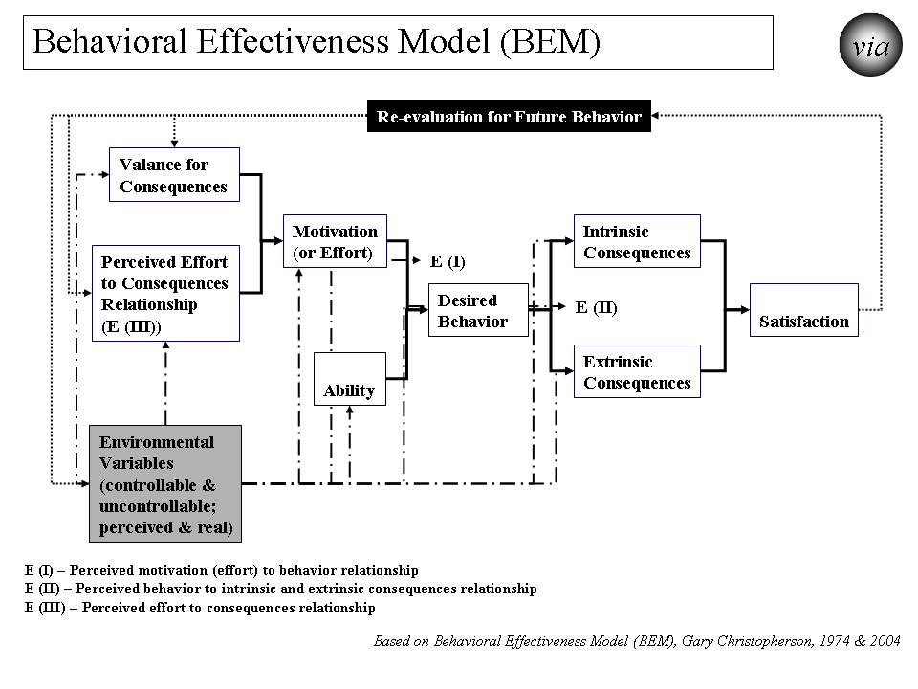

Figure A.1. “Behavioral Effectiveness Model (BEM) - Improving Personal (Human) Behavior/Performance

BEM’s value lies in 1) being relatively parsimonious, 2) incorporating key aspects of other behavioral models, 3) being “computable” (i.e., it can use databases (personal and environmental characteristics, desired behaviors and tailored interventions)), 4) tailoring applicability to more than one person simultaneously by using individual characteristics and desired behavior(s) and 5) using evidence-based interventions that can be tailored to those characteristics and the desired behavior.

As shown in Figure A.1 and in more detail in the spreadsheet in Figure A.2, the Behavioral Effectiveness Model (BEM) has several elements that operate as inputs to or outputs from the intervention models used and help change behavior. The elements include the following:
- Valence (value) of consequences is how a person values the consequences that he/she may or will face. They may be intrinsic (internal to person or organization) or extrinsic (external to person or organization).
- Expectancy III (E (III)) is the person’s perception (or the actual projected) probability that the person’s effort will result in each consequence.
- Motivation (effort) is what the person is expected to try to do (that is, try to do the behavior) and is calculated using the “valence of consequences” and E (III) above.
- Ability is the person’s capability to do the behavior. Any ability that is essential to the behavior and is at low levels means that the person is unlikely to be able to do the behavior even if other less essential ability factors are high.
- Behavior is the desired behavior to achieve the desired vulnerability/thriving outcome. Behavior probability is calculated using motivation and ability probabilities.
- Consequences are the expected results of effort to do the behavior or the behavior itself. Valence is modified to reflect the actual valence when the consequence occurred.
- Expectancy I (E (I)) is the person’s perception (or the actual projected) probability that the person’s effort will result in desired behavior.
- Expectancy II (E (II)) is the person’s perception (or the actual projected) probability that the person’s behavior will result in intrinsic and/or extrinsic consequences.
- Satisfaction is the person’s level and direction (positive/negative) of satisfaction with what happens, especially as compared to expectations. It is especially key when the behavior is recurring or when a future behavior is related.
- Environmental factors (EF) are those outside influences affecting motivation and ability and may be current or projected. They include program interventions to improve probability of desired behavior initially and over time. They may be controllable or uncontrollable and may be real and/or perceived. They are factors outside the factors in the model. Environmental factors can impact the model at several points as noted by the “EF” arrows depicted in the model figure above.
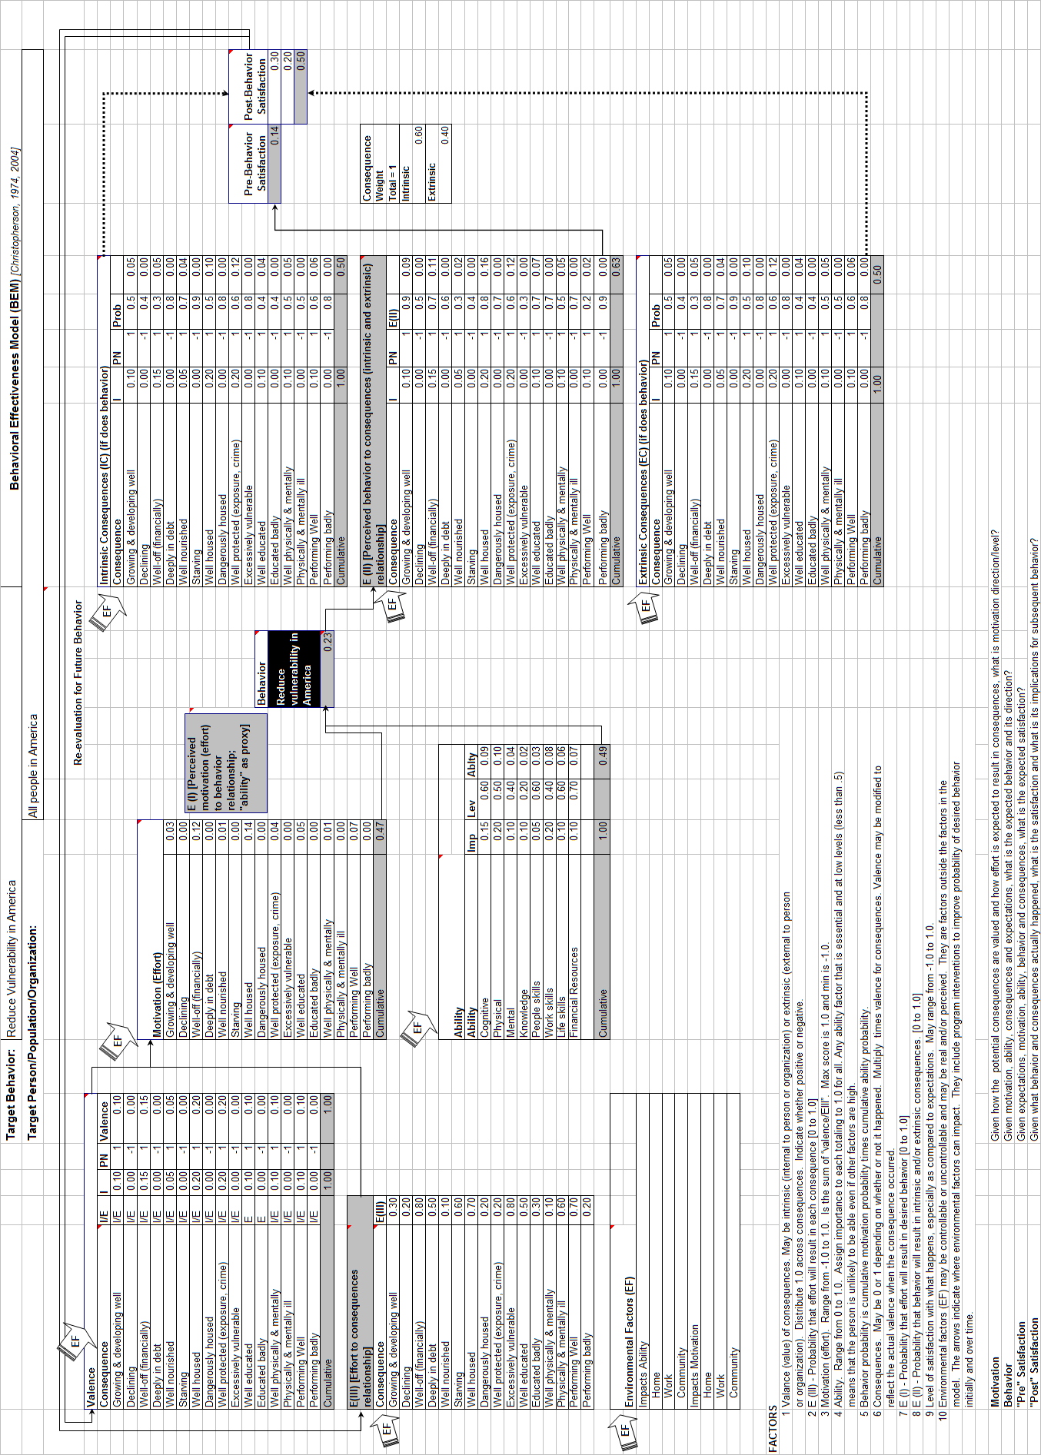

Figure A.2. “Behavioral Effectiveness Model (BEM)” - BEM as Applied to Reducing Vulnerability in America and Beyond.
There are several outputs provided by the model that predict what will happen initially and over time, including:
- Ability -- Given the person’s own abilities and the impacting environmental factors (factors that negatively and/or positively impact a person’s ability), how able is the person to do the desired behavior?
- Motivation -- Given how the potential consequences are valued and how effort is expected to result in consequences, what is motivation direction/level?
- Behavior -- Given motivation, ability, consequences and expectations, what is the expected behavior, its likelihood, and its direction?
- "Pre" Satisfaction -- Given expectations, motivation, ability, behavior and consequences, what is the expected satisfaction?
- "Post" Satisfaction -- Given what behavior and consequences actually happened, what is the satisfaction and what is its implication for subsequent behavior?

The BEM model, as noted below, is designed and used here to 1) apply interventions that help achieve the desired target behavior, 2) learn more about the person involved, 3) learn more about the intervention itself and 4) learn more about the “system” in which the intervention is used. Examples of the potential uses include:
- Impact behavior
  - Analyze current behavior and the factors that impact that behavior
  - Predict future behavior and the factors that impact that behavior
  - Support interventions that impact behavior and incorporate the factor that impact behavior
- Learn more about the person.
  - Information on ability and motivation.
  - Information that was initially incomplete or inaccurate.
  - Information that changes over time due to changes from the intervention, from the environment independently, and/or from the person independently.
- Learn more about the intervention.
  - On what individual person(s) does the intervention work and not work and what degrees in between (works X% of the time; produces Y% of the desired result)?
  - How can the intervention best be targeted for use by/with different individual persons?
  - How does the intervention need to be changed to match changes in individual persons?
  - How can the intervention be improved generally and for individual persons based on lessons learned?
- Learn more about the system in which the model is being used and the environment in which it and its persons operate.

The BEM model can be and is used here used for prediction, analysis and program development, including:
- It can be used and is used here as a predictive model for motivation/effort, behavior and satisfaction.
  - The person's characteristics (valence or value of potential consequences; expectations that effort will lead to specific consequences; cognitive and physical ability) are entered into the model and predicted results (expected level of motivation/effort, expected behavior and expected level of satisfaction) are processed through the model.
  - The model also can utilize environmental factors that influence any the person's characteristics. The model also can then use the predicted results and environmental factors to predict subsequent effort, behavior and satisfaction.
- It can be used and is used here as an analytic model to better understand what is working and not working, why, and what changes are needed.
  - If there is a lack of motivation, the model can help work through the perceived consequences, the perceived linkages of effort to those consequences and provide options for what needs to be changed.
  - If the desired behavior is not occurring, the model helps work through what factors (e.g., persons' ability, their expectations about consequences, their general motivation, their satisfaction with previous efforts with an intervention, the effects of environmental factors) need to be changed.
  - If the desired satisfaction is not achieved, the model can help work through why not and provide options for what needs to be changed..
- It can be used and is used here for program development to develop or modify a program intervention for particular individuals and/or generally.
  - Based on the person(s) characteristics and the desired behavior, the program intervention can be designed or modified to improve likelihood of successfully achieving the desired behavior. For some persons, the focus might be on ability, motivation or both..

The model can be applied and is applied here to 1) an individual, 2) populations whose characteristics are sufficiently the same, and/or 3) populations of individuals for which each individual gets a personalized/customized/tailored intervention.

The model can be linked to a database so that it can produce information and support personalized/customized/tailored interventions:
- For any number of individuals and over any period of time
- For one-time behaviors and behavior over time
- For change in a single behavior and multiple behaviors.

Figure A.2 provides an example of how BEM works when applied to an issue such as reducing vulnerability and increasing thriving. The example is a relatively simple one that is applicable to either an individual or a population with very similar characteristics. It shows how the basic calculations would be done and what the results would be on a first run of the model. To fully use the model, it should be run multiple times to see what changes occur and need to be incorporated into the model. For some uses, this basic model or even a simpler version may be adequate. For some uses, the model may need many more factors. It may need to be run separately for other individuals or populations. If the target behavior is a recurring behavior, then the model should be rerun consistent with the recurring behavior and over the relevant time.

As is true for almost any model and as has been true over the past decades, the Behavioral Effectiveness Model (BEM) will improve with more use and the knowledge gained from that use.

A people is a group of persons such as a family, community, country, world and other affinity groups.
Nonlinear means not going in a straight line or not continuously progressing or regressing.

