Next Generation Strategy for

Creating and Sustaining Positive, Large Scale Change

Abstract
As we look around us in America and the world, much of what is important to us is already broken or is endangered, much of it unnecessarily so. Unfortunately, most current policy and strategy models are inadequate for solving today’s problems and wholly inadequate for succeeding with a much more challenging future. If we are to achieve a better future, we need to use “next generation” strategy for solving large problems and creating and sustaining positive, large and timely change. “Next generation” strategies are better because they are successful with whole issues and whole communities (including nations) for the near and long term future. Further, they successfully address human behavior, individual persons, small and large systems, positive and timely change, personal and program performance, and improved outcomes and status. Potential “next generation” strategies do exist for systems (issue area, community, nation, regions) and individual persons. The “via” strategy is core set and system of supportive models that meet the criteria for “next generation” strategy. It can be successfully applied to politics (small and large “P”), strategy, policy, management, execution and evaluation. It is most beneficial when applied to all of these simultaneously. To successfully address the future, our vision should be to build a survivable and thriving future for individual persons, communities, states, regions, nations and the world as a whole. The “via” strategy is a “next generation” strategy that helps create and sustain large, positive and timely change and helps build a better and, preferably, thriving, future.
Gary A. Christopherson

“Next Generation” Strategy for

Creating and Sustaining Positive, Large and Timely Change

As we look around us in America and the world, much of what is important to us is already broken or is endangered, much of it unnecessarily so. Unfortunately, most current governance, policy and strategy and execution models are inadequate for solving today’s problems and wholly inadequate for succeeding with a much more challenging future. If we are to achieve a better future, we need to use more effective “next generation” strategy for solving large problems, creating and sustaining positive, large, and timely change, and building a better, preferably thriving, future. The “via” strategy set is a ”next generation” strategy. It is more effective with whole issues and whole communities (including nations) for the near and long term future. It can more effectively address human behavior, individual persons, small and large systems, positive and timely change, personal and program performance, and improved outcomes and status. Finally, “via” is applicable to and more effective with politics (small and large “P”), governance, decision- making, strategy, policy, management, execution and evaluation. “via” produces the greatest benefit when used as a set and applied to all of these simultaneously.

Why “Next Generation” Strategy?
First, let me strongly suggest that our “mission” should be to build a better future and our “vision” should be to achieve a positive, sustainable future - preferably a thriving future.
But how do we do it? Based on thirty years of experience at the national and local levels, most current governance, policy, strategy and execution models are inadequate for solving today’s problems and wholly inadequate for succeeding with a much more challenging future. Generally, current models fail to learn from past failures and fall far short of being next generation. “Next generation” governance, policy, strategy and execution models must succeed with a future world that is at high risk with threats to its sustainability, is large and broad of scope, is complex, is highly interactive and interdependent, will depend heavily on what people do, and will change with or without us.
Many people, with good intentions are trying to fix large problems and build a better future. That is good news, to some extent. Unfortunately, that includes much bad news unless we change our approach. Most people are focused on single issue areas, e.g. housing, health, income, transportation, education, plant/animal habitat, climate, natural resources. Most are focused on only a part of a single issue area. Most treat people as parts rather than whole persons. If successful, most make some progress in the near term and relatively little for the longer term. Most waste valuable resources and reach less than optimal near and long term solutions because they do not coordinate their work with that being done in related issue areas.
All this can be helpful, but solving a community’s, a nation’s or broader area (e.g. a region or larger) problems takes more than this. “Next generation” strategies are better because they are successful with whole issues and whole communities (including nations) for the near and long term future. Further, they successfully address human behavior, individual persons, small and large systems, positive and timely change, personal and program performance, and improved outcomes and status More specifically, “next generation” strategies are better for the following reasons?
- First, “next generation” strategy focuses on individual whole “persons” -- individuals with unique abilities, motivation, and behaviors uniquely affected by and affecting their “environment.” After all, it is people who create most problems and it is people who can and should fix the problems, create and sustain positive, large scale change, and build a better future.
- Second, “next generation” strategies are much more effective at addressing the important issue areas, especially large, complex ones.
- Third, “next generation” strategies effectively handle the cross-cutting issues of a highly interactive and interdependent world.
- Fourth, “next generation” governance, policy, strategy and execution models effectively tackle issues as a system (e.g. a health system, a resource system, a community) interacting with other systems and within larger systems (e.g. communities, nations, world).
- Fifth, “next generation” strategies effectively handle whole “systems”, including whole persons, whole communities, whole nations, and, whole broader areas.
- Sixth, “next generation” strategies effectively handle the future in terms of sustaining whatever progress we make and adjusting to a changing future.
No single strategy, model or tool by itself will help us do all this. But a core set of “next generation” strategies, models and tools together can help if it 1) is effective for individual and cross-cutting issues, 2) can incorporate and work well with other effective strategies, models and tools 3) is effective as a coordinated approach for addressing the “systems” and “wholes” requirement, and 4) can effectively address the future and adjust to and sustain the future. One such core set exists and is labeled “via”, a term whose definition is “by way of, through the medium or agency of, or by means of.”

Why The “via” Strategy?
As suggested, potential “next generation” models do exist for strategy at system (issue area, community, nation, broader areas) and person levels. The “via” strategy -- a core set and system of supportive models addressing persons, systems, motivation, ability, behavior, performance and its improvement, process measures, and, most importantly, positive outcomes and improved status – is one approach that meets the criteria for “next generation” strategy.
Why is the “via” strategy better? Going back to what does it mean to be “next generation”, here is how “via” matches up.
- First, the “via” strategy focuses on individual “persons” -- individuals with unique abilities, motivation, and behaviors uniquely affected by and affecting their “environment.” “Person” aspects are addressed by the Behavioral Effectiveness Model (BEM) and the “Person-centered Model”.
- Second, the “via” strategy is designed to be more effective at addressing issue areas, especially large, complex ones. Large, complex issue areas (e.g., health) have been addressed with the full “via” strategy core set.
- Third, the “via” strategy is designed to effectively handle the cross-cutting issues of a highly interactive and interdependent world. Cross-cutting issue areas (“e.g., vulnerability) have been explored with the full “via” strategy core set.
- Fourth, the “via” strategy is designed to tackle issues as a system (e.g. a health system) interacting with other systems and within larger systems (e.g. communities, nations, broader areas). Systems (personal health, health care delivery systems, and public health) have been addressed with the full “via” strategy core set, including the “system” models.
- Fifth, the “via” strategy is designed to effectively handle whole “systems”, including whole communities, whole nations, and whole broader areas. Systems have been addressed (e.g., population-based health, large health care delivery systems) or explored (e.g., vulnerability, community, nation) with the full “via” strategy core set.
- Sixth, the “via” strategy is designed to effectively handle the future in terms of sustaining whatever progress we make and adjusting to a changing future. Sustainable, future-adaptive systems have been addressed (e.g., personal health, large health care delivery systems) or explored (e.g., vulnerability, community, nation) with the full “via” strategy core set, including the predictive aspects of the core set’s models.

What Is The “via” Strategy Core Set and How Does It Work?
The “via” overall strategy and core set is explored here along with references to three areas of potential application:
- Health, a large, complex, individual issue area, where it has already been applied.
- Vulnerability, a large complex cross-cutting issue area, where it is being explored to develop coordinated strategy and policy.
- Whole communities, whole nations and whole broader areas where it is being explored to develop coordinated strategy and policy.
What does the “via” strategy core set consist of? As shown in Table 1, the core set includes the overall “via” Strategy, the Performance Improvement Model, the “via” Model, the Behavioral Effectiveness Model (BEM), the Person Model, the Population Model, the System(s) Model, the Strategy Model, and the Status Model. The strategy core set and its individual element can be successfully applied to politics (small and large “P”), governance, decision- making, strategy, policy, management, execution and evaluation. “via” produces the greatest benefit when used as a set and applied to all of these simultaneously.
The overall core set and the supportive components can be applied to a single issue area, cross-cutting issue areas, and whole communities, nations and broader areas. All of these will be described and discussed in more detail.

Table 1: “via” Strategy Core Set and Applicable Issue Levels and Scope
“via” Strategy Core Set | Issue Level and Scope
“via” Strategy Core Set | Single Issue  Area (E.g.  Health) | Cross-cutting  Issue Areas  (E.g. Vulnerability) | Whole  Community, Nation, Broader Areas
Overall “via” Strategy | X | X | X
System(s) Model, Including “Ideal” Systems | X | X | X
Performance Improvement Model | X | X | X
“via” Model | X | X | X
Behavioral Effectiveness Model (BEM) | X | X | X
Person Model (applying BEM over individual person’s time & life stages) | X | X | X
Population Model (applying BEM over multiple persons’ time & life stages) | X | X | X
Strategy Model (strategies & interventions) | X | X | X
Status Model | X | X | X

Overall “via” Strategy.
What is it? As displayed in Figure 1 and detailed in Table 2, the overall “via” strategy is to effectively use the “via” strategy core set as a set of integrated, coordinated components to produce the necessary knowledge and an effective overall strategy with supportive strategies. By using the full core set, we can better identify and understand the targeted system (e.g., community, nation), decide what we want to achieve on a sustained basis, understand and select the target behaviors, design and select what interventions we need, and develop the overall strategy and supportive strategies to achieve the desired state. [Table 1 and Figure 1.]

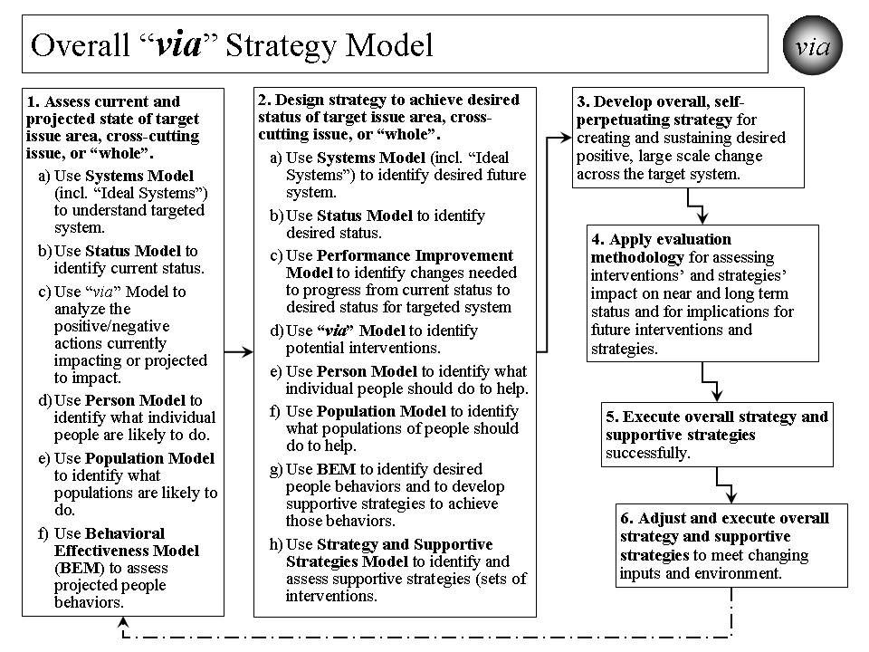
Figure 1. Overall “via” Strategy Model.

How does it work? It works through the systematic application of the core set by people who have both the motivation and the ability to help create and sustain positive, large scale change.
Though the steps laid out in Figure 1 and Table 2 imply their sequential application, that is not always the case. Step 1 is important in our understanding what is the current system, its status, its projected actions, and its projected people and population behaviors. Step 1c helps us organize that thinking of how we might get from the current situation to the desired status for the targeted system. Step 2 helps us work through what needs to be changed and how we might make that change. Step 3 pulls all this together to help us create and execute the overall strategy and supportive strategies. Step 4 is to make sure we evaluate how we are doing and provide input for changes in strategy. Step 5 focuses on the successful execution of the overall strategy and supportive strategies. Step 6 makes sure we understand that strategy is not static and needs to adjust to unanticipated input and environmental changes, and the strategy needs to be executed successfully on an ongoing basis.

Table 2. Overall “via” Strategy -

Creating and Sustaining Positive, Large Scale Change

The overall strategy for creating and sustaining positive, large scale change is as follows:
- Assess current and projected state of target issue area, cross-cutting issue, or “whole”.
  - Use Systems Model (including “Ideal Systems”) to understand targeted system (e.g. health system, community, nation, broader area) today.
  - Use Status Model to identify current status for “whole” (e.g., community, nation, broader areas), issue areas (e.g., health, education), or cross-cutting issue area (e.g., vulnerability, climate, habitat) targeted for positive, large scale change.
  - Use “via” Model to analyze the positive/negative actions currently impacting or projected to impact issue area, cross-cutting issue, or “whole”.
  - Use Person Model to identify what individual people are likely to do in the future.
  - Use Population Model to identify what populations are likely to do in the future.
  - Use Behavioral Effectiveness Model (BEM) to assess projected people behaviors.
- Design strategy to achieve desired status for target issue area, cross-cutting issue, or “whole”.
  - Use Systems Model (incl. “Ideal Systems”) to identify desired future system state.
  - Use Status Model to identify desired status for targeted system.
  - Use Performance Improvement Model to identify changes, including behavior, needed to progress from current status and achieve desired status for targeted system.
  - Use “via” Model to identify potential interventions for creating and sustaining desired positive, large scale change.
  - Use Person Model to identify what individual people should do to help achieve the desired positive, large scale change.
  - Use Population Model to identify what populations of people should do to help achieve the desired positive, large scale change.
  - Use BEM to identify ability, motivation and desired behaviors that help achieve desired change and to develop supportive strategies to achieve desired behaviors.
  - Use Strategy and Supportive Strategies Model to identify and assess and organize supportive strategies (sets of interventions) for creating/sustaining desired change.
- With above inputs, develop overall, self-perpetuating strategy for creating and sustaining desired positive, large scale change across target system.
- Apply evaluation methodology for assessing strategies’ and interventions’ impact on near and long term status and for implications for future interventions and strategies.
- Execute overall strategy and supportive strategies successfully.
- Adjust and execute overall strategy and supportive strategies to meet changing inputs and environment.

How has it been used and helped? The “via” strategy has been used for several large scale changes, including systems such as the $15+ billion Military Health System (Department of Defense), the $1+ billion HealtheVet VistA health information system (Veterans Health Administration), the draft Strategic and Operational Plan for the $500+ billion Centers for Medicare and Medicaid Services, a potential strategy (“Vulnerable In America” (www.VulnerableInAmerica.org)), for reducing vulnerability for communities and nations, a potential strategy (Building A Healthy America” (www.BuildingAHealthyAmerica.org)) for “building a healthy America” (over 1/6th of the U.S. economy) and a potential strategy (“Thrive!” and “Thriving Future” (www.ThrivingFuture.org)) for “building a thriving future”.
The strategy’s application to whole communities, nations and broader areas is also being explored as a total system interacting with other systems outside. In this case, the focus is on the whole population and its individual whole persons. The full range of significant issue areas within the target community, nation or broader area is explored, including their interaction and interdependency. Status indicators to assess current and desired future state are being developed. The intended result is an overall, sustainable, executable strategy for improving the status of a community, a nation or a broader area.

Performance Improvement Model.
What is it? The Performance Improvement Model lays out the process by which a desired performance or status (e.g. minimized vulnerability and maximized thriving, high health status, sustainable and good animal habitat, sustainable energy) is set and compared to the current status. Based on that, a strategy is developed that makes the necessary changes to achieve the desired performance or status. [See Figure 2.]

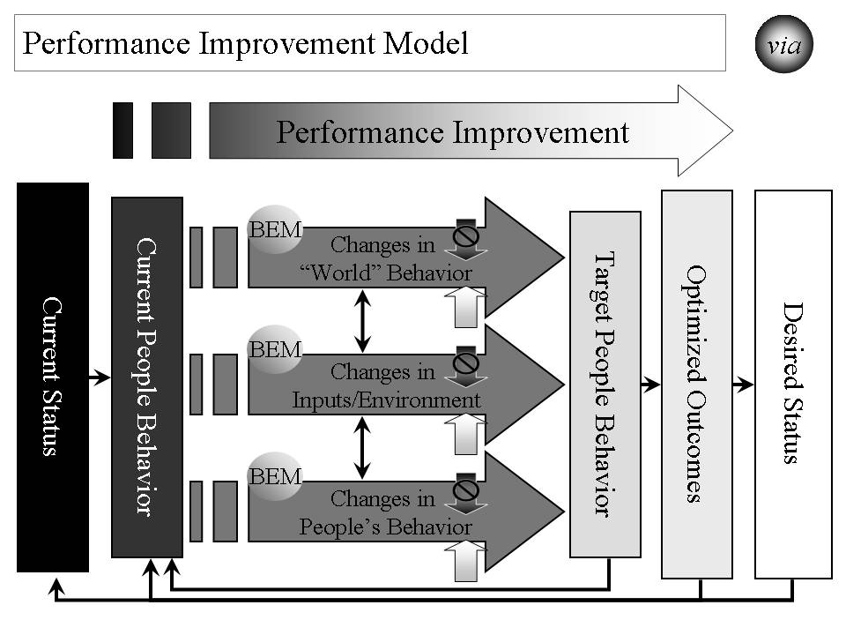
Figure 2. Performance Improvement Model - Strategies for Improving Performance to Achieve Desired Status.

How does it work? Based on an understanding of the system that is to be improved and its current status or performance level, a desired level of status or performance is chosen. The model is designed to help determine what it will take to achieve that performance or status level. [See Table 3.]

Table 3. Performance Improvement Model –

Strategies for Improving Performance to Achieve Desired Status

The overall strategy for improving performance is as follows:
- Based on an understanding of the system that is to be improved, assess its current status or performance level.
- Determine what should be the desired level of status or performance.
- Assess what is the delta (difference) between those two levels.
- Determine what outcomes need to be produced in order to achieve the desired level of status or performance.
- Determine what people’s current behaviors are.
- Determine what people’s target behaviors should be.
- Assess what is the delta between those two sets of behavior and what behavior changes are desired.
- Determine how “world”, input/environment, and people behavior already occurring or projected to occur affect people behaviors. “World” behaviors are changes in people behaviors that are outside the system being changed. “Inputs/Environment” changes are non-people behaviors such as climate change, and plant and animal change.
- Determine the set of strategies and interventions needed to change people behaviors by using other models, including the Behavioral Effectiveness Model (BEM), the “via” model, and the Person and Population models. These strategies and interventions may be applied to any or all of “world”, input/environment and people behavior already occurring or projected to occur.
- Measure the effect that these strategies and interventions are having on changing people’s behavior, the outcomes and the status.
- Feed the strategies and interventions into the Overall Strategy and Supporting Strategies.
- Determine how changes in status, outcomes and behavior create a new level of “current” status, outcomes and behavior and rerun the Performance Improvement Model on an ongoing basis.

How has it been used and helped? The Performance Improvement Model’s primary use to date has been for improving health care quality, outcomes and status. At the Centers for Medicare and Medicaid Services (CMS), the model was used in 2006 to design an overall strategy for national quality improvement for health care, including but not limited to care funded by Medicare and Medicaid. Its potential use is being explored in creating an overall strategy for reducing vulnerability and improving the status of a community, nation or broader area.

“via” Model.
What is it? The “via” Model serves as a basic framework for interventions that improve the status of an issue area (e.g., health, vulnerability, climate, animal habitat) or a “whole” (e.g., community, nation, or broader area). [See Figure 3.]

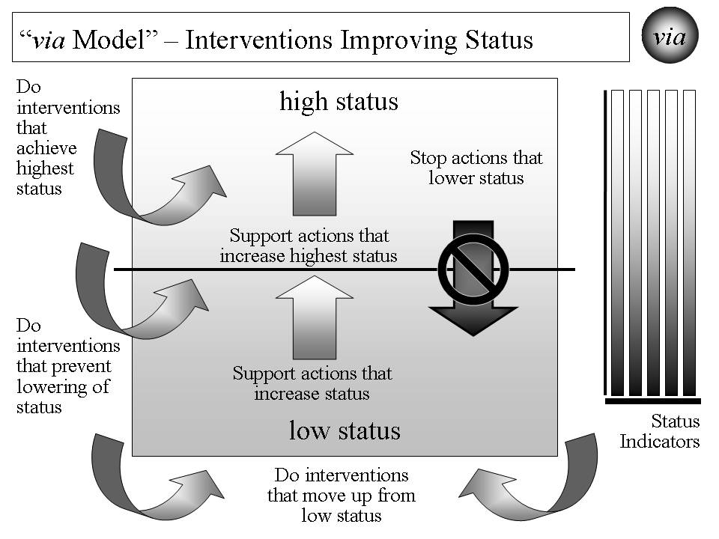
Figure 3. “via Model” for Interventions Improving Status.

How does it work? As detailed in Table 4, the “via” Model includes what it is we want to achieve and avoid, how to work through interventions and actions that affect that achievement, and how to measure progress.

Table 4. “via” Model - Interventions Improving Status

The “via” Model use for interventions improving status is as follows:
- Decide what issue area or “whole” needs status improvement.
- Decide what status indicators will be used to measure current and desired status.
- Identify current and projected actions that affect status in one of the following ways:
  - Actions that lower status.
  - Actions that increase status for that portion above the mean or median.
  - Actions that increase status for that portion below the mean or median.
- Identify what new interventions that positively affect status in one of the following ways:
  - Interventions that help achieve highest status, including supporting actions that further increase high or highest status.
  - Interventions that help prevent lowering of status, including stopping actions that lower status.
  - Interventions that help move up from low status, including supporting actions that increase status.
- Measure the effect that the interventions are having on the current and projected actions and on the status indicators.
- Feed the interventions into the Overall Strategy and Supporting Strategies.

How has it been used and helped? The “via” Model’s primary use to date has been for improving health care. Its potential use is being explored in creating an overall strategy for reducing vulnerability and improving the status of a community, nation or broader area.

Behavioral Effectiveness Model (BEM).
What is it? The Behavioral Effectiveness Model (BEM) is built upon several related models from expectancy theory, instrumentality theory, theory of reasoned action, contingency theory, system theory, social cognitive theory, behavioral theory, etc. that have been in use and refined over 30-40 years. The “via” approach is built upon the premise that a person or a population’s behavior is key to what creates and sustains change. [See Figure 4.]

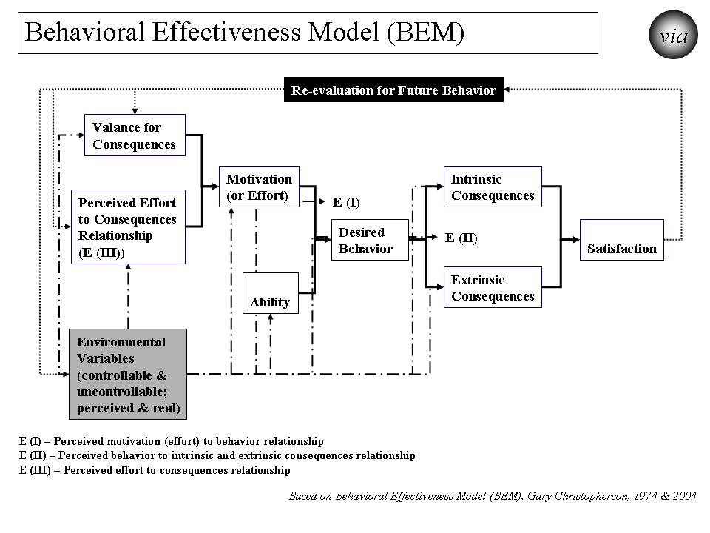

Figure 4. “Behavioral Effectiveness Model (BEM) - Improving Personal Human Behavior/Performance

BEM’s value lies in 1) being relatively parsimonious, 2) incorporating key aspects of other behavioral models, 3) being “computable” (i.e., it can use databases (personal characteristics, desired behaviors and tailored interventions)), 4) tailoring applicability to more than one person simultaneously by using individual characteristics and desired behavior(s) and 5) using evidence-based interventions that can be tailored to those characteristics and the desired behavior.
How does it work? As shown in Table 5, the BEM model is designed to 1) apply interventions that help achieve the desired target behavior, 2) learn more about the person or population involved, 3) learn more about interventions and 4) learn more about the “system” in which intervention are used. It can also be used for prediction, analysis and program development. The model can be applied to 1) an individual person, 2) populations whose characteristics are sufficiently the same, and/or 3) populations of individuals for which each individual gets a personalized and tailored intervention. The model can be linked to a database so that it can use and produce information and support personalized and tailored interventions:
- For any number of individuals and over any period of time
- For one-time behaviors and behavior over time
- For change in a single behavior and multiple behaviors.

Table 5. “Behavioral Effectiveness Model (BEM)” –

Improving Personal Human Behavior/Performance

The BEM Model use for achieving desired behavior is as follows:
- Identify the person or population whose behavior is targeted.
- Decide what is the desired behavior or behaviors. Note that some behavior is one-time and some is recurring.
- Assess motivation in terms of its current and future characteristics.
- Assess ability in terms of its current and future characteristics.
- Assess environmental variables, both controllable and uncontrollable and both perceived and real.
- Assess how motivation, ability and environmental variables are likely to affect future behavior without further intervention.
- Assess what are likely to be the intrinsic (internal to the person or population) and extrinsic (external to the person or population) consequences of projected behavior and what is likely to be the person or population’s satisfaction.
- Assess how consequences and satisfaction are likely to affect future behavior
- Assess how projected behavior, without further intervention, matches to desired behavior.
- Assess what interventions will best move projected behavior to desired behavior for the near and long term.
- Apply the interventions and assess their effect.
- Adjust the interventions as needed over time and based on result.
- Feed the interventions into the Overall Strategy and Supporting Strategies.

How has it been used and helped? The Behavioral Effectiveness Model’s primary use to date has been for improving health. Its potential use is being explored in creating an overall strategy for reducing vulnerability and improving the status of a community, nation or broader area.
BEM is also being used on the cross-cutting issue of vulnerability. Here it is being used to help identify what behaviors are associated with vulnerability and thriving. It helps identify what ability and motivational factors are and would be determinants of vulnerability and thriving behavior. The model is being used to determine what interventions could be used to improve the motivation and ability factors and, as a result, reduce vulnerability and maximize thriving. Based on these, a potential strategy has been created for minimizing vulnerability and maximizing thriving for a whole population, in this case the United States as a whole. As indicated earlier, the overall strategy has not been used to date, but is ready for application.
With respect to communities, nations or broader areas, BEM is being used to address the full breadth of issue areas and of people, animals/plants, and natural resources. Here it is used to help identify what behaviors are associated with the relevant status indicators. It helps identify what ability and motivational factors are and would be determinants of improving status. The model is used to determine what interventions could be used to improve the motivation and ability factors and, as a result, improve status. Based on these, a strategy is being created for improving status for a whole population, in this case the United States as a whole.

Person Model.
What is it? The Person Model helps us to understand that each person goes through several life stages depending on how long they live. If status (e.g. health, income, performance) is to be improved, it is seldom a one-time intervention and generally should be done across the life span. As a result, the Person Model works by applying the Behavioral Effectiveness Model over an individual person’s time and life stages. [See Figure 5.]

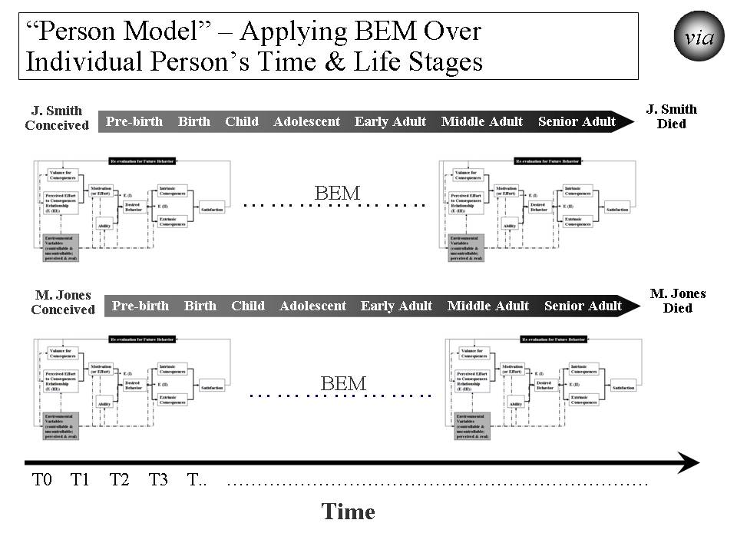
Figure 5. “Person Model” – Applying BEM Over Each Person’s Time and Life Stages.

How does it work? The Person Model, with BEM as the underlying model, recognizes that each person is different at the beginning, throughout the life stages, and near the end. For status to be improved, the strategy needs to be both specific to each person across the life span and effective across all persons across the life span. [See Table 6.]

Table 6. Person Model – Applying BEM Over Each Person’s Time and Life Stages

The Person Model use for achieving desired behavior is as follows:
- Identify the person or population whose behavior is targeted.
- Decide what is the time frame or life stage(s) to be addressed.
- Decide what is the desired behavior or behaviors over time and through life stages.
- Apply BEM model as a recurring model (running the model as many times as necessary) adjusting to changes in motivation, ability and environmental variables.
- Assess what interventions will best move projected behavior to desired behavior for the covered time and life stage(s).
- Apply the interventions and assess their effect on an ongoing basis.
- Adjust the interventions as needed over time and based on result.
- Feed the interventions into the Overall Strategy and Supporting Strategies.

How has it been used and helped? The Person Model’s primary use to date has been for improving health. The model was used in the early 2000s to create a new model called “person-centered health” to refine the programs of the Veterans Health Administration, including overall care, care in the community and the electronic health record and personal health record systems. Its potential use is being explored in creating an overall strategy for reducing vulnerability and improving the status of a community, nation or broader area.

Population Model.
What is it? The Population Model addresses status from the perspective of what is happening at any point in time and the effect on a diverse population. Again, BEM is the underlying model for adjusting strategy to address points in time across persons and their life stages. This model also applies to other differences (e.g., racial, ethnic, income, vulnerability). in the target population [See Figure 6.]

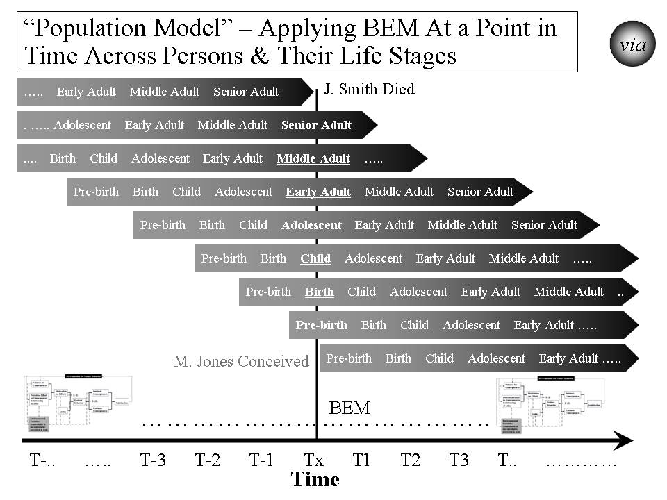
Figure 6. “Population Model” – Applying BEM at a Point in Time Across Persons and Their Life Stages

How does it work? The Population Model, with BEM as the underlying model, recognizes that strategy, at any point in time, needs to be both specific to each person across the life span and effective across all persons across the life span. [See Table 7.] Taking a time slice, the model recognizes that at any moment in time, the target population will likely include persons from all different stages of life (pre-birth, birth, child, adolescent, early adult, middle adult and senior adult). At that moment in time, each person has different status levels, different factors affecting status, and different responses to efforts at improving status. This can be seen in how major disasters (e.g., tsunamis, earthquakes, disease outbreaks, crop failures, drought) affect people differently. This can be seen in how program interventions (e.g. education, housing programs, financial assistance, health insurance programs, heating assistance, taxes) affect people differently.

Table 7. Population Model –

Applying BEM at a Point in Time Across Persons and Their Life Stages

The Population Model use for achieving desired behavior is as follows:
- Identify the population whose behavior is targeted.
- Decide what are the point(s) in time and life stage(s) to be addressed.
- Decide what is the desired behavior or behaviors at different points in time across persons and their life stages.
- Apply the BEM model across time and across persons and their life stages taking into account their differing motivation, ability and environmental variables.
- Assess what interventions will best move projected behavior to desired behavior across time and across persons and their life stages.
- Apply the interventions and assess their effect on a population on an ongoing basis.
- Adjust the interventions as needed over time and based on result.
- Feed the interventions into the Overall Strategy and Supporting Strategies.

How has it been used and helped? The Population Model’s primary use to date has been for improving health. For the DoD Military Health System (MHS), the model was used in the 1990s to work with pre-military, active service, Guard and Reserve, veterans, retirees and their families. Its potential use is being explored in creating an overall strategy for reducing vulnerability and improving the status of a community, nation or broader area.

System(s) Model (Including “Ideal” Systems).
What is it? The System(s) Model views the world as a system of systems. When a strategy is being designed, it is important to determine what the target system is, what system it is part of, what its subsystems are, and what other systems it relates to. A system can be a community, a nation, or a broader area. It can be an issue area system such a health system, an education system, or an ecological system. The Ideal Systems Model, developed by people such as industrial engineers (e.g. Gerald Nadler) decades ago and adapted by me, is another key model for looking at how well a system could perform and how to achieve the highest performance for that system. [See Figure 7.]

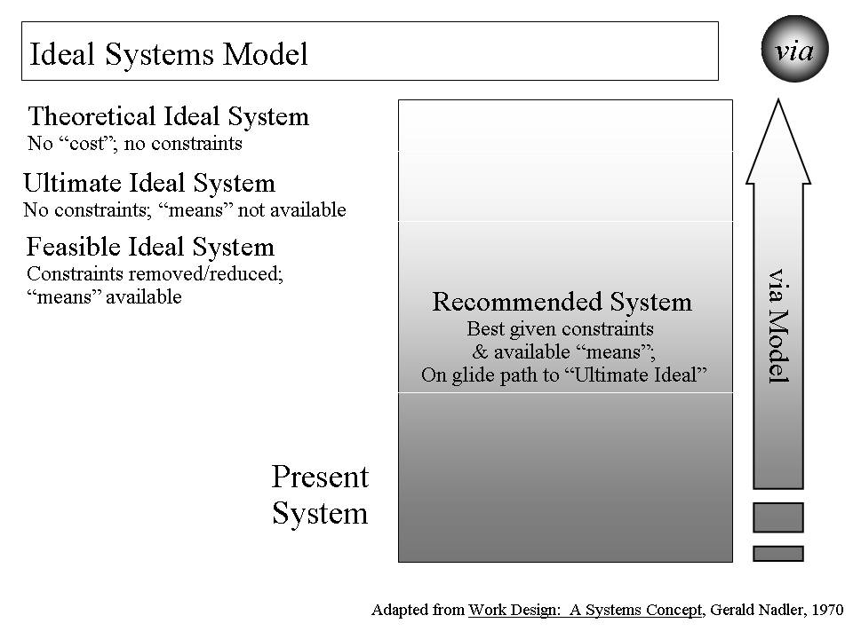
Figure 7. Ideal Systems Model

How does it work? For efforts to improve status to be successful and sustainable, the strategy and its execution need to be systematic and positively change a system (a whole community, a whole nation or a whole broader area) of systems (e.g., health, education, employment/income, housing, habitat, climate) on a sustained basis. [See Figure 7 and Table 8.]

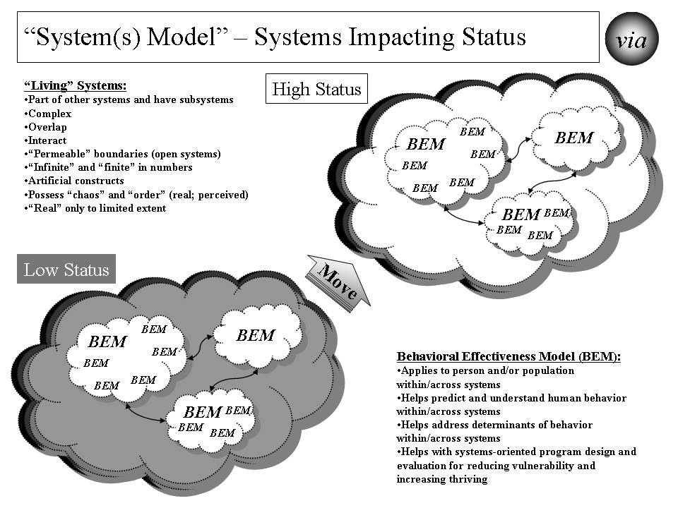
Figure 8. Systems Model – Systems Impacting Status

Table 8. Systems Model – Systems Impacting Status

The Systems Model use for achieving desired status is as follows:
- Identify the target system within which status is to be improved.
- Identify other systems that are related and might either be impacted or have an impact.
- Identify the status (lower than desired) for the current system and key characteristics of the current system.
- Identify the desired status and characteristics for the future system using the Ideal Systems Model.
- Identify the key behaviors in the current systems and what they need to be in the future system.
- Determine what changes need to be made to the current system to move it to the desired system.
- Assess what interventions will best change the current system into the desired future system.
- Apply the interventions and assess their effect on behavior change and on status.
- Adjust the interventions as needed over time and based on result.
- Feed the interventions into the Overall Strategy and Supporting Strategies.

In a systems model, there is recognition that systems are “living”. They change internally, impact other systems and are impacted by other systems. Systems are part of other systems and they have subsystems themselves. They are usually complex. They often overlap with other systems. They interact with other systems, sometimes fairly predictably and sometimes not. They often have permeable borders that are not always understood or constant. They may be nearly infinite in number. Often we apply an artificial construct to them to help us understand and work with them. Some systems are formal constructs (e.g., the British National Health Service system, the Kaiser Permanente system) and some are informal constructs (e.g. the American “health system”). They may be or appear to be “chaotic” or “ordered”. They may be or appear to be “real”.
To positively change a system (e.g. the American “health system”) on a sustained basis, we need to understand the impact that existing and future systems will have on each person’s or a population’s status. We need to understand the impact of systems that we create, change or delete will have on other systems and, ultimately, on each person’s status.
Within “human” systems are real people (individual persons, populations of persons) and organizations (made up of persons) whose behaviors collectively help determine the behavior of the system. The Behavioral Effectiveness Model (BEM) helps us understand the behaviors and their determinants (ability, motivation, environmental factors) on an individual level and on a population of individuals level. In the systems model used here, there is recognition that moving from low status to high status requires moving individual behavior on a massive scale if it is a large system like the American “health system”. This movement includes the persons we want to move to higher status and the persons that help or hinder that movement.
As shown in Figure 7, the Ideal Systems Model helps determine what the desired system should be. It starts out by assessing the current system. It then sets what is the theoretical ideal system assuming there are no costs or constraints preventing us from reaching that system. The theoretical ideal is a guide but is not reachable in the real world for the foreseeable future. Then the model helps us think through the options between the current system and the theoretical ideal system. The ultimate ideal system is one which imposes no constrains but is not yet feasible due to the “means” not yet being available. The feasible ideal system is one where the constraints are removed or reduced and the “means” are available. Finally, the recommended system is the best given the constraints and available means and is on the glide path to the ultimate ideal. The “via” Model helps in designing and assessing these different systems.
How has it been used and helped? The System Model’s (this adapted version) primary use to date has been for improving health. At the Centers for Medicare and Medicaid Services (CMS), the Systems Model was used in 2006 to design the draft CMS Strategic and Operational Plan for 2007-12. Its potential use is being explored in creating an overall strategy for reducing vulnerability and improving the status of a community, nation or broader area.

Strategy Model.
What is it? The Strategy Model builds on the above groundwork and brings this all together to develop and execute stainable, effective strategies for improving status. It includes the model for building the strategies as well as the framework into which the strategies fit. The model includes both the overall strategy and supportive strategies and the actual interventions supporting the strategies. [See Figure 9.]

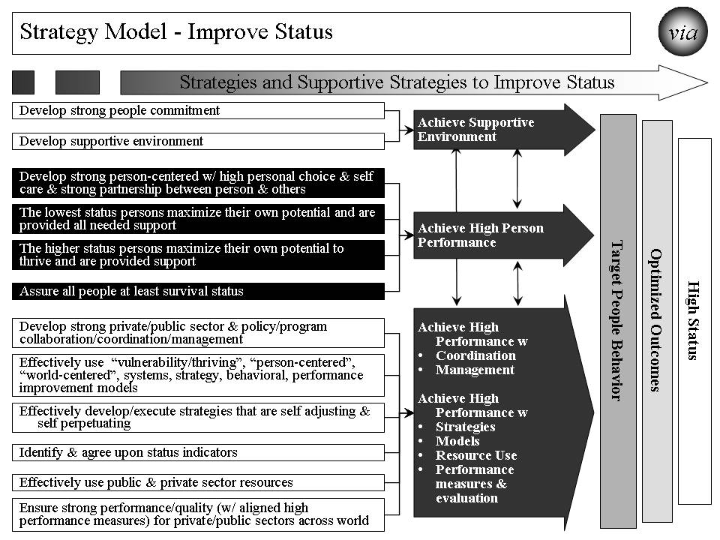
Figure 9. “Strategy Model” – Improve Status

How does it work? The model brings together all the previous information into an overall strategy and supportive strategies to improve status (e.g. health, income, vulnerability, habitat, climate). [See Table 9.]

Table 9. Strategy Model – Improve Status

The Strategy Model use for achieving desired status incorporates previous work from the other models and input and is as follows:
- Load the desired status and the associated indicators.
- Load the optimized outcomes that will best produce high status.
- Load the target behaviors that will best produce the optimized outcomes.
- Use the “channels” to connect how the supportive strategies will best produce the target behavior. The “channels’ are customized to the issue area or “whole”.
- Identify the specific supportive strategies that, working through the “channels” will best produce the target behaviors.
- Execute the strategy and its supportive strategies effectively.
- Assess the progress on improving status. Assess the effectiveness of the strategy and its supportive strategies.
- Revise strategy and supportive strategies as needed to be effective and sustained over time.

How has it been used and helped? The Strategy Model’s primary use to date has been for improving health. The model is being used on the overall American health system to answer how would we “achieve a healthy America” using the whole and enhanced health system. With similarities to the CMS Plan, it helps create a strategy but with the larger scope of all Americans and all health providers. Its potential use is being explored in creating an overall strategy for reducing vulnerability and improving the status of a community, nation or broader area.

Status Model.
What is it? The Status Model is used to identify the desired and current status for the “whole” (e.g., community, nation, broader area), issue areas (e.g., health, education) or cross-cutting issue areas (e.g., vulnerability, climate, habitat) being targeted for positive, large scale change. It also includes the status indicators and their supportive measures. [See Figure 10.]

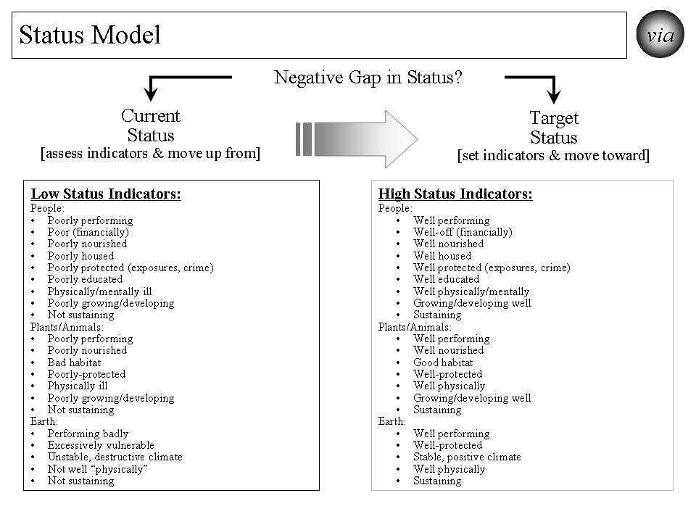
Figure 10. Status Model

How does it work? For efforts to create and sustain positive systems to be successful, we need to determine how we are doing today, how we are doing as we progress to the desired system and when we achieve and sustain the desired system. The Status Model helps do that as shown in Table 10.

Table 10. Status Model

The Status Model is as follows:
- Determine what is the issue area, cross-cutting area or “whole” for which the strategy is targeted and status indicators are needed.
- Decide how high, in general, is the desired status. Is it optimal? If not, how close can we get to optimal?
- Identify all of the indicators that, as a set, indicate the desired high status. These are the “Target Status” set of indicators.
- Decide what each indicator’s level should be to match the desired high status.
- Decide what each indicator’s level is to describe low status.
- To the extent needed, identify more detailed measures for each indicator.
- Assess the “Current Status”, i.e., the current level of indicators for the target population.
- Assess the “Negative Gap” between the current status and the desired target status. This is the gap to be closed with the overall strategy.
- Execute the status model effectively and measure progress.
- Assess the effectiveness of the status indicators.
- Revise status indicators, individually and as a set, as needed to be effective.

How has it been used and helped? The Status Model’s primary use to date has been for improving health. Its potential use is being explored in creating an overall strategy for reducing vulnerability and improving the status of a community, nation or broader area. For the broader work on communities, nations and broader areas, the full set of status indicators is very large but can be grouped into high level categories with supportive measures.

The Path Ahead
As suggested, potential “next generation” models do exist for strategy at system (issue area, community, nation, broader area) and person levels. As proposed here, one such approach is the “via” strategy -- a core set and system of supportive models addressing persons, systems, motivation, ability, behavior, performance and its improvement, process measures, and, most importantly, positive outcomes and improved status. While parts of the strategy can be used independently, they potentially have more power and are more likely to produce the best results when used as a full set.
The path ahead offers many opportunities, as outlined above, to tackle large, complex issue areas, cross-cutting issues and whole communities and nations. Already late, now is the time to aggressively use “next generation” strategies for solving large problems and creating and sustaining positive, large scale change.
Why? It is because our “mission” should be to build a better future and our “vision” should be to achieve a positive, sustainable future - preferably a thriving future.

Appendix.

“via” Strategy’s Past and Future Use and Benefit

The “via” strategy has been used for several large scale changes, including systems such as the $15+ billion Military Health System (Department of Defense), the $1+ billion HealtheVet VistA health information system (Veterans Health Administration), the draft Strategic and Operational Plan for the $500+ billion Centers for Medicare and Medicaid Services, a potential strategy for reducing vulnerability for individuals, communities and nations, a potential strategy for “building a healthy America”,, and a potential strategy for creating and sustaining large, positive and timely change and building a survivable and, preferably, a thriving future .
A single issue area for which it was used was in 2006 to draft a strategic and operational plan for 2007-12 for the Centers for Medicare and Medicaid Services (CMS). Essentially, the whole strategy was used, working with the CMS staff, to develop a strategy covering six years for the $500+ billion agency and its programs. The desired health status and outcome measures were identified. The “ideal” system was identified. The performance improvement model was developed as the framework. Evaluation measures were developed. The strategy addressed “person”, “population” and behavioral issues and how to address them. The end result was a comprehensive draft strategic and operational plan that was developed with the staff and presented to but not signed by the CMS Administrator. The plan remains available for future CMS use.
For the DoD Military Health System (MHS), the model was used in the middle 1990s to work with full set of DoD health-related systems and programs. The Military Health System was handled as a system that encompassed health care for service members when not engaged in military action, for service members (including the Guard and Reserve) when engaged in military action, family members, retirees, Guard and Reserve in non-active status, veterans served by other providers (e.g., Veterans Health Administration and private providers), preventive services for service members, and force health protection (including protective tools when deployed). The overall strategy for the MHS was built using the Ideal Systems Model coupled with other “futures” models. It included the health of all of these people. The strategy included all the services needed to protect and improve their health. It included working with other entities, including the Veterans Health Administration and the Centers for Disease Control. All of this was built into the overall strategy for the future Military Health System that was re-engineered, adopted a force health protection program, was made more effective and efficient, and was made more flexible to adjust to different futures.
In a single issue area within health, it was used in the early 2000s to create and sustain positive change to the Veterans Health Administration (VHA) health information system, a nationwide system covering over 1000 sites of care and with an annual budget of over $1 billion. The desired change was to build upon and expand the capability of VHA’s existing VistA health information system by creating a sustainable “next generation” system named HealtheVet VistA. The new system was approved by VHA, the Department of Veterans Affairs and the Office of Management and budget and received increased funding of about $125 million annually. Much of the new system is already in place and operating successfully.
The strategy is being explored on the cross-cutting issue of vulnerability. Here it is being used to create a potential strategy, “Vulnerable In America” (www.VulnerableInAmerica.org), for minimizing vulnerability and maximizing thriving for a whole population (e.g., community, nation). The resulting strategy addresses the system of a community or a nation. It sets the desired status as minimized vulnerability and maximized thriving and includes a set of measures for that status. It uses the full core set to lay out the performance improvement framework, to analyze and design interventions, to determine how best to address both an individual person and whole populations over time, to develop the behavioral interventions, and to design the overall strategy and supportive strategies. While the strategy has not been used to date, it is ready for application.
The strategy is being explored with respect to a large, complex issue area, substantially improving a nation’s “health”, The model is being used on the overall American health system under the title “Building A Healthy America” (www.BuildingAHealthyAmerica.org). It is being used to try to answer how would we “achieve a healthy America” using the whole and enhanced health system. With similarities to the CMS Plan, it helps create a strategy but with the larger scope of all Americans and all health providers. While the strategy has not been fully used to date, it is ready for full application in the context of the 2010 health reform.
The strategy’s application to whole communities, nations and broader areas is also being explored as a total system interacting with other systems outside. In this case, the focus is on a whole population and whole individual persons. It also addresses animals, plants and natural resources in the context of the community, nation or broader area. The full range of significant issue areas within the target community, nation or broader area is explored, including their interaction and interdependency. Status indicators to assess current and desired future state are being developed. The result of this effort is “Thrive!” and “Thriving Future” (www.ThrivingFuture.org) is an overall, sustainable, executable strategy for improving the status of and building a survivable and thriving future for a person, an issue, across-cutting issue, a community, a nation or a broader area.

