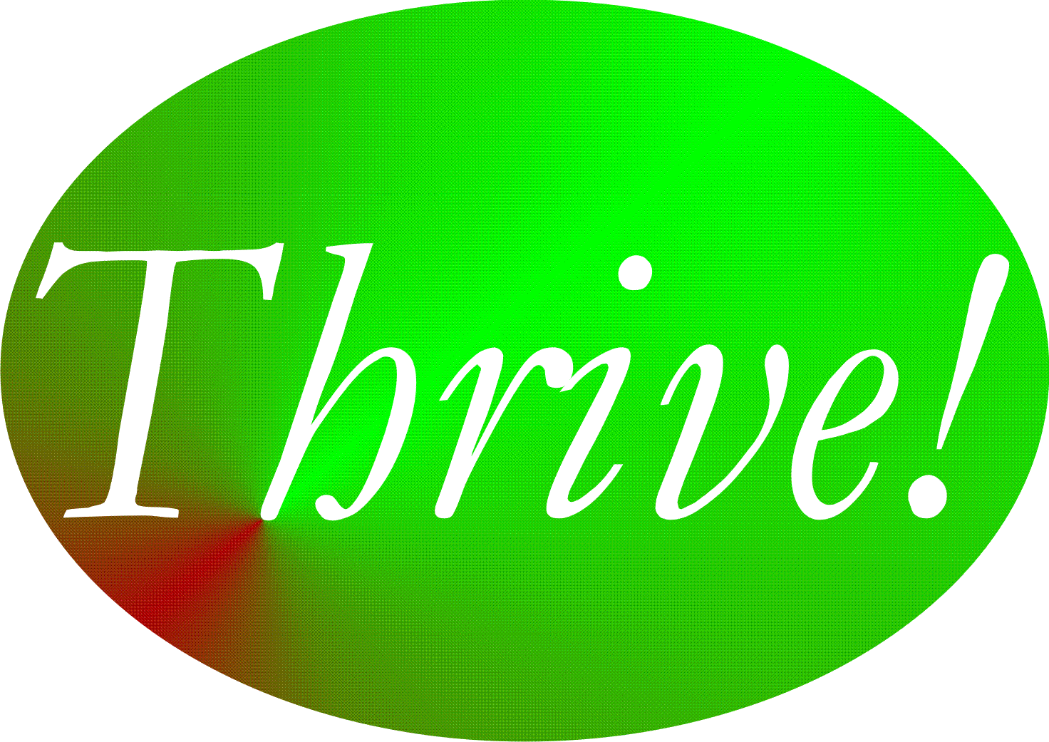

Thrive!
Building a Thriving Future

by

Gary “Chris” Christopherson

Founder of
Thrive! - Building a Thriving Future
viaFuture - Creating and Sustaining Large, Positive Change
HealthePeople - Building a Healthy America and World
Vulnerable - Vulnerable In America and World (via)

University Park, MD and Nelson, WI

Copyright - Gary “Chris” Christopherson - 2011 All rights reserved.

DEDICATION

People who help build and sustain a thriving future for all.

Irene and Lynn Christopherson, nurturing and inspiring parents.
Dr. Patricia Haeuser, friend and supporter.

ACKNOWLEDGMENT

Gary Lore and Bonnie Christopherson Lore for very helpful editing.

Thrive! - Building a Thriving Future

 | Page
Abstract
Executive Summary
Chapter 1: Thrive! - The Call for Building a Thriving Future | 1
Chapter 2: “Thrive” - A Philosophy of “Thriving” (Survive and Thrive Together) | 9
Chapter 3: viaFuture - Framework and Supportive Strategy to Thrive! and to Creating and Sustaining Large, Positive Change | 18
Chapter 4: HealthePeople - Building a Healthy and Thriving Future - Improving Health Via Thrive! Strategy and viaFuture Supportive Strategy | 51
Chapter 5: Vulnerable - Vulnerable in America and World (via) - Reducing Vulnerability and Maximizing Thriving Via Thrive! Strategy and viaFuture Supportive Strategy | 61
Chapter 6: Thriving Communities – Building a Better Future for Communities Via Thrive! Strategy and viaFuture Supportive Strategy | 78
Chapter 7: Thriving Future - Building and Sustaining a Thriving Future Via Thrive! Strategy and viaFuture Supportive Strategy | 92
Appendix: Behavioral Effectiveness Model (BEM) | 98

ABOUT THE AUTHOR

GARY (CHRIS) CHRISTOPHERSON has worked on national and local issues on health and human service strategy, policy, systems, models, performance, reform and management and on reducing vulnerability. Currently, he is independently developing strategy, management, policy and performance models and tools for creating, managing and sustaining large scale, positive change and building a better and preferably thriving future. ThrivingFuture.org viaFuture.org

This draws from 30+ years of experience in creating, managing, evaluating and sustaining large scale change at national and local levels in public and private sectors. Over his career, he has served in many senior leadership, management and policymaking positions, including with organizations with multi-billion dollar budgets and thousands of employees. His experience includes: Principal Deputy Assistant Secretary and Acting Assistant Secretary of Defense for Health Affairs and Senior Advisor to Assistant Secretaries for Health and Reserve Affairs, Department of Defense; Associate Director, Presidential Personnel, Executive Office of the President, White House; Fellow, National Academy for Public Administration; Senior Advisor to Chief Operating Officer and Deputy Director for the Quality Improvement Group, Centers for Medicare and Medicaid Services, DHHS; Senior Advisor to Under Secretary, Veterans Health Administration, VA; Senior Fellow and Scholar-In-Residence, Institute of Medicine, National Academy of Sciences; Chief Information Officer, Veterans Health Administration, VA; Director of Health Legislation, House Select Committee on Aging, U.S. House of Representatives; and Deputy Director, Municipal Health Services Program (funded by The Robert Wood Johnson Foundation and based at John Hopkins Medical Institutions); and Special Projects Director, City of Milwaukee Health Department.

He is a sculptor of abstract art, focusing on mobile and stabile sculptures and having created over 150 sculptures. GChris.com

He received his bachelor’s degree in political science and his master’s degree in urban and regional planning from the University of Wisconsin – Madison, and did doctoral work in health policy and management at the John Hopkins University School of Public Health.

Abstract

As we look around us in America and the world, much of what is important to us is already broken or endangered, much of it unnecessarily so. Because it is people who have broken much of the world and endangered its future, it is people that can and must fix what is broken and build a survivable and thriving future. This is our moral imperative.

People’s behavior is the key to creating and sustaining large, positive, and timely change for a thriving future. People’s behavior is what most endangers our future. People’s behavior is also what offers the best chance to change and build a thriving future.

But for transformation and the behavior that brings about that change to occur, people must be motivated and able. Thrive! is the motivating call for action by our leaders, all of us together, and each of us. viaFuture provides “next generation” strategy and the enabling framework and strategy for creating that large, positive, and timely change. While helpful to issues (e.g., health) and subpopulations (e.g., the vulnerable), the framework and strategy are especially helpful for whole communities (including non-geographic populations, towns, cities, counties, states, regions, nations and the whole world). Four examples demonstrate their use: HealthePeople - Building a Healthy and Thriving Future, Vulnerable - Vulnerable in America and World (via), Building and Sustaining a Thriving Community, and Building and Sustaining a Thriving Future, the most comprehensive approach.

We are now at a “tipping point” when our future is most endangered and we are most capable. Large, positive and timely change must happen now. Creating and sustaining a thriving future requires understanding that it is we who have broken the present and endangered the future. It is only we, working together that can create and sustain the necessary large, positive and timely change for building a thriving future for all.
Executive Summary

As we look around us in America and the world, much of what is important to us is already broken or is endangered, much of it unnecessarily so. Because it is people who have broken much of the world and endangered its future, it is people that can and must fix what is broken and build a survivable and thriving future. This is our moral imperative.

In order to create and sustain large, positive and timely change and a thriving future, the key is people’s behavior. People’s behavior is what most endangers our future. People’s behavior is what offers the best chance to build a thriving future. But for change and the behavior that brings about that change to occur, people must be motivated and able.

The initial focus (Chapter 1) is on motivation as it speaks to why we must create and sustain large, positive and timely change. There is a call for action by our leaders, all of us together, and each of us. Thrive! is that call and a rallying cry for a thriving future.

The second focus (Chapter 2) lays out the underlying philosophy for Thrive! The “Thrive” philosophy is that “a person and a people need to survive and desire to thrive in the current world and a sustainable future world.” Its mission is “to help a person, a people and the world achieve a survivable and thriving future.” The philosophy is built on the underlying assumption that “a person needs to survive and desires to thrive.”

The third focus (Chapter 3) is on ability as it speaks to how we create and sustain large, positive and timely change. viaFuture provides “next generation” strategy. It provides the framework and strategy for supporting Thrive! and for creating large, positive and timely change. via is the core set of strategies, models and tools supporting change in the viaFuture framework and strategy.

With motivation and ability addressed, three large change efforts are proposed. The first change effort (Chapter 4) targets a major challenge and the issues that relate to it. Among the most complex and challenging issues we face is to get and keep people healthy. In this case, the focus is on HealthePeople - Building a Healthy and Thriving Future. The second change effort (Chapter 5) targets a major subpopulation and all the issues that have a substantial impact on that subpopulation. A population is treated as a “non-geographic community”. Among the most complex and challenging populations we face are the vulnerable. In this case, the focus is on Vulnerable in America and World (via). The third change effort (Chapter 6) targets whole geographic “communities”, including those that are local, state level, national or global. Here the focus is on Building a Thriving Community. Any of these change efforts could be applied to any community within or outside America.

Having provided examples of a specific issue (health), a non-geographic community and cross-cutting issue (vulnerability/thriving), and a geographic community, the final focus (Chapter 7) is on bringing all this together with the Thrive! call for Building and Sustaining a Thriving Future. Building and Sustaining a Thriving Future builds on and goes beyond the three previous change efforts. It brings together Thrive! (motivation) and viaFuture (ability) to build a thriving future (behavior) for more encompassing “communities” and for all their key issues, key cross-cutting issues, non-geographic subpopulations/communities, and encompassed communities (for example, a city or state within a nation).

We are now at a “tipping point” when our future is most endangered and we are most capable. The time is right. We must act now and we must not fail. Creating and sustaining a thriving future requires understanding that it is we who have broken the present and endangered the future. It is only we, working together and using “next generation” strategies and tools, that can create and sustain necessary large, positive and timely change and build a thriving future for us all.

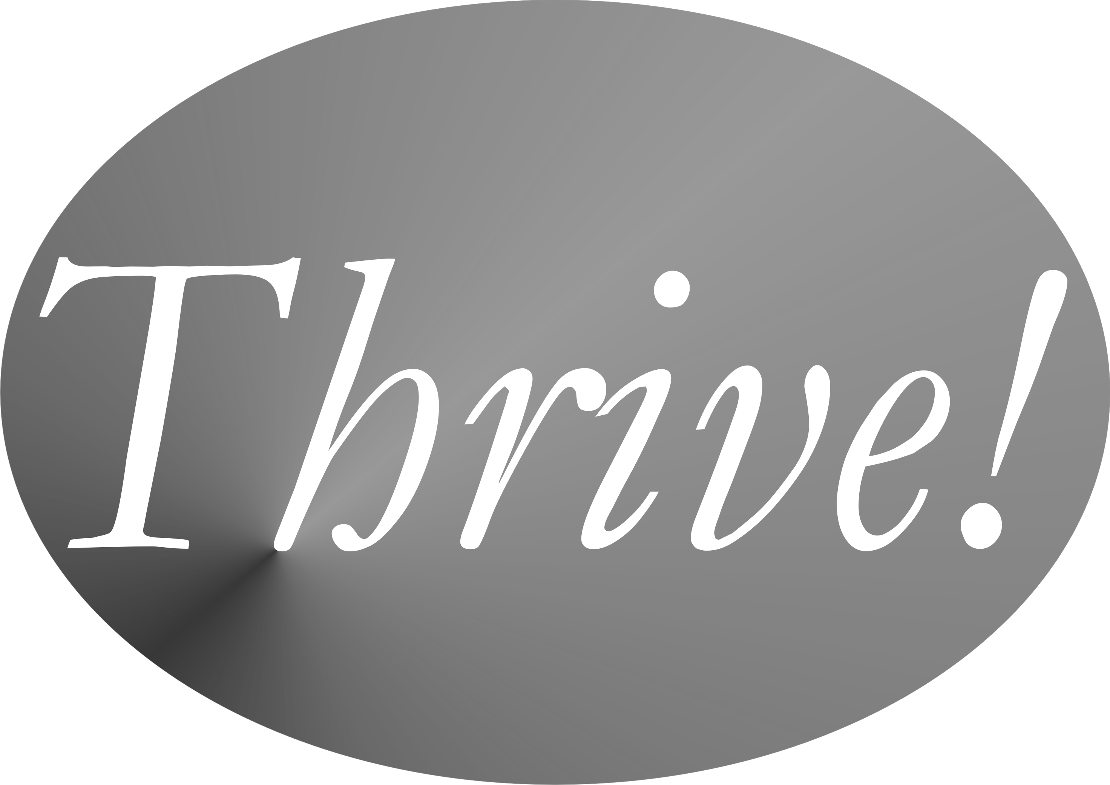

Chapter 1
Thrive! – The Call for
Building and Sustaining a Thriving Future

Thrive! Vulnerable! These are the keys to a call for creating and sustaining large, positive and timely change and building a thriving future. We are all vulnerable but that can change for the better. Thrive! is that call to action and a rallying cry for a better and a thriving future. It is a vision and a mission for those wanting to build a better future. It strives to energize and empower people together building a thriving future for our families, communities, nations and world.

What Thrive! Is.

Thrive! envisions, calls for and strives to achieve a thriving future. Its mission is to help create and sustain positive change to help communities and a world not only survive but thrive.

Thrive! Vision | A thriving future. Calls for and envisions a thriving future for non-geographic populations and our families, communities, states, nations, regions, and world.
Thrive! Mission | Build and sustain a thriving future. To help create and sustain large, positive and timely change to help non-geographic populations and our families, communities, states, nations, regions, and a world to not only survive but thrive.
Thrive! Strategy | All generations together using “next generation” strategies and tools to fix what is broken and save an endangered future.
Thrive! Path | Uses viaFuture’s vision, mission, strategy (including policy, program, management, operations) to increase thriving and reduce vulnerability using via strategic and operational models and tools.

The Thrive! strategy is to have people of all backgrounds and generations join together. It strives to motivate governments, private sector organizations and people to seek a thriving future and to work together to build that future. Key is people joining, networking, spreading the word, and acting on key issues, cross-cutting issues, non-geographic populations, communities, nations and world.

Thrive! plays a shepherding, supportive role to ensure we stay true to our “thriving future” mission and our actions are positive and create and sustain positive change for the near and long term future.

Supporting the Thrive! mission, based on years of change efforts in and out of government, are viaFuture, HealthePeople - Building a Healthy and Thriving Future, Vulnerable in America and World, and Building and Sustaining a Thriving Future. viaFuture provides “next generation” strategies, models and tools to determine where we are today and where we want to go in the future. To achieve that future, it helps design, manage and execute the supportive strategies, policies and programs, and fosters critical collaborative and individual actions.

Why Thrive.

As we look around us in America and the world, much of what is important to us is already broken or is endangered, much of it unnecessarily so. Because it is people who have broken much of the world and endangered its future, it is people that can and must fix what is broken and build a survivable and thriving future. This is our moral imperative.

Achieving a better future demands a great effort using “next generation” strategies for solving large problems and creating and sustaining positive, large scale change. We need them to build and sustain a thriving future.

To say that our approach to dealing with major problems is broken is an enormous understatement. Our financial systems’ failure did and still could bring down nations’ and the world’s financial system. Housing bubbles have burst and now many people cannot buy homes or own homes they cannot afford or sell. Health care remains inaccessible, unaffordable and of poor quality for many people. Education systems leave children behind and fail to educate children to their full potential. Our economic system rewards many people far beyond their contribution, hold many far below their potential contribution, and keep many in or near poverty. Our environment is seemingly under more stress than it can handle in the decades and centuries to come. On energy, our future was bet on non-renewable energy sources and now we must turn to conservation and renewable energy at a level commensurate with long term energy needs. What is worse is these are only individual, usually “stove piped” issues that become more challenging when they “crosscut” with related issues, e.g. health with the economy.

But these are just individual issues whose proposed solutions are often disconnected from the rest of what is going on in a “community”. Here the term “community” applies to a non-geographic population, a family, a neighborhood, a town or city, a county, a state, a country, a region or the whole world. To truly create and sustain change and to build a thriving future, a whole community and all its issues (individually and together) must be successfully addressed. This means substantially improving a community (e.g., Detroit, New Orleans, Haiti, central Africa) deep in trouble on all issues. Or it means substantially improving a community that is barely surviving but is unlikely to ever thrive (many urban and rural communities, some developing countries, the world as a whole). Or it means moving a community upward that is surviving reasonably well and with reasonable potential to thrive (e.g. some urban and rural communities, some developing and most developed countries).

Thrive! and its supportive efforts grow out of a realization that saving parts of a "community" is helpful if done well, but is not enough. It is an effort that takes a "whole community" view and has a "whole community" vision of what we must, can and will achieve.

What are the issues that Thrive! is designed to address? First, there is too much vulnerability:
- Vulnerable people (individuals and groups of persons)
- Vulnerable families
- Vulnerable neighborhoods, villages, cities, counties
- Vulnerable regions
- Vulnerable states
- Vulnerable nations
- A vulnerable world

Second, our world, especially certain parts of the world, is doing poorly:
- Performing poorly or badly (as individuals and communities on all levels and on key issues)
- Poor (financially)
- Poorly nourished
- Poorly housed
- Poorly protected (exposures, crime)
- Poorly educated
- Poor physical and mental health
- Poorly growing/developing
- Poor physically
- Living within poor, bad, or deteriorating habitat
- Excessively vulnerable
- Not sustainable

How does Thrive! Do It.

Our past demonstrates that most current policy and strategy models are too limited in scope for addressing today’s problems and wholly inadequate for succeeding with a much more challenging future. Generally, current policy and strategy models fail to learn from past failures and fall far short of being “next generation”. Next generation policy and strategy models must succeed with a future world that has high aspirations but is at high risk with threats to its sustainability, is large and broad of scope, is complex, is highly interactive and interdependent, will depend heavily on what people do, and will change with or without us.

Many people with good intentions are trying to fix large problems and build a better future. That is good news, to some extent. Unfortunately, that includes much bad news unless we change our approach. Most people are focused on single issue areas, e.g., housing, health, income, transportation, education, plant/animal habitat, climate, or natural resources. Most are focused on only a part of a single issue area. Most treat people as parts rather than whole persons. If successful, most make some progress in the near term and relatively little for the longer term. Most waste valuable resources and reach less than optimal near and long term solutions. Many do not coordinate their work with that being done in related issue areas.

All this can be helpful, but solving a community’s, a nation’s or broader area (e.g., a region or larger) problems takes more than this. We need to have and effectively use “next generation” strategy. But what does that mean?
- First, “next generation” strategy must focus on whole “persons” -- individuals with unique abilities, motivation, and behaviors uniquely affected by and affecting their “environment.” After all, it is people who build the future. But is also people who create most problems and it is people who can and should fix the problems. It is people who must create and sustain a better future.
- Second, “next generation” strategies must be much more effective at addressing the important issue areas, especially large, complex ones like jobs, economy, energy, environment, education, food, housing and health.
- Third, “next generation” strategies must effectively handle the cross-cutting issues (e.g. energy and environment together) of a highly interactive and interdependent world.
- Fourth, “next generation” strategy and policy must tackle issues as “systems” (e.g. a health system, a resource system, a community) interacting with other systems and within larger systems (e.g. communities, nations, world).
- Fifth, “next generation” strategies need to effectively handle whole “systems”, including whole persons, whole communities, whole nations, and, whole broader areas.
- Sixth, “next generation” strategies need to effectively handle the future in terms of sustaining whatever progress we make and adjusting to a changing future.

Past and current approaches have major limitations and defects. Thrive! is unique and better because it:
- Strives to achieve a thriving and sustainable future. But it also helps ensure survival, a necessary but not sufficient step to achieving a thriving future
- Joins people of all backgrounds/generations together to achieve a thriving future.
- Able to address every person, community and issue.
- Uses whole "community" (local, regional, State, national, global) strategy for creating and sustaining change and building thriving futures. No longer should we rely on just survival and piecemeal strategies.
- Uses whole "person" strategy for change and thriving futures. No longer is the focus only on parts (health, hunger, poor education, insufficient income, etc.).
- Uses whole "system" (community, health, education, economy, housing, etc.) strategy for change and thriving futures. No longer should we rely on survival and piecemeal strategies for just parts of a system.
- Takes an integrated approach to cross-cutting issues.
- Uses an integrated approach to people/environment strategy, change and thriving futures. No longer is the focus only on people or the environment.
- Uses a "person-centered" strategic approach that recognizes people's behaviors are the problem and the solution. No longer should we fail to address "people’s behavior".
- Uses strategic/operational planning with strategic/operational execution.
- Uses next generation (viaFuture/via) strategy, models and tools to create and sustain change and build thriving futures. No longer should we rely on past approaches that failed or had limited success.
- Uses social networking to expand communication and joint action and activate a large community in "real time".

To enact our vision and measure progress, the first composite measures that Thrive! addresses and strives to maximize and sustain are:
- Thriving people (persons)
- Thriving families
- Thriving neighborhoods, villages, towns, cities, counties
- Thriving regions
- Thriving states
- Thriving nations
- A thriving world

The second composite measures that Thrive! addresses and strives to improve performance so that we and our world are:
- Performing well
- Well-off (financially)
- Well nourished
- Well housed
- Well protected (exposures, crime)
- Well educated
- Well physically/mentally
- Growing/developing well
- Living within good habitat
- Not vulnerable
- Performing to produce personal and public goods
- Living within a stable, positive climate
- Sustainable

No single strategy, model or tool by itself will help us do all this. But a core set of “next generation” strategies, models and tools together can help if it:
- First, is effective for individual and cross-cutting issues,
- Second, is effective in dealing with people’s behavior,
- Third, can incorporate and work well with other effective strategies, models and tools,
- Fourth, is effective as a coordinated approach for addressing the “systems” and “wholes” requirement,
- Fifth, can effectively address the future and adjust to and sustain the future.

The good news is that “next generation” strategies and supporting models do exist. One example, viaFuture (and via) is discussed in the next chapter. viaFuture supports Thrive! by providing strategies/models/tools to help create and sustain large, positive, strategic and operational change. Today it is ready to address persons, behavior, systems, individual and cross-cutting issues, and performance, outcomes and status improvement.

The times require us to set aside policymaking approaches that fail to deliver and waste scarce, valuable resources. By immediately adopting “next generation” policymaking and management approaches that are more efficient, effective and future-oriented, we can build and sustain a thriving America and a thriving world overall.

Why Thrive! Action Is Needed Now!

We are in trouble and it is getting worse every day. To change this, people and their leaders must lead large, positive and sustainable change. We need a better future and a better vision for that future. Our vision should be of communities, an America and a world where, for example, we:
- Strengthen schools to maximize our greatest future resource – children.
- Have an energy policy that gets us closer to the goal of sustainable energy.
- Protect our environment and ensure its long term sustainability and long term capability to support life.
- Ensure the right to affordable, quality and accessible health care.
- Protect current and future elders by protecting retirement income support, strengthening retirement savings and ensuring affordable health care.
- Protect current and future children by providing effective education, providing basic necessities of life (shelter, food), strong family and community support, and ensuring quality, accessible, and affordable health care.
- Substantially reduce poverty by expanding access to jobs, making work pay, strengthening families, increasing the supply of affordable housing, and by tackling concentrated poverty.
- Combat our common threats, including nuclear weapons, terrorism, climate change, poverty, genocide and disease.
- Reduce vulnerability and increase thriving for every person.

This vision includes but goes beyond our current efforts to save "parts of the world" - a country, a race, a religion, a gender, a generation, a species or the environment. Our vision should be bolder - a better future for every community, for every nation and for the "whole world", including the earth upon which we live and depend.

Must we achieve it? Can we achieve it? Will we achieve it?

We must because our communities and world are in trouble and our future is at great risk. All our generations have the responsibility to fix our communities and world and help them survive and thrive for both the near and long term.

We can because we have the people, knowledge, tools and resources to create and sustain large, positive and timely change for communities, nations and the world. We can use the lessons from the past to help us understand how to succeed. We can use the knowledge we have on how to make our communities and world less vulnerable and on how to build a better future. We can create large change efforts which can positively change the future without repeating many of the negative effects of some past efforts.

We can work together collaboratively. All generations can unite for this common cause. We can save all generations today and for the future.

We can positively lead and manage this large, complex, long-term effort. We can address the world’s problems as a whole and join with those who are constructively addressing its parts (an issue, a country, a race, a religion, a gender, a generation, a species or the environment).

We can make systems (e.g. a person, a population, a health system, a financial system, an energy system, an environment, a neighborhood, a community, a State, a nation, a world) function better on a sustained basis by using the knowledge we have of how systems work and perform highly. We are more able as we learn more about people’s behavior (both its destructive and constructive elements) and use our knowledge to change it for the better. We can continue to improve our technology, understand its positive and negative consequences, and carefully use it to help build a better future world.

We can measure the status of communities, nations and the world as they improve or decline and keep people informed on our progress or lack of it. We can continue to learn from and build upon our successes and failures as our and our children’s future unfolds.

We now can, but will we?

We will save our endangered future if all generations join together to achieve this vision.

We will if all of us together and each of us individually make this happen.

We will if all of us are leaders and press ourselves and our leaders to build a positive, sustainable future.

We will if all of us together act upon the Thrive! call to action for building a thriving future for people, key issues, and communities, nations and world.

We will if we:
- Join together with Thrive! and together help build a thriving future.
- Spread the word on the Thrive! vision, mission and call for action using blogs and networks.
- Network, with Thrive!, using blogs and networks.
- Act, together with others, to help build a thriving future on key issues.
- Act, together with others, to help build a thriving future for our people, communities, states, nations and world.

With America and our whole world in trouble and our future at risk, all must join together if we are to succeed. More than ever, we need leaders who will provide vision of and hope for the future. We need leaders, with us as partners, who will fix our broken world, save our endangered future and build a thriving future.

Chapter 2
Thrive - A Philosophy of “Thriving”
(Survive and Thrive Together)

The “Thrive” philosophy is that “a person and a people need to survive and desire to thrive in the current world and a sustainable future world.” Its mission is “to help a person, a people and the world achieve a survivable and thriving future.” The philosophy is built on the underlying assumption that “a person needs to survive and desires to thrive.”

“Thriving” for a person, a people and the world is the human endeavor and the ideal. As the ideal, “Thriving” is “a person, a people and the world surviving and thriving together.” As the human endeavor, “Thriving” is “the lifelong (a person) and neverending (a people and the world) striving to survive and thrive in the current world and a survivable and thriving future world.”

“Thrive” is designed to be a defensible, understandable, usable, sustainable and valuable philosophy for a person and a people for today and the future.

The “Thrive” philosophy strives to help achieve a survivable and thriving future for the world and the people who live in it. The philosophy’s ultimate aspiration and ideal is “Thriving”, the achievement of a survivable and thriving future for a person, a people and the world. Its value lies in improving life for a person, a people and/or the world. Its greater value lies in helping a person, a people and the world survive together on a sustained basis. Its greatest value lies in helping a person, a people and the world thrive together on a sustained basis.

The “Thrive” Philosophy.

What is the “Thrive” philosophy? The “Thrive” philosophy is that “a person and a people need to survive and desires to thrive in the current world and a sustainable future world.” Its mission is “to help a person, a people and the world achieve a survivable and thriving future.”

The philosophy is built on the underlying assumption that “a person needs to survive and desires to thrive.” With that underlying assumption, the philosophy makes two more assumptions:
- a person depends on other persons (a people) for survival and thriving, and
- a person’s future survival and thriving depends on there being a future world.
If these three assumptions are true, the philosophy argues that:
- a person and a people both need to survive and desire to thrive,
- this need and desire applies to both the current and future world, and
- the future world must be sustainable and sustained to fully meet the need and desire.

“Thriving” for a person, a people and the world is the human endeavor and the ideal. As the ideal, “Thriving” is “a person, a people and the world surviving and thriving together.”

As the human endeavor, “Thriving” is “the lifelong (a person) and neverending (a people and the world) striving to survive and thrive in the current world and a survivable and thriving future world.” A person and a people strive for and can achieve a high level of motivation and ability (including knowledge). That achievement is the foundation for striving for and achieving even higher levels of ability and motivation and even higher levels of survival and thriving.

Ideally, the person and the rest of the world are continuously and simultaneously striving with the best combination of independence and interdependence in joint pursuit of survival and thriving.

The “Thrive” philosophy is designed to be a defensible, understandable, usable, sustainable and valuable philosophy for a person and a people for today and the future. It addresses what are generally a full philosophy’s key elements:
- Our nature, as a person and a people, is our need to survive and desire to thrive in the current world and a sustainable future world. “Being” is what a person is currently or will be at a future time. It is always temporary. “Becoming” is a person changing when striving to survive and thrive. The philosophy’s aspiration is reached when what a person is and is becoming are in harmony at very high levels and a person is still moving to higher and higher levels.
- Our knowledge of our selves and the world comes from a) inputs resulting from striving to survive and thrive and b) the mind processing those inputs to achieve knowledge and thinking.
- Our actions are driven by our need to survive and desire to thrive but influenced by a) other persons and the surrounding world and b) the need and desire for a long term, sustainable future.
- Our relationship with other persons and the surrounding world is driven and governed by our need to survive and desire to thrive in the current world and a sustainable future world.
- Our mind and body relationship is a combination of independence and interdependence based on their individual and joint need to survive and desire to thrive.

What is its context? Philosophy is a human creation. It is unique to human beings as they strive to understand themselves in their current and future world. It is unique to human beings as they strive to best live in their current and future world.

Throughout human history, philosophers offered views on reality, knowledge and life’s guiding principles. While this work contributed much to current knowledge and thinking, it has not always been defensible, has often been difficult to understand, has been difficult to apply to real life, has limited sustainability, and has often had limited value to real life.

“Thrive” is designed to be a defensible, understandable, usable, sustainable and valuable philosophy for a person and a people in the current world and a sustainable future world.

By design, this brief treatise on “Thrive” does not go into great detail. Rather, it starts down a path. It lays out the basics of the philosophy. It lays out the underlying assumptions and arguments for the “Thrive” philosophy. It very briefly addresses several of philosophy’s key elements. Finally, it lays out the philosophy’s potential uses in real life.

What are its underlying assumptions and argument? The “Thrive” philosophy is that “a person and a people needs to survive and desires to thrive in the current world and a sustainable future world.”

As stated previously, the philosophy is built on the underlying assumption that “a person needs to survive and desires to thrive.” With that underlying assumption, the philosophy makes two more assumptions:
- a person depends on other persons (a people) for survival and thriving, and
- a person’s future survival and thriving depends on there being a future world.
If these three assumptions are true, the philosophy argues that:
- a person and a people both need to survive and desire to thrive,
- this need and desire applies to both the current and future world, and
- the future world must be sustainable and sustained to fully meet the need and desire.

What are the human endeavor and the ideal? “Thriving” for a person, a people and the world is the human endeavor and the ideal. As the ideal, “Thriving” is “a person, a people and the world surviving and thriving together.”

As the human endeavor, “Thriving” is “the lifelong (a person) and neverending (a people and the world) striving to survive and thrive in the current world and a survivable and thriving future world.” A person and a people strive for and can achieve a high level of motivation and ability (including knowledge). That achievement is the foundation for striving for and achieving even higher levels of ability and motivation and even higher levels of survival and thriving.

A person’s and a people’s striving for a survivable and thriving future is motivated by needs and desires and enabled by experience, knowledge, and thinking (for example, creativity and reasoning).

During the striving, there are successes and failures. There are progress and regress. All contribute to achieving and continuing “Thriving”. Over time and as a person and a people strives and grows, successes should exceed failures and progress should exceed regress.

Striving follows a nonlinear path through a complex world toward the ideal. The nonlinear path makes life more challenging and more interesting. But there is a negative risk during the nonlinear progression toward the ideal. A particular regression can be so severe as to end progression. Human existence, for all practical purposes, can end before the ideal can be reached.

Within the “Thrive” philosophy and ideally, the person and the rest of the world are continuously and simultaneously striving with the best combination of independence and interdependence in joint pursuit of survival and thriving. This is also true for a people.

The “Thrive” philosophy strives to achieve a survivable and thriving future for the world and the people who live in it. The philosophy’s ultimate aspiration and ideal is “Thriving”, the achievement of a survivable and thriving future for a person, a people and the world.

What are key elements and questions? A full philosophy should address key elements and related questions. The “Thrive” philosophy addresses these as follows:
- What is the nature of being and the world? The nature of human being (and becoming) is that a person (and a people) needs to survive and desires to thrive in the current world and a sustainable future world. These are life’s drivers. Through successes and failures and progress and regress, these drivers produce a desired nonlinear progression of a person, a people and the world toward a survivable and thriving future. However necessary and desirable, achieving a survivable and thriving future is not inevitable. The philosophy’s aspiration is reached when what a person is and is becoming are in harmony at very high levels and a person is still moving to higher and higher levels. This is also true for a people.
- What is the nature and scope of knowledge? A person’s knowledge of one’s self, of a people and of the world is the combination of a) inputs resulting from striving to survive and thrive and b) the mind processing those inputs to achieve knowledge and future thinking. This recognizes that knowledge cannot be gained by the mind by itself alone or by only sensing the world. Knowledge comes only when a mind interacts with the surrounding world, receives inputs from the world, and successfully processes those inputs.
- How should a person and a people act? A person’s actions are driven by one’s need to survive and desire to thrive but are influenced by a) the surrounding world and b) the need and desire for a sustainable future. This sustainability applies to one’s self. This also applies to the people (for example, family and friends) and the world (for example, plants and animals) with which a person has a personal bond. This also applies to the people and world on which a person depends for survival and thriving. Though striving to survive and thrive has the potential to become selfish and destructive, it becomes constructive when there is recognition of the personal bond with other persons and the world. It also becomes constructive when there is recognition that survival and thriving depend on other persons and the world. This is especially true when moving beyond the short term future to a sustainable, long term future. This governs much of how a person and a people should and will act.
- What is the relationship of a person and a people to other persons and the state? A person’s relationship with other persons (including family, community and state) and the rest of the world is driven and governed by a person’s need to survive and desire to thrive in the current world and a sustainable future world. This is affected by a) a person’s current and future personal bond with other persons and the world and b) a person’s current and future dependency on other persons and the rest of the world for surviving and thriving. The state’s relationship to its people is driven and governed by the people’s need to survive and desire to thrive in the current world and a sustainable future world. The state’s relationship is also affected by the state’s current and future dependency on the rest of the world its and its people’s survival and thriving.
- What is the nature of the mind and its relationship to the body? The mind and body relationship is a combination of independence and interdependence based on their individual and joint need to survive and desire to thrive. At times, the mind temporarily reduces that interdependence so as not to be constrained by the immediate needs of the body or immediate inputs from the body or the surrounding world. This temporary reduced interdependence better enables the mind to achieve knowledge and/or future thought. At times, the mind and body are totally interdependent as they carry out life activities. This is also true for a people. Over a person’s and a people’s life, this produces a positive progression of mind and body separately and as an integrated whole.

The “Thrive” Philosophy in Real Life.

To meet the full need and provide the full value desired of a philosophy, it must be defensible and it must be understandable to, usable by, sustainable for and valuable to essentially all persons. The defense (the underlying assumptions and arguments) of “Thrive” has been laid out previously.

Is it understandable? The first test of “real life” understandability is whether or not a person who creates, teaches, or analyzes philosophy finds it understandable. This is the “expert”. The second and more important test of “real life” understandability is whether or not a person who wants to use philosophy in real life finds it understandable. This is the “general public”. While the “Thrive” philosophy is designed to pass both tests, the final determination will be made by the “experts” who analyze it and by the “general public” who tries to use it in real life.

In real life, the philosophy is understandable because it is what a person lives and understands every day. From the moment that a person awakes in the morning and throughout most of each day, ensuring survival drives a person’s life. A person eats, drinks and practices hygiene to survive. A person works or otherwise obtains resources (for example, income) to acquire the basic survival necessities such as food, shelter, knowledge, and health. A person acquires these basic survival necessities throughout most of their life. A person acquires and develops relationships with other persons in order to gain survival necessities. This may be related to social needs, resource acquisition needs, and/or survival necessities. A person acquires and develops relationships with the surrounding world (for example, the state) as the person strives to survive. This might be to a) get a driver’s, vehicle or a professional license, b) obtain a permit to build or renovate shelter, c) buy food and clothing, d) obtain health care, or e) meet societal/legal obligations (for example, pay taxes).

Unless survival is all consuming, a person also desires to thrive in the current world and a sustainable future world. A person desires a better, preferably thriving life. This may be better food, health, knowledge/skills, recreation, shelter and/or relationships. The latter may take on the form of a better relationship with existing family (for example, parents and siblings) or acquiring a family (for example, a spouse and children). This desire to thrive can take on a longer term perspective because a person generally does not want life to end and wants a sustainable, thriving future. A person may want a family line, a people and/or a state to continue into the future. The strength of the desire for a sustainable thriving future by a person, a people and a state will determine the strength of the drive to build a sustainable, thriving future.

This is not new or difficult to understand. It emerges in early childhood and matures throughout life. It is essentially what a person and a people know and live.

Is it usable? The philosophy can be used to help a person understand one’s self, other persons and the world as the person survives and progresses through life. To successfully survive and progress through life, it is critical to understand the power of the need to survive for one’s self and for other persons. Until and unless that survival need is ensured, a person (or a people) is highly unlikely to a) relate well to other persons (even those upon whom the person (or people) depends for survival), b) think about or act on the long term future, or c) think about or act on moving beyond surviving to thriving. Until basic, real and physical necessities are ensured, it is difficult to impossible for the person and other persons to focus on and strive toward a sustainable, thriving future. If and when a person does focus on and strive toward a sustainable, thriving future, the philosophy can help a person understand how the desire to thrive drives self behavior and other persons’ behavior.

The philosophy can be used to better understand and manage the nonlinear (progress and regress) nature of life and a person’s own needs (survive) and desires (thrive), and a person’s own aspirations and ideals. If a person understands that life is nonlinear and will likely include many instances of progress (good things; going forward toward meeting needs and desires) and regress (bad things; going backward on meeting needs and desires), the person has context in which to think and act. Consistent with needs, desires, aspirations and ideals, a person can think through and act to avoid, stop, minimize and/or manage bad things and regress. Similarly, a person can think through and act to seek, start, maximize and/or manage good things and progress. These thoughts and actions help produce a better outcome (for example, less negative impact from regress, more positive impact from progress, and greater knowledge). Very importantly, it helps produce more knowledge for future thought and action.

It can be used to design and manage a person’s own path through an ever changing life. A person can better design and manage a more positive path once the person a) better understands the need to survive and desire to thrive, b) better understands other persons and the surrounding world, c) better recognizes and accepts a changing world, and d) better understands the desire for a sustainable thriving future. A person can better use the needs, desires, aspirations and ideals to design the future path. A person’s future path should ensure survival in a changing world and, at the same time, strive toward a thriving future. The path should be flexible to adapt to a nonlinear world and the changing future. The path should adjust as a person’s needs and desires change. The path should be adjusted or a new and better path created if and when the world changes and/or when a path does not seem to be on track. While on the path, there should be ongoing scanning of other persons and the surrounding world for changes affecting the path.

The philosophy can be used to understand and manage a person’s relationship with those with whom there is a personal bond (for example, friends and family). Once a person understands that a person with whom there is a personal bond has thoughts and behaviors driven by the need to survive and desire to thrive, the relationship with the other person is more understandable. Relating to the other person is easier, more positive and more likely to succeed. There is also the opportunity to jointly and cooperatively act in ways that are more likely to be successful and produce better outcomes for both.

It can be used to understand and manage relationships with that upon which a person depends for surviving and thriving. That includes other persons (for example, family, friends, co-workers, employers, government, educators, health care providers, food suppliers) and the world. Once a person understands that a person upon whom the person depends for one’s own success has thoughts and behaviors driven by the need to survive and desire to thrive, the relationship with the other person is more understandable. Relating to the other person is easier, more positive and more likely to succeed. There is also the opportunity to jointly and cooperatively act in ways that are more likely to be successful and produce better outcomes for both. Similarly, a person needs to understand that the world (for example, plants, animals, and natural resources) upon which the person depends also needs to survive and is better if it thrives. With that understanding, the person’s relationship with the surrounding world can be more mutually beneficial.

The philosophy can help a person understand and deal with today and the near and long term future. It helps a person understand the strong driving force of a person’s needs today and in the near term, foreseeable future. It helps a person understand that the failure to successfully address today’s and near term needs is likely to result in the failure to address the long term future and build a sustainable, thriving future. As a result, the first action of a person, a people or a state is to ensure survival today and for the near term, foreseeable future. Recognizing this, one option is to build a sustainable, thriving future that includes survival for today and the foreseeable future. Another option puts off action to build a sustainable, thriving future until near term survival is ensured in real and perceived terms. The first option is better for the long term and possibly even for the short term. Short term survival actions should never be at the expense of long term survival and thriving.

It can help a person understand and help build a sustainable, thriving future for one’s self, other persons and the world. A person can better understand how to create more effective paths to a survivable future and, preferably, a sustainable, thriving future. A person understands better what drives one’s own and other persons’ thoughts and behavior. As a person better understands a) one’s own needs and desires, b) other persons’ needs and desires and c) the surrounding world, a person is more able to build one’s own sustainable, thriving future. Likewise, a person is more able and motivated to jointly build a survivable and sustainable, thriving future for a people and the surrounding world.

Is it sustainable? The philosophy is designed specifically to be sustainable. It should have a high probability of being sustainable because it is designed to be a defensible, understandable, usable, sustainable and valuable philosophy for a person, a people and the world for today and a sustainable, thriving future. It is a defensible philosophy in that it builds upon preceding philosophies and builds upon the basic nature of a person and a person’s need to survive and desire to thrive on a sustained basis.

It is an adaptable philosophy that recognizes that the world changes and that a sustainable philosophy must retain defensibility, understandability, usability, sustainability and value throughout those changes. Change is inherent to the philosophy. Striving to survive and thrive by a changing person among a changing people in a changing world is inherent to the philosophy.

Is it valuable? The philosophy is valuable because it can help improve life for a person, a people and/or the world. It is most valuable when it is applied synergistically to all three. The philosophy does that. In real life, the philosophy can provide a better understanding of life’s driving forces and how those forces affect near and long term behavior. It can provide a better understanding of how to use those driving forces to improve human behavior and improve human behavior’s outcome - an improved life for a person, a people and the world.

It is more valuable because it can help a person, a people and/or the world survive together on a sustained basis. In real life, it can help a person and a people better understand the need to survive. It can help with understanding real need to survive versus perceived (but not real) need versus desire to thrive. It can help with understanding the conditions necessary to survival. It can help create and effectively execute an adaptable path to near and long term survival in an ever changing world.

It is most valuable because it can help a person, a people and/or the world thrive on a sustained basis. In real life, it can help a person and a people better understand the desire to thrive. It can help with understanding the desire to thrive on a sustained basis. It can help with understanding the conditions necessary to a sustainable, thriving future. It can help create and effectively execute an adaptable path to achieving a sustainable, thriving future in an ever changing world.

Conclusion.

In conclusion, the “Thrive” philosophy is that “a person and a people needs to survive and desires to thrive in the current world and a sustainable future world.” The philosophy is built on the underlying assumption that “a person needs to survive and desires to thrive.”

“Thriving” for a person, a people and the world is the human endeavor and the ideal. As the ideal, “Thriving” is “a person, a people and the world surviving and thriving together.” As the human endeavor, “Thriving” is “the lifelong (a person) and neverending (a people and the world) striving to survive and thrive in the current world and a survivable and thriving future world.”

The “Thrive” philosophy’s mission is “to help a person, a people and the world achieve a survivable and thriving future.” It strives to help achieve a survivable and thriving future for a person, a people and the world for the foreseeable future. The philosophy’s ultimate aspiration and ideal is “Thriving”, the achievement of a survivable and thriving future for a person, a people and the world.

The “Thrive” philosophy is a defensible, understandable, usable, sustainable and valuable philosophy for a person and a people for today and the future. Its value lies in improving life for a person, a people and/or the world. Its greater value lies in helping a person, a people and the world survive together on a sustained basis. Its greatest value lies in helping a person, a people and the world thrive together on a sustained basis.

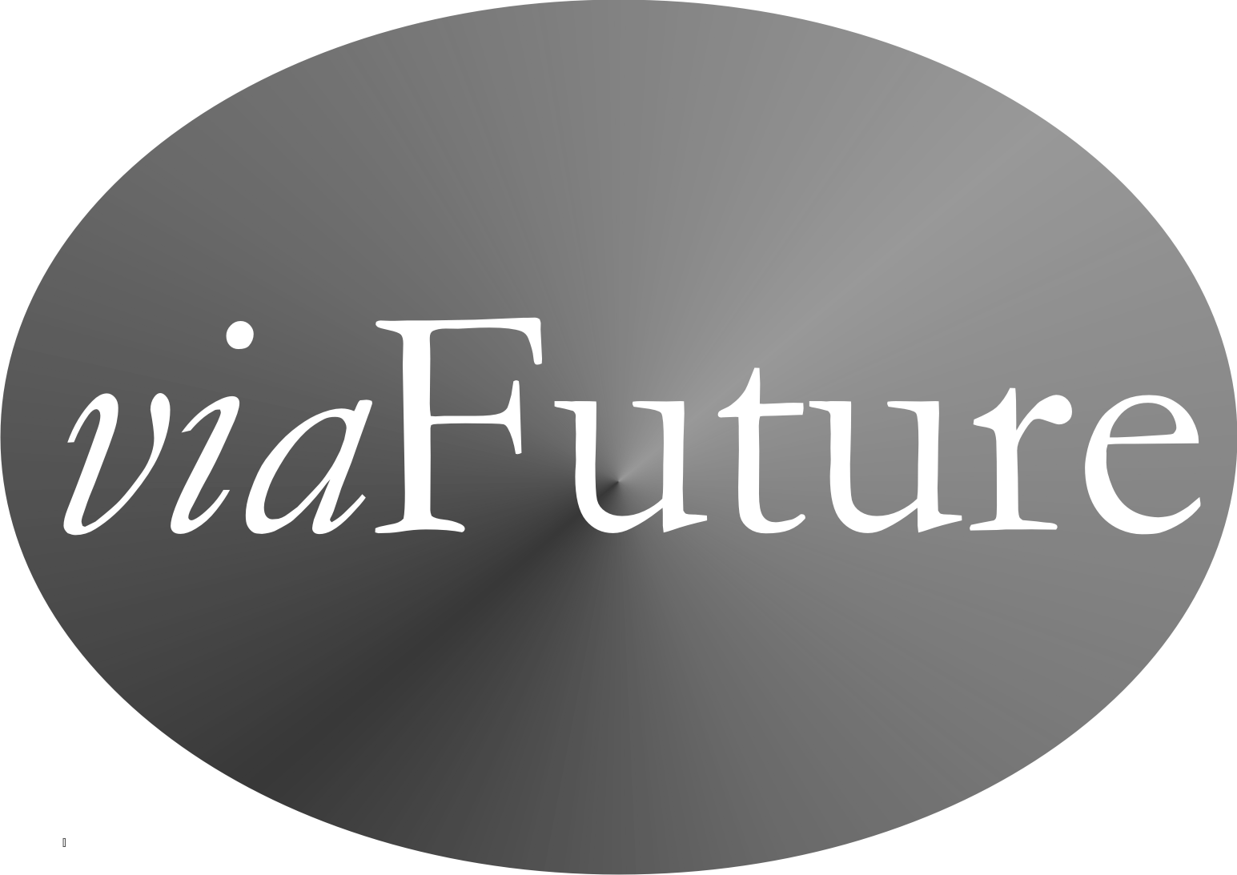

Chapter 3
viaFuture - Framework and Supportive Strategy to Thrive! and for
Creating and Sustaining Large, Positive Change.

If we are to achieve a better future, we need “next generation” strategies for solving large problems and creating and sustaining positive, large and timely change. We need them to build and sustain a thriving future. viaFuture and the supportive via strategies, models and tools are “next generation” strategy.

Thirty years of experience at the national and local levels strongly suggests that most current policy and strategy models are too limited in scope for addressing today’s problems and wholly inadequate for succeeding with a much more challenging future. No single strategy, model or tool by itself will help us do all this. However, a “next generation” strategic framework (viaFuture) coupled with a core set (via) of “next generation” strategies, models and tools together can help. The via core set and system of supportive models addresses persons, systems, motivation, ability, behavior, performance and its improvement, process measures, and, most importantly, positive outcomes and improved status.

To help create and sustain large, positive and timely change and a thriving future, the combined viaFuture vision, mission, framework and strategy includes but is not limited to the following elements:
- Thrive! - Motivation for action(s) that build and sustain a thriving future. ThrivingFuture.org
- viaFuture - Vision for creating and sustaining change and a thriving future coupled with the necessary enhanced ability (next generation strategy/models/tools) and strong motivation. Includes "via", the needed supportive strategies/models/tools. viaFuture.org
- HealthePeople - Building a Healthy and Thriving Future - Using viaFuture for an issue to build a healthy community, America and world. www.HealthePeople.com or BuildingaHealthyAmerica.org
- Vulnerable - Vulnerable in America and World (via) - Using viaFuture for "communities" (non-geographic populations, localities, states, nations, regions) to minimize vulnerability and maximize thriving. VulnerableInAmerica.org
- Thriving Future - Overall use of viaFuture to build and sustain a thriving future for a "community" (non-geographic populations, localities, states, nations, regions) and/or a specific and/or cross-cutting issue. ThrivingFuture.org

The last three elements are addressed in subsequent chapters.

Why viaFuture Framework And via Supportive Strategies?

Why viaFuture and via? Going back to what it means to be “next generation”, here is how they match up to the need.
- First, they focus on individual “persons” -- individuals with unique abilities, motivation, and behaviors uniquely affected by and affecting their “environment.” “Person” aspects are addressed by the Behavioral Effectiveness Model (BEM) and the “Person-centered Model”. They have been used to help improve health and health care.
- Second, they are designed to be more effective at addressing issue areas, especially large, complex ones. Large, complex issue areas (e.g., health) have been addressed with them.
- Third, they are designed to effectively handle the cross-cutting issues of a highly interactive and interdependent world. Cross-cutting issue areas, including health and vulnerability, have been explored with the full via strategy core set.
- Fourth, they are designed to tackle issues as a system (e.g. a health system) interacting with other systems and within larger systems (e.g. communities, nations, broader areas). Systems (personal health, health care delivery systems, and public health) have been addressed with the full via strategy core set, including the “system” models.
- Fifth, they are designed to effectively handle “whole” systems, including whole communities, whole nations, and whole broader areas. Systems have been addressed (e.g., health system for America in context of America and the world) or explored (e.g., vulnerability, community, a nation) with the full via strategy core set.
- Sixth, they are designed to effectively handle the future in terms of sustaining whatever progress we make and adjusting to a changing future. Sustainable, future-adaptive systems have been addressed (e.g., personal health, large health care delivery systems) or explored (e.g., vulnerability, community, nation) with the full via strategy core set, including the predictive aspects of the core set’s models.

What Is The via Strategy Core Set And How Does It Work In Supporting viaFuture?

The viaFuture overall strategy and via strategy core set is explored here along with three areas of potential application:
- Health, a large, complex, individual issue area, where it has already been applied.
- Vulnerability, a large complex cross-cutting issue area, where it is being explored to develop coordinated strategy and policy.
- Whole communities, whole nations and whole broader areas where it is being explored to develop coordinated strategy and policy.

What does the via strategy core set include? As shown in Table 3.1, the core set includes the overall via Strategy, the Performance Improvement Model, the via Model, the Behavioral Effectiveness Model (BEM), the Person Model, the Population Model, the System(s) Model, the Strategy Model, and the Status Model. Using viaFuture, the overall core set and the supportive components can be applied to a single issue area, cross-cutting issue areas, and whole non-geographic populations, communities, nations and broader areas. Though this paper focuses on their use as a set, each can be used independently as well.

Overall viaFuture Strategy and via Strategy Core Set.

What is it? As displayed in Figure 3.1 and detailed in Table 3.1, the overall via strategy core set is to effectively use the via strategy core set as a set of integrated, coordinated components to produce the necessary knowledge and an effective overall strategy with supportive strategies. By using the full core set in viaFuture, we can better identify and understand the targeted system (e.g., community, nation), decide what we want to achieve on a sustained basis, understand and select the target behaviors, design and select what interventions we need, and develop the overall strategy and supportive strategies to achieve the desired state. [Table 3.1 and Figure 3.1.]

Table 3.1: via Strategy Core Set and Applicable Issue Levels and Scope
via Strategy Core Set | Issue Level and Scope
via Strategy Core Set | Single Issue  Area (E.g.  Health) | Cross-cutting  Issue Areas  (E.g. Vulnerability) | Whole  Community, Nation, Broader Areas
Overall via Strategy | X | X | X
System(s) Model, Including “Ideal” Systems | X | X | X
Performance Improvement Model | X | X | X
via Model | X | X | X
Behavioral Effectiveness Model (BEM) | X | X | X
Person Model (applying BEM over individual person’s time & life stages) | X | X | X
Population Model (applying BEM over multiple persons’ time & life stages) | X | X | X
Strategy Model (strategies & interventions) | X | X | X
Status Model | X | X | X

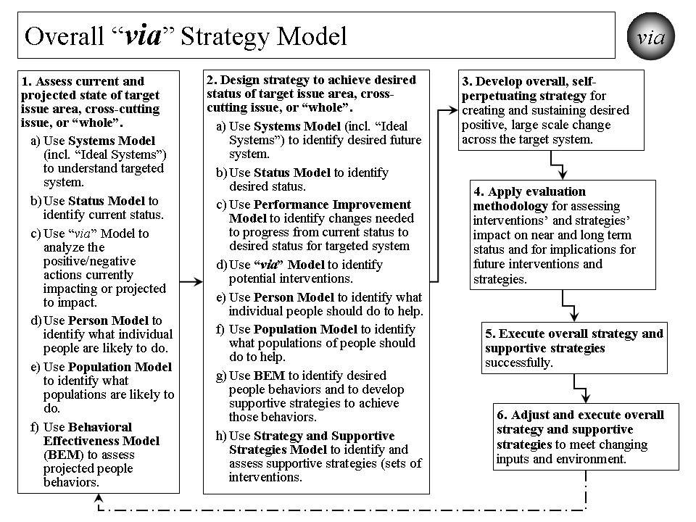
Figure 3.1. Overall via Strategy Model.

How does it work? It works through the systematic application of the core set by people who have both the motivation and the ability to help create and sustain positive, large and timely change.

Though the steps in Table 3.2 imply their sequential application that is not always the case. Step 1 is important in our understanding what is the current system, its status, its projected actions, and its projected people and population behaviors. Step 1c helps us organize that thinking of how we might get from the current situation to the desired status for the targeted system. Step 2 helps us work through what needs to be changed and how we might make that change. Step 3 pulls all this together to help us create and execute the overall strategy and supportive strategies. Step 4 is to make sure we evaluate how we are doing and provide input for changes in strategy. Step 5 focuses on the successful execution of the overall strategy and supportive strategies. Step 6 makes sure we understand that strategy is not static and needs to adjust to unanticipated input and environmental changes, and the strategy needs to be executed successfully on an ongoing basis.

Table 3.2. Overall via Strategy -

Creating and Sustaining Positive, Large Scale Change
The overall strategy for creating and sustaining positive, large scale change is as follows:
- Assess current and projected state of target issue area, cross-cutting issue, or “whole”.
  - Use Systems Model (including “Ideal Systems”) to understand targeted system (e.g. health system, community, nation, broader area) today.
  - Use Status Model to identify current status for “whole” (e.g., community, nation, broader areas), issue areas (e.g., health, education), or cross-cutting issue area (e.g., vulnerability, climate, habitat) targeted for positive, large scale change.
  - Use via Model to analyze the positive/negative actions currently impacting or projected to impact issue area, cross-cutting issue, or “whole”.
  - Use Person Model to identify what individual people are likely to do in future.
  - Use Population Model to identify what populations are likely to do in future.
  - Use Behavioral Effectiveness Model (BEM) to assess projected people behaviors.
- Design strategy to achieve desired status for target issue area, cross-cutting issue, or “whole”.
  - Use Systems Model (incl. “Ideal Systems”) to identify desired future system state.
  - Use Status Model to identify desired status for targeted system.
  - Use Performance Improvement Model to identify changes, including behavior, needed to progress from current status and achieve desired status for targeted system.
  - Use via Model to identify potential interventions for creating and sustaining desired positive, large scale change.
  - Use Person Model to identify what individual people should do to help achieve the desired positive, large scale change.
  - Use Population Model to identify what populations of people should do to help achieve the desired positive, large scale change.
  - Use BEM to identify ability, motivation and desired behaviors that help achieve desired change and to develop supportive strategies to achieve desired behaviors.
  - Use Strategy and Supportive Strategies Model to identify and assess and organize supportive strategies (sets of interventions) for creating/sustaining desired change.
- With above inputs, develop overall, self-perpetuating strategy for creating and sustaining desired positive, large scale change across target system.
- Apply evaluation methodology for assessing strategies’ and interventions’ impact on near and long term status and for implications for future interventions and strategies.
- Execute overall strategy and supportive strategies successfully.
- Adjust and execute overall strategy and supportive strategies to meet changing inputs and environment.

How has it been used and helped? The combination of viaFuture and the via strategy core set has been used for several large scale changes, including systems such as the $15+ billion Military Health System (Department of Defense), the $1+ billion HealtheVet VistA health information system (Veterans Health Administration), the draft Strategic and Operational Plan for the $500+ billion Centers for Medicare and Medicaid Services, a potential strategy for reducing vulnerability for communities and nations, and a potential strategy for Building a Healthy America (over 1/6th of the U.S. economy).

In 2006, the Centers for Medicare and Medicaid Services (CMS) used the combination for drafting a strategic and operational plan for 2007-12. Essentially, the whole strategy was used, working with the CMS staff, to develop a strategic plan covering six years for the $500+ billion agency and its programs. The desired health status and outcome measures were identified. The “ideal” system was identified. The performance improvement model was developed as the framework. Evaluation measures were developed. The strategy addressed “person”, “population” and behavioral issues and how to address them. The end result was a comprehensive draft strategic and operational plan that was developed with the staff. The plan remains available for future CMS use.

An important example of the combination’s use in the early 2000s, was to create and sustain positive change to the Veterans Health Administration (VHA) health information system, a nationwide system covering over 1000 sites of care and with an annual budget of over $1 billion. The desired change was to build upon and expand the capability of VHA’s existing VistA health information system by creating a sustainable next generation system named HealtheVet VistA. The new system was approved by VHA, the Department of Veterans Affairs and the Office of Management and budget and received increased funding of about $125 million annually. Much of the new system is already in place and operating successfully.

The combination of viaFuture and the via strategy core set is being explored on the cross-cutting issue of vulnerability. Here it is being used to create a potential strategy for minimizing vulnerability and maximizing thriving for a whole population (e.g., community, nation). The resulting strategy addresses the system of a community or a nation. It establishes the desired status as minimized vulnerability and maximized thriving and includes a set of measures for that status. It uses the full core set to lay out the performance improvement framework, to analyze and design interventions, to determine how best to address both an individual person and whole populations over time, to develop the behavioral interventions, and to design the overall strategy and supportive strategies. While the Vulnerable In America strategy has not been used to date, it is ready for application.

The combination has also been used to design a HealthePeople strategy to improve health and health care across America. The same design has applicability in communities, states, and other nations.

The combination’s application to whole communities, nations and broader areas is also being explored as a total system interacting with other systems.. In this case, the focus is on the whole population and its individual whole persons. It also addresses animals, plants and other natural resources in the context of the community, nation or broader area. The full range of significant issue areas within the target community, nation or broader area is explored, including their interaction and interdependency. Status indicators to assess current and desired future state are being developed. The intended result is an overall, sustainable, executable strategy for improving the status of a community, a nation or a broader area.

Performance Improvement Model.

What is it? The Performance Improvement Model lays out the process by which a desired performance or status (e.g. minimized vulnerability and maximized thriving, high health status, sustainable and good human and animal habitat, sustainable energy) is set and compared to the current status. Based on that, a strategy is developed that makes the necessary changes to achieve the desired performance or status. [See Figure 3.2.]

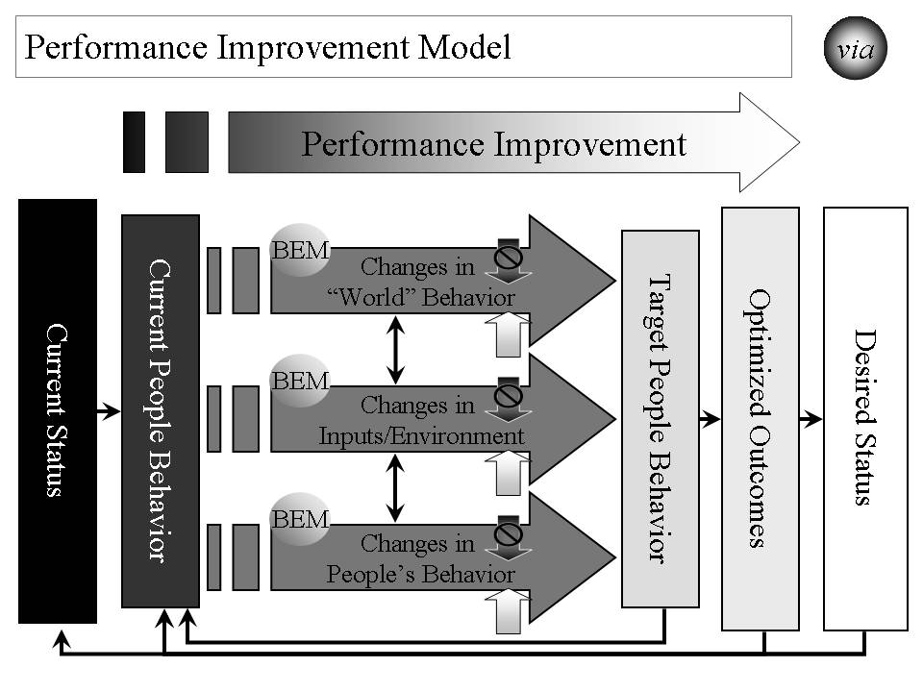

Figure 3.2. Performance Improvement Model - Strategies for Improving Performance to Achieve Desired Status.

How does it work? Based on an understanding of the system that is to be improved and its current status or performance level, a desired level of status or performance is chosen. The model is designed to help determine what it will take to achieve that performance or status level. [See Table 3.3.]

Table 3.3. Performance Improvement Model –

Strategies for Improving Performance to Achieve Desired Status

The overall strategy for improving performance is as follows:
- Based on an understanding of the system that is to be improved, assess its current status or performance level.
- Determine what should be the desired level of status or performance.
- Assess what is the delta (difference) between those two levels.
- Determine what outcomes need to be produced in order to achieve the desired level of status or performance.
- Determine what people’s current behaviors are.
- Determine what people’s target behaviors should be.
- Assess what is the delta between those two sets of behavior and what behavior changes are desired.
- Determine how “world”, input/environment, and people behavior already occurring or projected to occur affect people behaviors. “World” behaviors are changes in people behaviors that are outside the system being changed. “Inputs/Environment” changes are non-people behaviors such as climate change, and plant and animal change.
- Determine the set of strategies and interventions needed to change people behaviors by using other models, including the Behavioral Effectiveness Model (BEM), the via model, and the Person and Population models. These strategies and interventions may be applied to any or all of “world”, input/environment and people behavior already occurring or projected to occur.
- Measure the effect that these strategies and interventions are having on changing people’s behavior, the outcomes and the status.
- Feed the strategies and interventions into the Overall Strategy and Supporting Strategies.
- Determine how changes in status, outcomes and behavior create a new level of “current” status, outcomes and behavior and rerun the Performance Improvement Model on an ongoing basis.

How has it been used and helped? The Performance Improvement Model’s primary use to date has been for improving health care quality, outcomes and status. Its potential use is being explored in creating an overall strategy for reducing vulnerability and improving the status of a community, nation or broader area.

At the Centers for Medicare and Medicaid Services (CMS), the model was used in 2006 to design an overall strategy for national quality improvement for health care, including but not limited to care funded by Medicare and Medicaid. The desired outcome was health status based on the best knowledge on how much health status can be improved through health care. The current status was based on the best available information on current health status. The model helped identify what outcomes, properly optimized, could best produce the desired health status. Further, it helped identify what target people (persons, health care personnel) behaviors could best produce those optimized outcomes. The Person Model was used to understand how individual persons do and should behave over time. The Population Model was used to understand how populations do and should behave over time. The BEM Model was used to determine what interventions would likely produce the desired behavior change. The via Model was used to determine how to apply those interventions as a coordinated, ongoing strategy. These strategies and interventions were used to enhance the overall quality improvement program for CMS.

via Model.

What is it? The via Model serves as a basic framework for interventions that improve the status of an issue area (e.g., health, vulnerability, environment) or a “whole” (e.g., a non-geographic population, a community, a nation, or a broader area). [See Figure 3.3.]

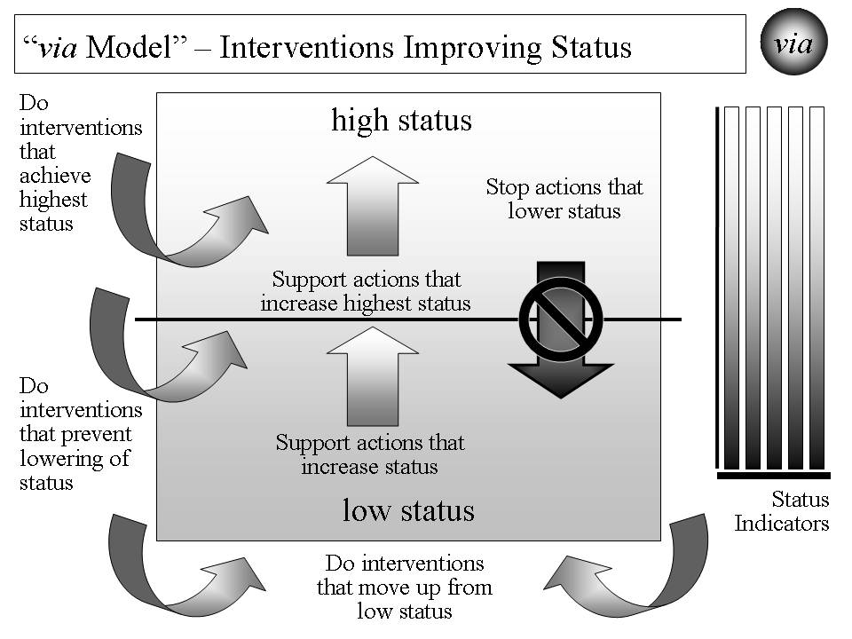

Figure 3.3. “via Model” for Interventions Improving Status.

How does it work? As detailed in Table 3.4, the via Model includes what it is we want to achieve and avoid, how to work through interventions and actions that affect that achievement, and how to measure progress.

How has it been used and helped? The via Model’s primary use to date has been for improving health care. Its potential use is being explored in creating an overall strategy for reducing vulnerability and improving the status of a community, nation or broader area.

The combination has also been used to design a HealthePeople strategy to improve health and health care across America and beyond. The same design has applicability in communities, states, and other nations.

Table 3.4. via Model - Interventions Improving Status

The via Model use for interventions improving status is as follows:
- Decide what issue area or “whole” needs status improvement.
- Decide what status indicators will be used to measure current and desired status.
- Identify current and projected actions that affect status in one of the following ways:
  - Actions that lower status.
  - Actions that increase status for that portion above the mean or median.
  - Actions that increase status for that portion below the mean or median.
- Identify what new interventions that positively affect status in one of the following ways:
  - Interventions that help achieve highest status, including supporting actions that further increase high or highest status.
  - Interventions that help prevent lowering of status, including stopping actions that lower status.
  - Interventions that help move up from low status, including supporting actions that increase status.
- Measure the effect that the interventions are having on the current and projected actions and on the status indicators.
- Feed the interventions into Overall Strategy and Supporting Strategies.

At the Centers for Medicare and Medicaid Services (CMS), the model was used in 2006 to design the draft CMS Strategic and Operational Plan for 2007-12. It assessed current and projected actions by CMS and others affecting health status. It identified new interventions to stop actions that lower health status and to support actions that increase high and low status. New interventions were also identified that directly help achieve high and highest health status, prevent lowering of health status and move up from low health status. These via Model interventions were then used to develop the draft overall Strategic and Operational Plan for CMS.

The model is being used on the cross-cutting issue of vulnerability. Here it is used to help create a proposed strategy for minimizing vulnerability and maximizing thriving for a whole population (e.g., a non-geographic population, a community, a nation). In this case, high status was “high thriving” and low status was “high vulnerability”. An assessment has been done on what actions are already occurring or projected to occur that will affect vulnerability. The model is being used to determine what interventions could be used to reduce vulnerability and maximize thriving. As indicated earlier, the overall Vulnerable In America and World strategy has not been used to date, but is ready for application and can be applied in America and beyond.

Preliminary work has also been done on using the model for non-geographic populations, communities, nations and broader areas. That work incorporates the work done on health and vulnerability into an expanded use applicable to whole communities, nations or broader areas. The focus is on a whole population and its whole persons, along with the respective animals, plants and other natural resources. It addresses the target area as a system with subsystems (e.g. issue areas like health, income, habitat, climate) and with interactions and interdependencies with other systems (i.e., other communities, nations, and broader areas).

Behavioral Effectiveness Model (BEM).

What is it? The Behavioral Effectiveness Model (BEM) is built upon several related models from expectancy theory, instrumentality theory, theory of reasoned action, contingency theory, system theory, social cognitive theory, behavioral theory, etc. that have been in use and refined over 30-40 years. A very detailed explanation of the BEM model and its use is provided in the Appendix: Behavioral Effectiveness Model (BEM). The via approach is built upon the premise that a person or a population’s behavior is key to what creates and sustains positive change. [See Figure 3.4.]

BEM’s value lies in 1) being relatively parsimonious, 2) incorporating key aspects of other behavioral models, 3) being “computable” (i.e., it can use databases (personal and environmental characteristics, desired behaviors and tailored interventions)), 4) tailoring applicability to more than one person simultaneously by using individual characteristics and desired behavior(s) and 5) using evidence-based interventions that can be tailored to those characteristics and the desired behavior.

How does it work? As shown in Table 3.5, the BEM model is designed to 1) apply interventions that help achieve the desired target behavior, 2) learn more about the person or population involved, 3) learn more about interventions and 4) learn more about the “system” in which intervention are used. It can also be used for prediction, analysis and program development and evaluation. The model can be applied to 1) an individual person, 2) populations whose characteristics are sufficiently the same, and/or 3) populations of individuals for which each individual gets a personalized and tailored intervention. The model can be linked to a database so that it can use and produce information and support personalized and tailored interventions:
- For any number of individuals and over any period of time
- For one-time behaviors and behavior over time
- For change in a single behavior and multiple behaviors.

How has it been used and helped? The Behavioral Effectiveness Model’s primary use to date has been for improving health. Its potential use is being explored in creating an overall strategy for reducing vulnerability and improving the status of a non-geographic population, a community, a nation or a broader area.

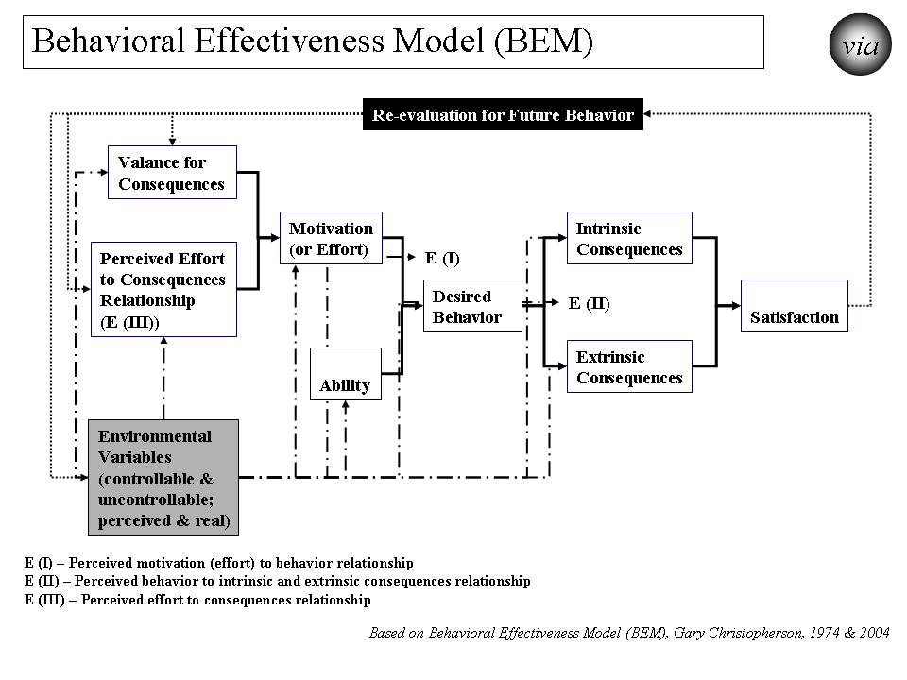

Figure 3.4. “Behavioral Effectiveness Model (BEM) - Improving Personal Behavior/Performance

Its earliest use was in the middle 1970’s, helping develop a high blood pressure control program in Milwaukee, Wisconsin. The desired behavior was adherence to methods for controlling high blood pressure. These methods could be medication use and/or life style change (e.g., diet, exercise, stress reduction). Through the use of BEM, the program was better able to get people to get their blood pressures checked and controlled and to determine the likely success of particular methods with a specific person and with persons with similar characteristics. The blood pressure control program was seen as a national model for community blood pressure control.

Table 3.5. “Behavioral Effectiveness Model (BEM)” –

Improving Personal Behavior/Performance

The BEM Model use for achieving desired behavior is as follows:
- Identify the person or population whose behavior is targeted.
- Decide what is the desired behavior or behaviors. Note that some behavior is one-time and some is recurring.
- Assess motivation in terms of its current and future characteristics.
- Assess ability in terms of its current and future characteristics.
- Assess environmental variables, both controllable and uncontrollable and both perceived and real.
- Assess how motivation, ability and environmental variables are likely to affect future behavior without further intervention.
- Assess what are likely to be the intrinsic (internal to the person or population) and extrinsic (external to the person or population) consequences of projected behavior and what is likely to be the person or population’s satisfaction.
- Assess how consequences and satisfaction are likely to affect future behavior
- Assess how projected behavior, without further intervention, matches to desired behavior.
- Assess what interventions will best move projected behavior to desired behavior for the near and long term.
- Apply the interventions and assess their effect.
- Adjust the interventions as needed over time and based on result.
- Feed the interventions into the Overall Strategy and Supporting Strategies.

BEM is also being used on the cross-cutting issue of vulnerability. Here it is being used to help identify what behaviors are associated with vulnerability and thriving. It helps identify what ability and motivational factors are and would be determinants of vulnerability and thriving behavior as well as establishing what interventions to use to reduce such vulnerability and maximize thriving. Based on these, the potential strategy, Vulnerable In America and World, was created for minimizing vulnerability and maximizing thriving for a whole population, in this case America as a whole. As indicated earlier, the overall has not been used to date, but is ready for application.

With respect to communities, nations or broader areas, BEM is used for addressing the full breadth of issue areas and of people, animals/plants, and other natural resources. Here it helps identify what behaviors are associated with the relevant status indicators. It helps identify what ability and motivational factors are and would be determinants of improving status. The model determines what interventions could improve the motivation and ability factors and, as a result, improve status. Based on these, a strategy is being created for improving status for a whole population, in this case America as a whole.

Person Model.

What is it? The Person Model helps us to understand that each person goes through several life stages depending on how long they live. If status (e.g. health, income, performance) is to be improved, it is seldom a one-time intervention and generally should be done across the life span. As a result, the Person Model works by applying the Behavioral Effectiveness Model over an individual person’s time and life stages. [See Figure 3.5.]

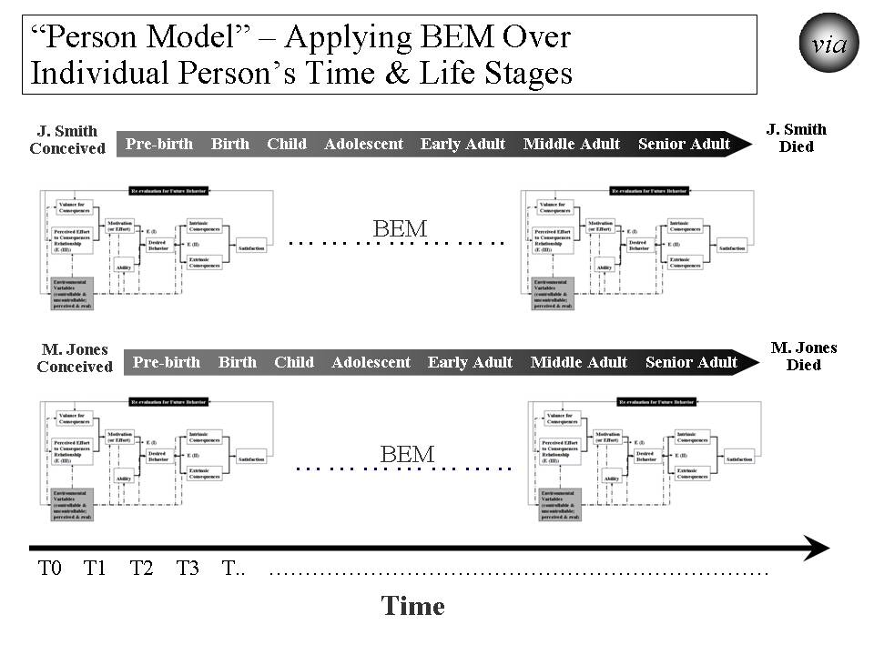
Figure 3.5. “Person Model” – Applying BEM Over Each Person’s Time and Life Stages.

How does it work? The Person Model, with BEM as the underlying model, recognizes that each person is different at the beginning, throughout the life stages, and near the end. For status to be improved, the strategy needs to be both specific to each person across the life span and effective for all persons across the life span. [See Table 3.6.]

Table 3.6. Person Model – Applying BEM Over Each Person’s Time and Life Stages

The Person Model use for achieving desired behavior is as follows:
- Identify the person or population whose behavior is targeted.
- Decide what is the time frame or life stage(s) to be addressed. The preferred time frame is the whole life.
- Decide what is the desired behavior or behaviors over time and through life stages.
- Apply BEM model as a recurring model (running the model as many times as necessary) adjusting to changes in motivation, ability and environmental variables.
- Assess what interventions will best move projected behavior to desired behavior for the covered time and life stage(s).
- Apply the interventions and assess their effect on an ongoing basis.
- Adjust the interventions as needed over time and based on result.
- Feed the interventions into the Overall Strategy and Supporting Strategies.

How has it been used and helped? To date, the Person Model’s primary use has been for improving health. Its potential use is being explored for creating an overall strategy for reducing vulnerability and improving the status of a community, nation or broader area.

The model has been used to design the HealthePeople strategy to improve health and health care across America. The same design has applicability in communities, states, and other nations.

Its earliest use was in the middle 1970s to develop a high blood pressure control program in Milwaukee, Wisconsin. The desired behavior was adherence to a protocol for controlling high blood pressure over the person’s remaining life. Through the use of the Person Model, the program was better able to understand how to match the intervention to time and different life stages. With respect to time, the interventions needed during the initial treatment were different than during the maintenance phase of treatment. With respect to life stages, interventions required refining for matching the behavioral determinants for a younger versus middle-age versus older persons. The blood pressure control program served as a model of community blood pressure control programs.

At the Centers for Medicare and Medicaid Services (CMS), the model was used in 2005 to enhance the overall strategy for national quality improvement for health care. The desired behavior was of health care providers over time and their careers. The model helped identify what target health care personnel behaviors, on an ongoing basis, could produce the best outcomes. Based on that, an approach was laid out using current and new interventions to improve health care provider behavior in a way that would produce improved outcomes and health status for the foreseeable future and over the health care providers’ careers (life stages). These interventions were used to improve the overall quality improvement program for CMS.

The model was used in the early 2000s to create a new model called “person-centered health”. [See Figure 3.6.] The Person-Centered Health Model has been used to refine the programs of the Veterans Health Administration, including overall care, care in the community and the VHA health information system (electronic health record and personal health record systems). It was also used at the Centers for Medicare and Medicaid Services to help with the draft strategic and operational plan.

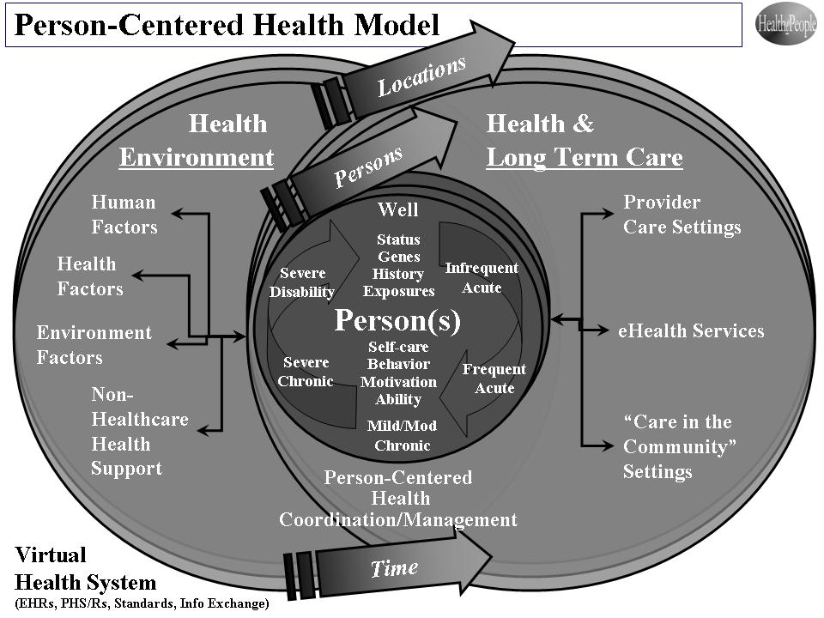

Figure 3.6. Person-Centered Health Model.

The Person Model is also being used on the cross-cutting issue of vulnerability. Since vulnerability is relevant over a person’s whole life span and changes through the life stages, the model helps identify what ability and motivational factors, over time and across life stages, would be determinants of vulnerability and thriving behavior. It recognizes that reducing vulnerability prior to birth is very different than doing so for an adolescent or for a senior adult. Some factors (e.g. financial and cognitive ability) carry across a person’s life and can help lower vulnerability throughout a person’s life. Some factors (e.g. ability reduced by Alzheimer’s disease or low birth weight) always or most likely occur at a specific life stage. As a result, Vulnerable In America and World, the strategy for minimizing vulnerability and maximizing thriving in America and beyond, is a living strategy that adjusts for time and life stages. This comprehensive strategy has not been used to date, but is ready for application.

Population Model.

What is it? The Population Model addresses status from the perspective of what is happening at any point in time and the effect on a diverse or non-diverse population. Again, BEM is the underlying model for adjusting strategy to address points in time across persons and their life stages. This model also applies to other differences (e.g., racial, ethnic, income, vulnerability) in the target population [See Figure 3.7.]

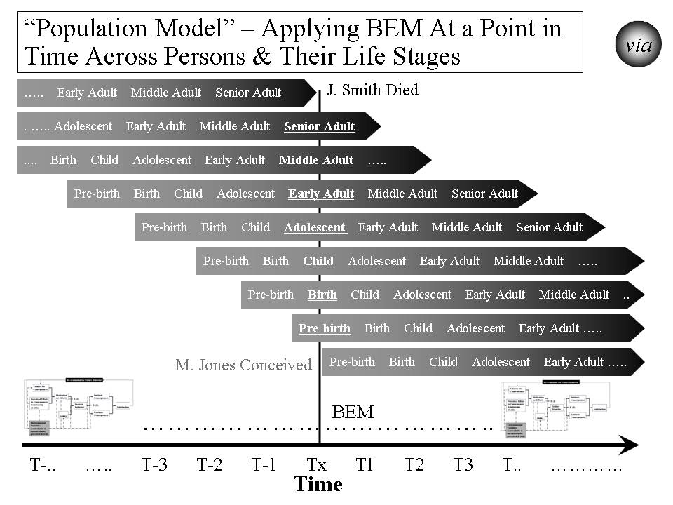

Figure 3.7. “Population Model” – Applying BEM at a Point in Time Across Persons and Their Life Stages

How does it work? The Population Model, with BEM as the underlying model, recognizes that strategy, at any point in time, must be both specific to each applicable person across the life span and effective across all persons across the life span. [See Table 3.7.] Taking a time slice, the model recognizes that at any specific time, the target population likely includes persons from all different stages of life (pre-birth, birth, child, adolescent, early adult, middle adult and senior adult). At that time, each person has different status levels, different factors affecting status, and different responses to efforts at improving status. This can be seen in how major disasters (e.g., tsunamis, earthquakes, disease outbreaks, crop failures, drought) affect people differently. This can be seen in how program interventions (e.g. education, housing programs, financial assistance, health insurance programs, heating assistance, taxes) affect people differently.

Table 3.7. Population Model –

Applying BEM at a Point in Time Across Persons and Their Life Stages

The Population Model use for achieving desired behavior is as follows:
- Identify the population whose behavior is targeted.
- Decide what are the point(s) in time and life stage(s) to be addressed.
- Decide what is the desired behavior or behaviors at different points in time across persons and their life stages.
- Apply the BEM model across time and across populations and their life stages taking into account their differing motivation, ability and environmental variables.
- Assess what interventions will best move projected behavior to desired behavior across time and across populations and their life stages.
- Apply the interventions and assess their effect on a population on an ongoing basis.
- Adjust the interventions as needed over time and based on result.
- Feed the interventions into the Overall Strategy and Supporting Strategies.

How has it been used and helped? The Population Model’s primary use to date has been for improving health. Its potential use is being explored for creating an overall strategy for reducing vulnerability and improving the status of a community, nation or broader area.

At the Centers for Medicare and Medicaid Services (CMS), the model was used in 2006 to design the draft CMS Strategic and Operational Plan for 2007-12. It was used to address CMS’s disparate beneficiary population and the timing and design of program interventions. The plan was designed to address the needs of both younger and older Medicaid beneficiaries, beneficiaries with disabilities, and healthier and severely ill Medicare beneficiaries. It also addressed the populations that are pre-Medicaid and pre-Medicare. The plan recognized that over time, these populations change as new age cohorts moved into the program. These Population Model interventions were then used to develop the draft overall Strategic and Operational Plan for CMS.

For the DoD Military Health System (MHS), the model was used in the 1990s to work with pre-military, active service, Guard and Reserve, veterans, retirees and their families. All are the responsibility of the MHS. Key points in time greatly affect how the health programs work and their effect. Earlier wars (and their effects) such as the two World Wars and the Korean War are very different than the Vietnam War than the first Iraq War, as well as the second Iraq War and then the Afghanistan operations. They are all likely to be different than future wars and other military actions. All of these factors were built into the overall strategy for the future Military Health System that was re-engineered to improve performance, adopted as a force health protection program, and was made more flexible to adjust to different futures.

The model has also been used to design a HealthePeople strategy to improve health and health care across America. The same design has applicability in communities, states, and other nations.

The Population Model is also being used on the cross-cutting issue of vulnerability. Since vulnerability is relevant at different points across a person’s life stages, it is used to help identify what ability and motivational factors at those different points are most likely determinants of vulnerability and thriving behavior. For example, applying new policies on financial assistance or taxes over the next twelve months will have very different effects across the population of persons. If the intent of the new policies is reducing financial vulnerability across the U.S. population, then they must be modeled, at a minimum, against each subpopulation and, preferably, against each “person”. The more desirable policies are those that both reduce vulnerability most for the most vulnerable and substantially reduce vulnerability for all persons. The most desirable policies are the ones that do this and continue the positive effect as the population moves through time (i.e., sustainable, reduced vulnerability for all people). As indicated earlier, the overall strategy has not been used to date, but is ready for application.

System(s) Model (Including “Ideal” Systems).

What is it? The System(s) Model views the world as a system of systems. When a strategy is being designed, it is important to determine what the target system is, what larger system it is part of, what its subsystems are, and what other systems it relates to. A system can be a community, a nation, or a broader area. It can be an issue area system such a health system, an education system, or an ecological system. The Ideal Systems Model, developed by people such as industrial engineers (e.g. Gerald Nadler) decades ago, is another key model for looking at how well a system could perform and how to achieve the highest performance for that system. [See Figure 3.8.]

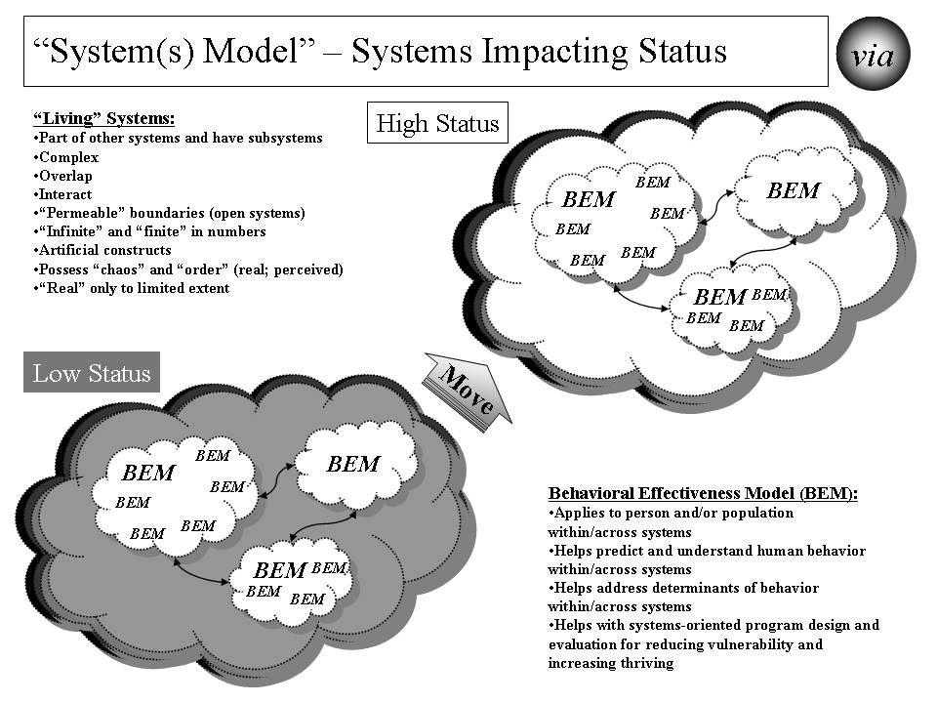

Figure 3.8. Systems Model – Systems Impacting Status

How does it work? For efforts to improve status to be successful and sustainable, the strategy and its execution need to be systematic and positively change a system (a whole community, a whole nation or a whole broader area) of systems (e.g., health, education, employment/income, housing, habitat, climate) on a sustained basis. [See Table 3.8.]

Table 3.8. Systems Model – Systems Impacting Status

The Systems Model use for achieving desired status is as follows:
- Identify the target system within which status is to be improved.
- Identify other systems that are related and might either be impacted or have an impact.
- Identify the status (lower than desired) for the current system and key characteristics of the current system.
- Identify the desired status and characteristics for the future system using the Ideal Systems Model.
- Identify the key behaviors in the current systems and what they need to be in the future system.
- Determine what changes need to be made to the current system to move it to the desired system.
- Assess what interventions will best change the current system into the desired future system.
- Apply the interventions and assess their effect on behavior change and on status.
- Adjust the interventions as needed over time and based on result.
- Feed the interventions into the Overall Strategy and Supporting Strategies.

In a systems model, there is recognition that systems are “living”. They change internally, impact other systems and are impacted by other systems. Systems are part of other systems and they have subsystems themselves. They are usually complex. They often overlap with other systems. They interact with other systems, sometimes fairly predictably and sometimes not. They often have permeable borders that are not always understood or constant. They may be nearly infinite in number. Often we apply an artificial construct to them to help us understand and work with them. Some systems are formal constructs (e.g., the British National Health Service system, the Kaiser Permanente system, the Military Health System, the veterans health system) and some are informal constructs (e.g. the American “health system”). They may be or appear to be “chaotic” or “ordered”. They may be or appear to be “real”.

To positively change a system (e.g. the American “health system”) on a sustained basis, we need to understand the impact that existing and future systems will have on each person’s or a population’s status. We need to understand the impact of systems that we create, change or delete will have on other systems and, ultimately, on each person’s status.

Within “human” systems are real people (individual persons, populations of persons) and organizations (made up of persons) whose behaviors collectively help determine the behavior of the system. The Behavioral Effectiveness Model (BEM) helps us understand the behaviors and their determinants (ability, motivation, environmental factors) on an individual level and on a population of individuals level. In the systems model used here, there is recognition that moving from low status to high status requires moving individual behavior on a massive scale if it is a large system like the American “health system”. This movement includes the persons we want to move to higher status and the persons that help or hinder that movement.

As shown in Figure 3.9, the Ideal Systems Model helps determine the desired system. It starts out by assessing the current system. It then sets what is the theoretical ideal system assuming there are no costs or constraints preventing us from reaching that system. The theoretical ideal is a guide but is not reachable in the real world for the foreseeable future. Then the model helps us think through the options between the current system and the theoretical ideal system. The ultimate ideal system is one which imposes no constrains but is not yet feasible due to the “means” not yet being available. The feasible ideal system is one where the constraints are removed or reduced and the “means” are available. Finally, the recommended system is the best given the constraints and available means and is on the glide path to the ultimate ideal. The via Model helps design and assess these different systems.

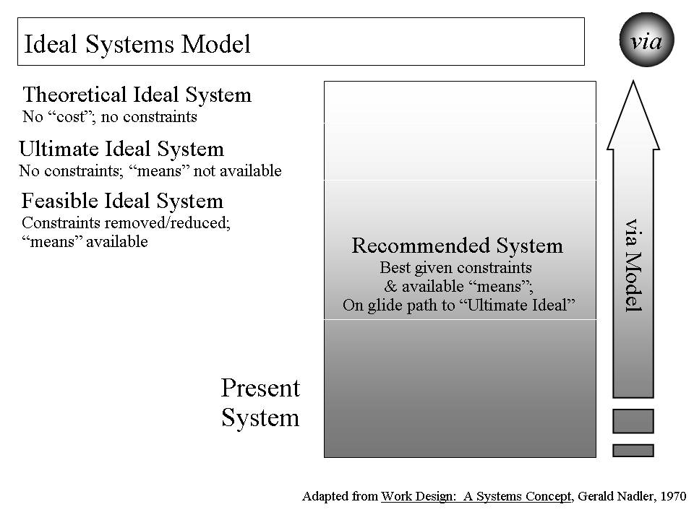

Figure 3.9. Ideal Systems Model

How has it been used and helped? The primary use of the System Model (this adapted version) to date has been for improving health. Its potential use is being explored in creating an overall strategy for reducing vulnerability and improving the status of a community, nation or broader area.

One of its earliest uses was in the late 1970s to design and execute an inner city health system for Milwaukee, Wisconsin. The result was a new public/private multi-clinic system providing preventive services, primary care, maternal and infant care, mental health care, dental care, and social services for the community poorest and highest risk people. The total system also included hospital services from public and private hospitals. The system operated successfully for over 30 years and has been viewed as a successful model for improving inner city health care.

At the Centers for Medicare and Medicaid Services (CMS), the Systems Model was used in 2006 to design the draft CMS Strategic and Operational Plan for 2007-12. Rather than approaching the plan as a program by program plan or a CMS only plan, the whole American “health system” was used as the framework. The plan was designed using the Ideal Systems Model to improve health across the total American population using the entire American “health system”. The CMS plan strategies were built on how best to move to high health status by using both CMS programs focused on Medicare and Medicaid beneficiaries and programs with broader scope. For example, CMS’s quality improvement program has impact far beyond care for CMS beneficiaries. Similarly, CMS’ payment programs serve as the driver for non-CMS payment programs (e.g. health insurers). The plan was designed to address the needs of both younger and older Medicaid beneficiaries, beneficiaries with disabilities, and healthier and severely ill Medicare beneficiaries. It also addressed the populations that are pre-Medicaid and pre-Medicare. These Systems Model interventions were then used to develop the draft overall strategic and operational plan for CMS.

For the Department of Defense (DoD) Military Health System (MHS), the model was used in the middle 1990s to work with full set of DoD health-related programs. The Military Health System was treated as a system that encompassed health care for 1) service members when not engaged in military action, 2) service members (including the Guard and Reserve) when engaged in military action, and 3) family members, retirees, Guard and Reserve in non-active status, veterans served by other providers (e.g., Veterans Health Administration and private providers). It also encompassed preventive services for service members, and force health protection (including protective tools when deployed). The overall MHS strategy was built using the Ideal Systems Model coupled with other “futures” models. It included the health of all of these people. The strategy included all the services needed to protect and improve their health. It included working with other entities, including the Veterans Health Administration and the Centers for Disease Control. All of this was built into the overall strategy for the future Military Health System that was re-engineered, adopted a force health protection program, was more effective and efficient, and was more flexible to adjust to different futures.

The model has also been used to design a HealthePeople strategy to improve health and health care across America. The same design has applicability in communities, states, and other nations.

The Systems Model is also being used on the cross-cutting issue of vulnerability. Since vulnerability is both personal and heavily affected by the “system” in which people live, the model is the best way to address both. Similar to what is shown in Figure 3.8, the idea is to move from low status (high vulnerability and low thriving) to high status (low vulnerability and high thriving). To best accomplish that, the Systems Model is being used to address the whole system (e.g. the United States) but has its impact on the person level. The Ideal System Model is used to determine what overall strategy would not only minimize vulnerability and maximize thriving at a point in time but to do it on a sustained basis. The strategy identifies what status measures would be relevant at the system-wide level and at the individual person level. It identifies what interventions and actions would both reduce vulnerability most for the most vulnerable and reduce vulnerability substantially for all persons. The Ideal Systems Model is being used to ensure the strategy is one that does this in both the near and long term. As indicated earlier, the overall Vulnerable In America and World strategy has not been used to date, but is ready for application.

The model’s application is being explored for whole communities, nations and broader areas where these are treated as total systems interacting with other systems outside. Building an appropriate set of status indicators is a critical step given the breadth of such systems and the need to assess current and desired future status. The focus is on the whole human population (as well as its individual whole persons), and on animals, plants and natural resources within the targeted community, nation or broader area. The full range of significant issue areas within the target community, nation or broader areas is explored, including their interaction and interdependency. The Ideal Systems model is used to both set the vision and design the recommended systems for now and for the future. The intended result is an overall, sustainable, executable strategy for improving the status of a community, a nation or a broader area.

Strategy Model.

What is it? The Strategy Model builds on the above groundwork and brings this all together to develop and execute stainable, effective strategies for improving status. It includes the model for building the strategies as well as the framework into which the strategies fit. The model includes both the overall strategy and supportive strategies and the actual interventions supporting the strategies. [See Figure 3.10.]

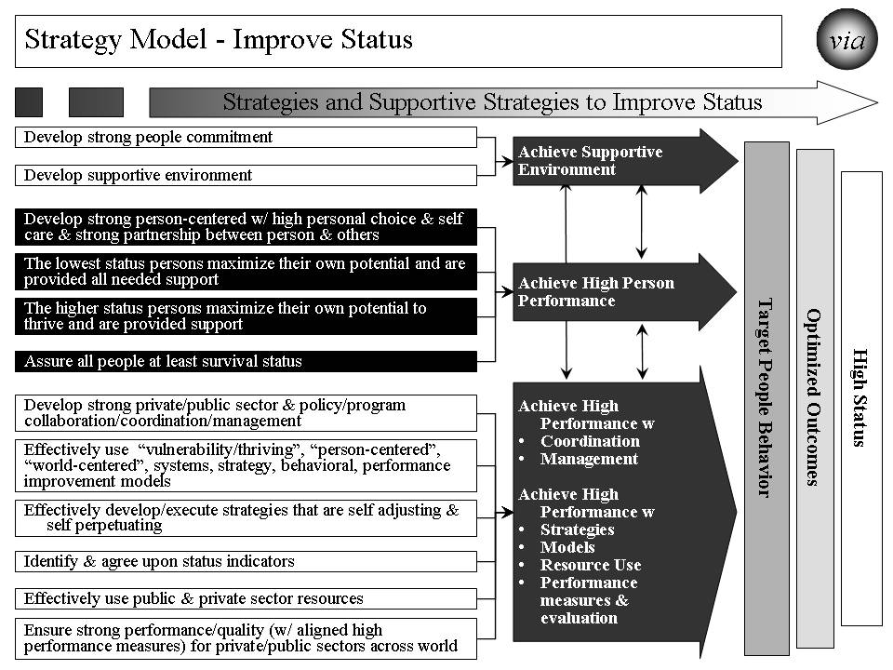

Figure 3.10. “Strategy Model” – Improve Status

How does it work? The model brings together all the previous information into an overall strategy and supportive strategies to improve status (e.g. health, income, vulnerability, habitat, climate). [See Table 3.9.]

Table 3.9. Strategy Model – Improve Status

The Strategy Model use for achieving desired status incorporates previous work from the other models and input and is as follows:
- Load the desired status and the associated indicators.
- Load the optimized outcomes that will best produce high status.
- Load the target behaviors that will best produce the optimized outcomes.
- Use pathways to connect how the supportive strategies will best produce the target behavior. The pathways are customized to the issue area or “whole”.
- Identify the specific supportive strategies that, working through the pathways will best produce the target behaviors.
- Execute the strategy and its supportive strategies effectively.
- Assess the progress on improving status. Assess the effectiveness of the strategy and its supportive strategies.
- Revise strategy and supportive strategies as needed to be effective and sustained over time.

How has it been used and helped? The Strategy Model’s primary use to date has been for improving health. Its potential use for creating an overall strategy for reducing vulnerability and improving the status of a community, nation or broader area is being explored.

At the Centers for Medicare and Medicaid Services (CMS), the Strategy Model was used in 2006 to design the draft CMS Strategic and Operational Plan for 2007-12. The result of that effort was a plan similar to what is shown in Figure 3.11. For each of the supportive strategies, a set of specific interventions were developed to make the plan fully operational. With respect to quality improvement for CMS, a more in-depth strategy was developed using the Strategy Model.

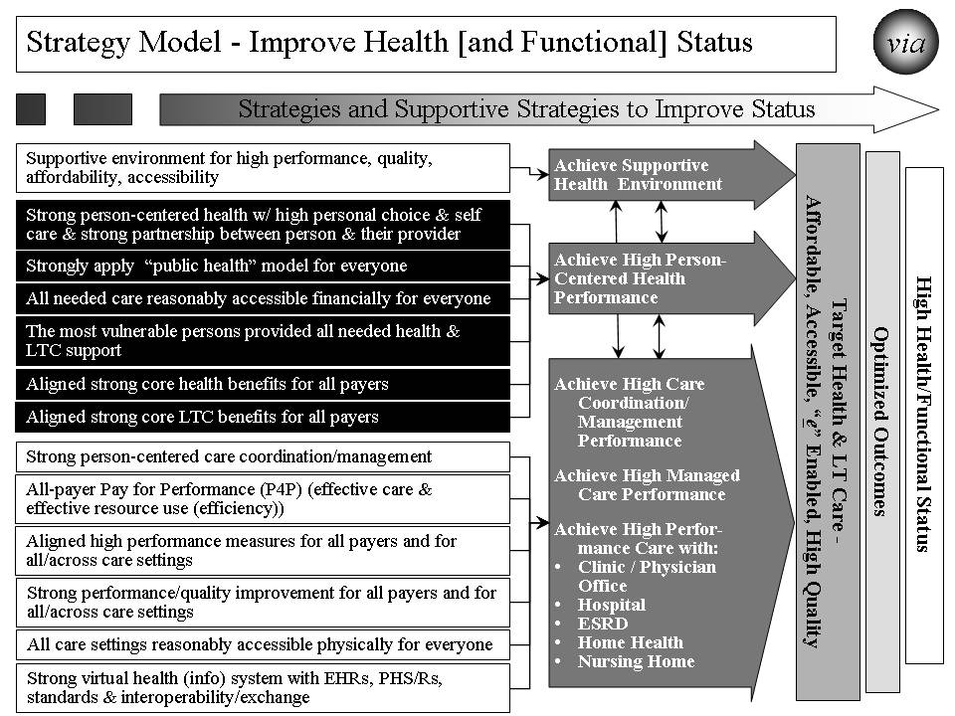

Figure 3.11. Strategy Model – Improve Health [and Functional] Status

The model is being used on the overall American health system. It is being used to try to answer how could we “achieve a healthy America” using an enhanced whole American health system. With many similarities to the CMS Plan, the strategy model helps create a strategy, HealthePeople, but with the larger scope of all Americans, all payers and all health providers.

The Strategy Model is also being used on the cross-cutting issue of vulnerability. As indicated earlier, the overall strategy, Vulnerable In America and World, has not been used to date, but is ready for application.

Similarly, it is being used to build an overall strategic approach, Building a Better Future, addressing whole communities, nations and broader areas.

Status Model.

What is it? The Status Model is used to identify the desired and current status for “whole” systems (e.g., a non-geographic population, a community, a nation, a broader area), issue areas (e.g., health, education) or cross-cutting issue areas (e.g., vulnerability, climate, habitat) that are targeted for positive, large scale change. It also includes the status indicators and their supportive measures such as those shown in Figure 3.12.

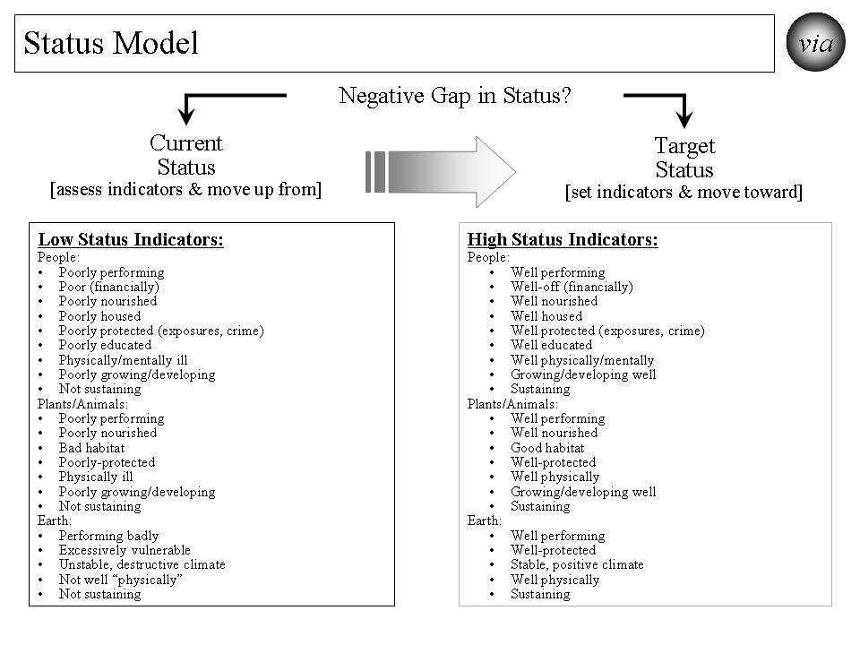
Figure 3.12. Status Model

How does it work? For efforts to create and sustain positive systems to be successful, we need to determine how we are doing today, how we are doing as we progress to the desired system and how we are doing when we achieve and work to sustain the desired system. The Status Model helps do that as shown in Table 3.10.

Table 3.10. Status Model

The Status Model is as follows:
- Determine what is the issue area, cross-cutting area or “whole” system for which the strategy is targeted and status indicators are needed.
- Decide how high, in general, is the desired status. Is it optimal? If not, how close can we get to optimal?
- Identify all of the indicators that, as a set, indicate the desired high status. These are the “Target Status” set of indicators.
- Decide what each indicator’s level should be to match the desired high status.
- Decide what each indicator’s level is to describe low status.
- To the extent needed, identify more detailed measures for each indicator.
- Assess the “Current Status”, i.e., the current level of indicators for the target population.
- Assess the “Negative Gap” between the current status and the desired target status. This is the gap to be closed with the overall strategy.
- Execute the status model effectively and measure progress.
- Assess the effectiveness of the status indicators.
- Revise status indicators, individually and as a set, as needed to be effective.

How has it been used and helped? The Status Model’s primary use has been for improving health. Its potential use is being explored in creating an overall strategy for reducing vulnerability and improving the status of a community, nation or broader area.

In both the draft CMS Strategic and Operational Plan (2006) and the work being done on how to “achieve a healthy America”, the model’s applications are similar. Both include status indicators that apply across America. Both depend on more detailed measures to support and add depth to the indicators. The CMS approach focused a bit more on CMS beneficiaries but did include all Americans. The “healthy America” approach uses status indicators that apply to all Americans. The health status indicators address the person’s ability and motivation to achieve high health status. The same is true for health care providers. These are more process indicators. The status indicators include outcomes of various treatments and other health interventions. The status indicators go further and include what most consider as “health status” indicators such as low morbidity and mortality, high quality of life, high satisfaction, and low future risk for adverse events. Current status is assessed as well as the negative gap between the desired future high health status and current lower health status.

The model is being used on the overall American health and to answer what is a “healthy America”. With similarities to the CMS Plan, the status model helps support a strategy, HealthePeople, with the larger scope of all Americans and all health providers. [See Figure 3.13.]
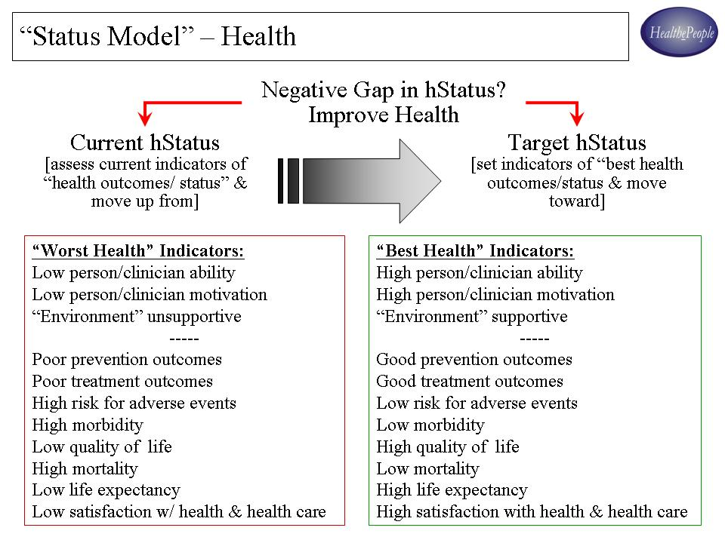
Figure 3.13. Status Model - Health

In the cross-cutting work Vulnerable In America and World, the primary status indicators are the ones in the overall model that apply to people. However, there are several others that are important to working on human vulnerability, including many of the “earth” and “plant/animal” indicators.

For the broader work on communities, nations and broader areas, the full set of status indicators is very large but can be grouped into high level categories with supportive measures. They should encompass all the significant indicators covering the full breadth of the target area. On the highest level, they must be meaningful enough to provide guidance on improving the whole target area as a whole system. They must be supported by clearly defined measures that can be measured by data that is available into the future. Further, the status indicators must be flexible enough to adjust to changing future conditions. With these status indicators, a strategy can be developed and its progress assessed.

The Path Ahead

Potential “next generation” models do exist for strategy at system (issue area, community, nation, broader area) and person levels. As proposed here, one such model is the combination of viaFuture and via - a core set and system of supportive models addressing persons, systems, motivation, ability, behavior, performance and its improvement, process measures, and, most importantly, positive outcomes and improved status. While parts of the strategy can be used independently, they have more power and are more likely to produce the best results when used as a full set.

The path ahead offers many opportunities, as outlined above, to tackle large, complex issue areas, cross-cutting issues and whole communities and nations. Already late, now is the time to aggressively use “next generation” strategies for solving large problems and creating and sustaining positive, large scale change and a thriving future.

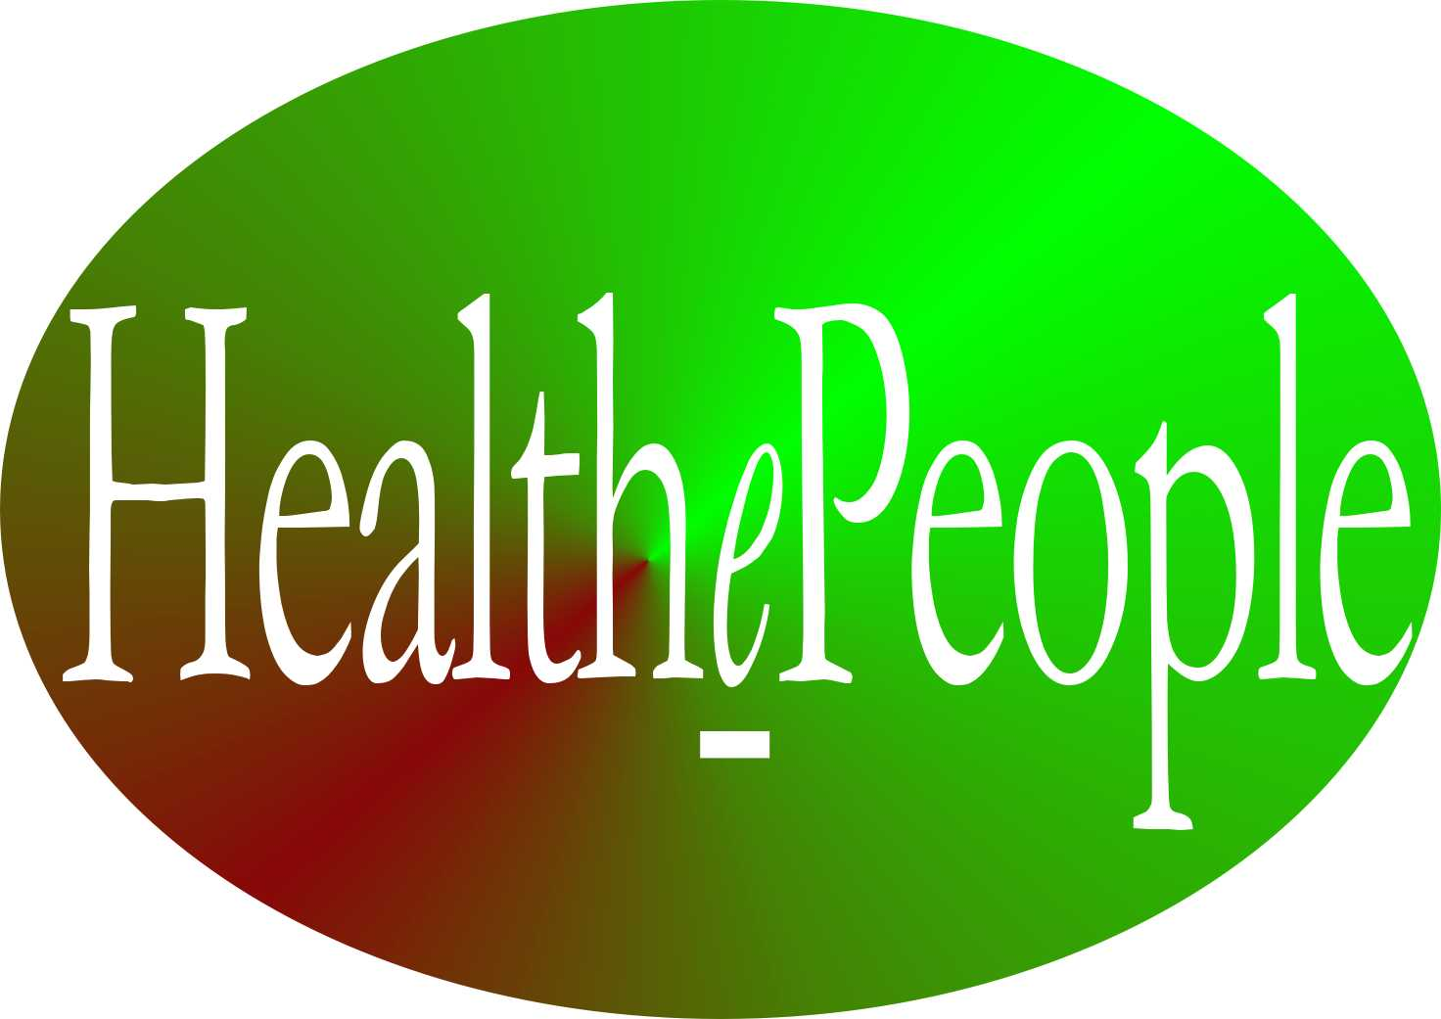

Chapter 4
HealthePeople - Building a Healthy and Thriving Future – Improving Health Via Thrive! Strategy and viaFuture Supportive Strategy

Today in America, we spend 1/6th (about $2.6 trillion) of our national economy on health. Unfortunately, we do this without producing healthy Americans or a healthy America. Without a quantum change in health vision, strategy and execution, our future will be as disappointing as our past. To positively change that future, HealthePeople - Building a Healthy and Thriving Future is a national strategy whose near-term vision is to achieve substantially healthier Americans and a substantially healthier America. The long-term vision is to achieve healthy Americans and a healthy America.

This HealthePeople change effort was created using the combination of viaFuture and the via strategy core set. It was created with the belief that America can reach this vision via an endgame strategy of a high performance, American health and long term care system for all Americans. This American health system must be self-perpetuating, affordable, accessible, “e” enabled, and producing high health quality, outcomes and status. Such a system, partly physical and partly virtual and put into place by collaborative private and public partnerships, will greatly improve accessibility, quality and affordability for all Americans. Such an American system can greatly improve health and help achieve a healthy America.

Rationale

There is and should be little disagreement over the need for America to have a substantially better health system. None of the key indicators – health status, accessibility, quality, affordability – are at acceptable levels for a nation spending 1/6th of its economy on health.
- Accessibility – Over 45 million Americans are uninsured for health care and millions more are underinsured. This number will go down as the latest health reform takes effect. Most Americans are uninsured or underinsured for long term care. Needed health and long term care services are insufficiently available and/or accessible to many inner city and rural communities. A collaborative partnership of people, public and private payers, and health care organizations should and can substantially improve access for all Americans.
- Quality – Health status and outcomes produced by the American health “system” are inadequate given the needs of the American people and the 1/6th of the national economy expended. Too little of our medical and health knowledge is being effectively applied to prevent and treat health problems and to ensure health care is safe. A collaborative partnership of health care organizations and the people they serve should and can substantially improve health care quality and health outcomes for all Americans.
- Affordability – The unaffordability of health care is challenging America as a nation (1/6th of the national economy and growing) and Americans as individuals and families (inhibiting needed access and causing bankruptcies). The latest health reform should improve this situation for some people and to some extent. A collaborative partnership (health care organizations, the people they serve, and the people and organizations who pay) should and can use America’s valuable health resources much more effectively.

We, as a nation, are spending enough money. We are just not getting the requisite payoff in terms of health outcomes/status or satisfaction.

Guidance

HealthePeople is a national strategy guided by and aligned with the Institute of Medicine (IOM) recommendations. IOM provides a way of viewing the health system’s performance through the eyes of people themselves. What people want from a high performing health and long term care system is that they are “staying healthy”, “getting better”, “living with illness or disability” and/or “coping with the end of life.” Some people may experience more than one of these at the same time. IOM’s quality reports have six aims for a high performing health system. They stress it should be safe, effective, person/patient-centered, timely, efficient, and equitable.

Utilizing their guidance, a very high performing health and long term care system would perform well from the person’s perspective and achieve the IOM aims. As depicted in the attached table, that very highly performing health system would “check all the boxes.” (See Figure 4.1.)

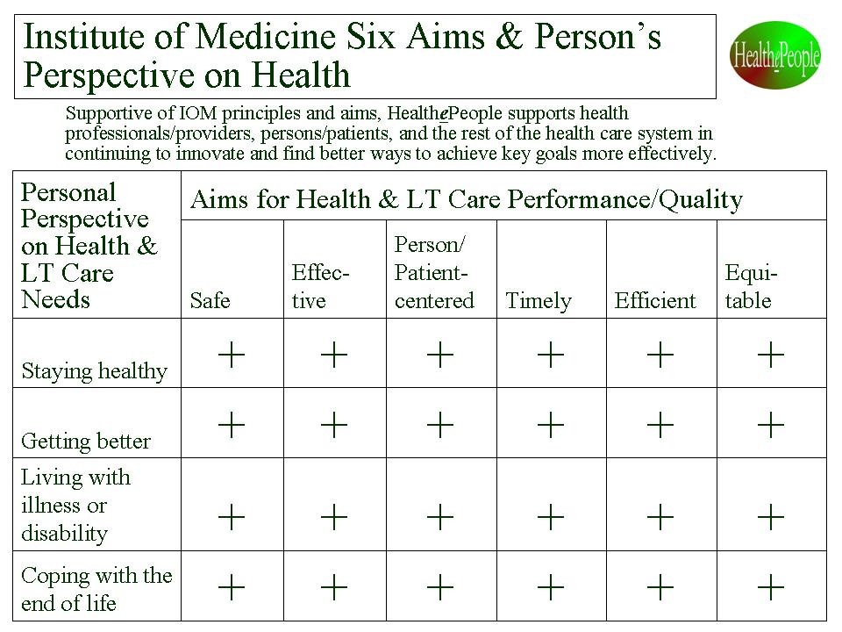
Figure 4.1. “Institute of Medicine Six Aims & Person’s Perspective on Health”

Second, we need to recognize the following as key health drivers and use them to guide our work and measure our progress toward a healthy America:
- Maximize health status
- Maximize outcomes
- Maximize abilities
- Maximize satisfaction
- Maximize quality
- Maximize accessibility/ portability
- Maximize affordability
- Maximize patient safety (drive defects/errors to zero)
- Minimize time between disability/illness and maximized function/health (drive time to zero)
- Minimize inconvenience (drive inconvenience to zero)
- Maximize security & privacy

Third, we need to understand and successfully deal with the American health system’s complexity if we want to substantially improve health outcomes and health status for all Americans. The Figure below lays out the complexity gauntlet which must be successfully run. (See Figure 4.2.) To be fully successful, we have to address the people factors (population, diversity, insurance status, health factors, health-related factors) and the non-people factors (health resources, health care, health-related environmental factors). We have to focus on a) positively affecting the actions that improve/reduce health quality to b) create a strong partnership between the person and their clinicians to c) improve health care quality and effective resource use, and d) use those results to substantially improve health outcomes and status.
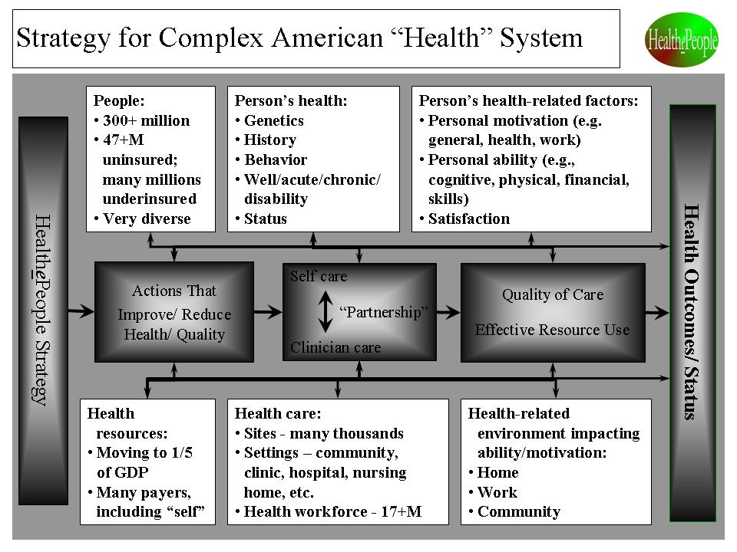
Figure 4.2. “Strategy for Complex American “Health” System”
Vision, Endgame Strategy and Mission

The HealthePeople near-term vision – achieve substantially healthier Americans and a substantially healthier America - is far different than the one we can expect from our current glidepath. While recent health reform appears to improve that glidepath, much was not addressed and much is dependent on effective execution. Even more so is the long-term vision - achieve healthy Americans and a healthy America. All current indicators and trends point to a future where access, quality and affordability still continue to be unacceptable. Under a better vision and strategy with the same resource commitment, America can achieve substantially healthier Americans and a substantially healthier America.

To reach this vision, the endgame strategy is to achieve a high performance, American health and long term care system for all Americans that is self-perpetuating, affordable, accessible, “e” enabled, and producing high health quality, outcomes and status. An American health system should bring to bear the full force of people and their clinicians, their healthcare providers, their healthcare payers, their communities and their governments.

To reach this vision and endgame strategy, the mission is to create and support collaborative partnerships that help build that high performance, American health and long term care system for all Americans. This unprecedented collaboration can achieve great progress as we have seen America achieve great progress on other national issues. Building a Healthy America achieves full success when an American health system achieves and sustains healthy Americans and a healthy America.

Strategy for a Healthy America and World

HealthePeople is a collaborative strategy to transform to affordable, person-centered, outcomes-driven, and "e" enabled health systems that help achieve better health. Succeeding with this strategy across all healthcare should positively transform health care. We can use our nation’s valuable health resources much more effectively, reduce vulnerability, and achieve much healthier Americans and a much healthier America. Within this strategy are two core elements:
- First, achieve affordable, accessible, and high quality/performance health systems. This involves more than medical interventions or traditional healthcare services. It requires a full range of health-related resources from across the community and beyond.
- Second, focus on people—consumers, patients, enrollees, and members. People are the center of the health universe and must be treated as such, forming strong partnerships between individual persons/patients and their healthcare providers.

To build out the strategy and supportive strategies, this strategy utilizes a public health intervention model designed to help increase the number of healthy people and reduce the number of vulnerable and/or unhealthy people. (See Figure 4.3.) It targets interventions that best achieve the highest level of health and function, best prevent more poor health, and best move our most vulnerable people up from poor health. Success is measured by the degree to which we stop actions that decrease health and support actions that improve health. Success is also measured by how well the private and public sectors, including health professional leadership, “move the numbers”, i.e., substantially improving the key status indicators of health and function.

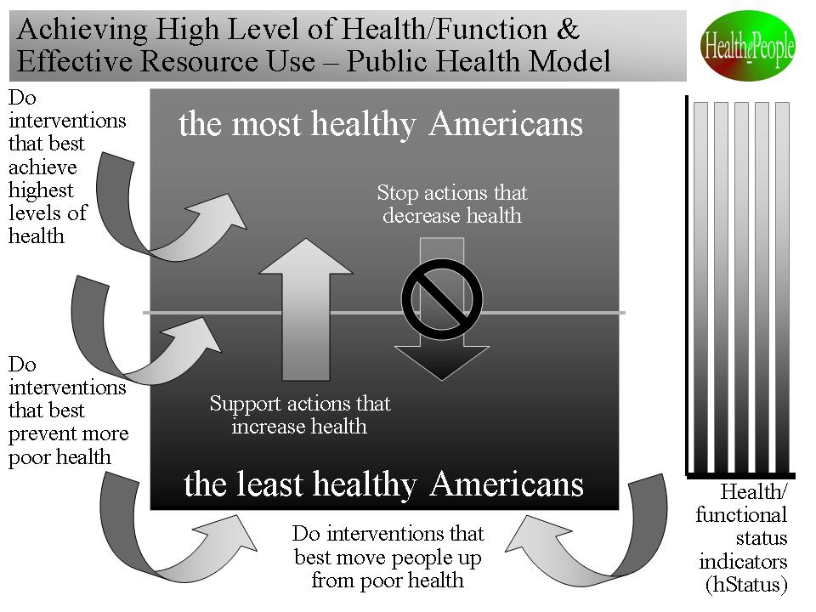
Figure 4.3. See “Achieving High Level of Health/Function & Effective Resource Use – Public Health Model”

Within the model, there are interventions that improve health or make it worse. To improve health, there are the overall key strategic areas – stop those interventions/actions that make health worse and support those interventions/actions that improve health. To improve health most, we need to execute a "systematic strategy" – a “system” of actions that continuously stops actions that push people down to less healthy states and supports actions that lift people out of poor health and toward being healthy. This “system” of actions, when well designed and executed, can perpetually prevent much poor health and support people moving up from poor health to being healthy.

The overall strategy is built by applying a strategic improvement and behavior model to health. Using the model depicted below, we set the target health and functional status we are trying to achieve.. (See Figure 4.4.) Using the target status, we can decide on the target outcomes needed and on the target health system needed to achieve those outcomes. Comparing the optimized outcomes and health system with the current health system and its performance, we can determine the “delta”, i.e., the needed improvements in the current health system and its outcomes.

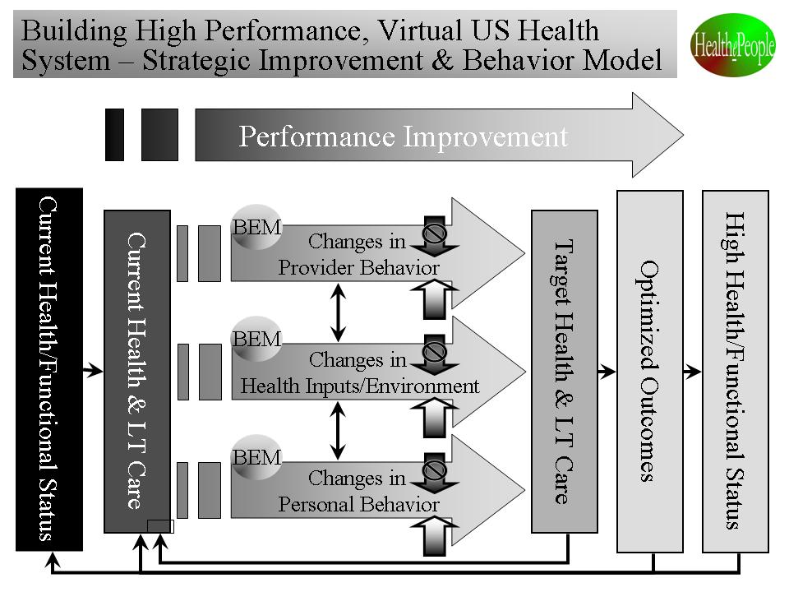
Figure 4.4. “Building High Performance, Virtual US Health System – Strategic Improvement and Behavior Model”

Knowing what needs to be improved, we can then determine what personal and health provider behaviors should change. People’s behavior, both by persons (beneficiaries, enrollees, consumers, patients) and health providers, is key to making and sustaining the improvements. The behavioral model helps us think through how we bring about the behavior change necessary to make the improvements.

Under the HealthePeople vision and overall strategy and supportive strategies and models, we can positively transform the overall American health system and achieve a healthier America requires by successfully applying the 15 supportive strategies:
- Create a supportive environment for high performance, quality, affordability, accessibility
- Support strong person-centered health with high personal choice, self care and a strong partnership between the person and their health professional/provider to improve resource use and health outcomes
- Support strongly and collaboratively applying “public health” model
- Support all needed care reasonably accessible financially
- Support the most vulnerable persons being provided all needed health and long term care (LTC) support
- Support strong core health benefits
- Support strong core LTC benefits
- Support strong person-centered care coordination/management
- Support effectively using prevention to avoid illness and disability and associated cost
- Help ensure long term affordability
- Support pay for effective care & effective resource use
- Support aligned high performance measures for all/across care settings
- Support strong quality/performance improvement for all/across care settings
- Support all care settings being reasonably accessible physically
- Support strong virtual health (info) system with EHRs, PHS/Rs, standards & interoperability/exchange

Figure 4.5 lays out from right to left how a) high health and functional status is produced by b) optimizing health outcomes which are produced by c) an affordable, accessible, “e” enabled and high quality health system which is produced and enhanced by d) a supportive health environment and high personal and health care performance which is produced by e) the successful application of 15 strategies. (See Figure 4.5.)

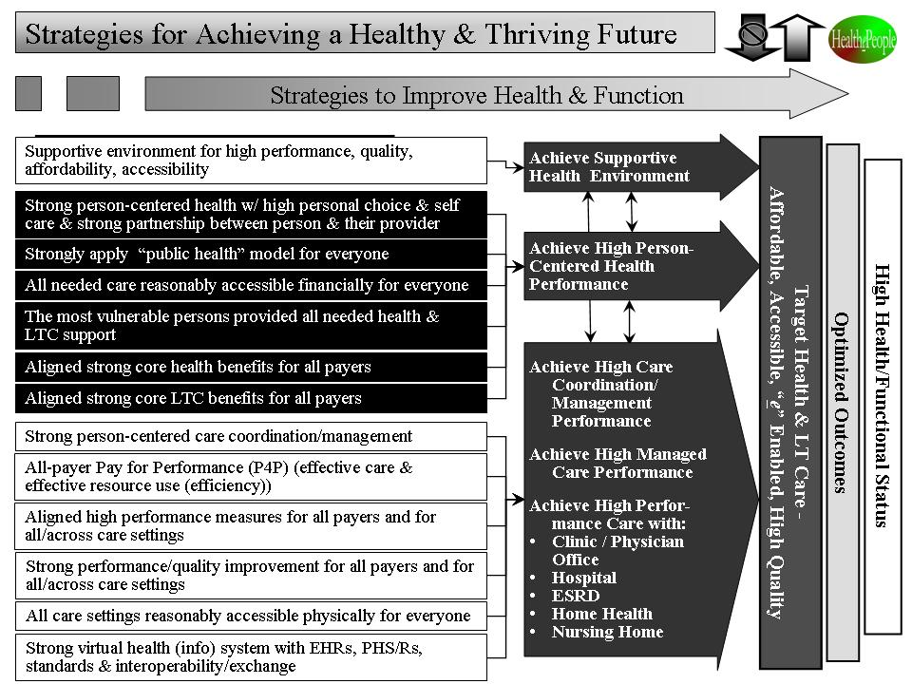
Figure 4.5. “Strategies for Achieving a Healthy & Thriving Future”

While all 15 supportive strategies are essential, there are several strategies that have unique potential and deserve greater attention:
- Person-Centered Health - the person a) is at the center of self care, formal health care and informal health support and b) has that health care/support coordinated via an effective person/clinician partnership.
- High Performance Health Systems - the best systems design and operational thinking is applied to and across the full range of health care settings from individual clinics to hospitals to integrated health systems.
- Care in the Community – care coordination and eHealth are utilized as means to better support people’s health outside (“in the community”) and within health facilities in real time at any time and anywhere.
- Quality/Health Improvement - we build upon IOM work on quality, better use evidence-based care, and develop and use behavioral models for person and clinician behavior to improve health care quality and health outcomes and status. One key driver is “right care for every person every time.” Another key driver to more effectively use prevention and early intervention to avoid illness and disability.
- Un- and Underinsured - we build upon IOM work on uninsured and develop and execute strategies that solve the un- and under-insured problem in way supportable by key leaders and American public. This includes and goes beyond recent health reform.
- Virtual Health Systems - we develop and use “virtual health system(s)” of electronic health records (EHR), personal health systems/records (PHS/R), information exchange (IE) and standards. Though “virtual health systems” are only part of the answer, creating an American health system requires the enabling “e”.

HealthePeople - Building a Healthy and Thriving Future Vision and Strategy

As a nation, we should proceed with the belief that America can reach this vision via an endgame strategy of a high performance, American health and long term care system for all Americans that is self-perpetuating, affordable, accessible, “e” enabled, and producing high health quality, outcomes and status. Such an American system, partly physical and partly virtual and put into place by collaborative private and public partnerships, will greatly improve accessibility, quality and affordability for all Americans. Utilizing HealthePeople - Building a Healthy and Thriving Future as an organizing strategy, we can build a substantially healthier America and move toward a truly healthy America and better address health needs and status in other parts of the world.



Chapter 5
Vulnerable - Vulnerable in America and World (via) – Reducing Vulnerability and Maximizing Thriving Via Thrive! Strategy and viaFuture Supportive Strategy

Vulnerable - Vulnerable in America and World (via) focuses on vulnerable people and what are the most effective approaches for minimizing vulnerability and maximizing thriving. The approach is applicable to the American people as a whole, subpopulations within America, and people in other nations. They are vulnerable due to many causes. Their vulnerabilities range widely

. Many persons have multiple vulnerabilities. Many people fail to survive and many more fail to thrive. If we are to minimize vulnerability worldwide, the global community needs to stop actions that push people down to more vulnerable states and support actions that lift people out of vulnerability.

This change effort, Vulnerable, uses the combination of viaFuture and the via strategy core set to develop a model of vulnerability and the interventions that positively and negatively impact vulnerability and thriving. It developed vulnerability status indicators (vStatus) and a framework for setting the desired target vulnerability/thriving status for nations and worldwide. It determined a model for strategizing on how best to stop negative interventions and support positive interventions. It argues that the best strategy should be self-perpetuating. Such a strategy, as it is implemented, should be assessed for progress against the target vStatus (vulnerability/thriving status) and for success of the strategy and its supportive interventions.

What has been learned to date suggests that we should move forward on an overarching strategy that appears likely to help minimize vulnerability and maximize thriving on a sustained basis. via is a strategy where we analyze a) who are the most vulnerable people and why, b) what forces are increasing/reducing vulnerability, and c) what strategy would minimize vulnerability and maximize thriving on a sustained basis. We then proceed to execute best strategy as an ongoing effort with ongoing evaluation and adjustments.

Background

In the world today, there are billions of vulnerable people. They are vulnerable due to many causes (poverty, un- or underinsured; poor education, un- or underemployment, poor housing, poor environment, etc.) Their vulnerabilities range widely, e.g., low physical or cognitive ability, low motivation, low performance, diminished quality of life, high developmental risks for children, high risk for adverse events, low life expectancy for newborns & children, low adult life expectancy)

. Many have multiple vulnerabilities. Many fail to survive and many more fail to thrive.

Vulnerability is often a non-geographic issue in that it may only substantially affect part of a geographic area’s population. It may be non-geographic in that it crosses geographic borders. For example, vulnerability is clearly an issue that crosses national borders and affects people globally. It is a cross-cutting issue that is often a result of problems in multiple areas such as health, education, food, jobs, housing, financial, environment.

While we have many people who are vulnerable today, many more people are at risk of vulnerability in the years ahead. Further, many people are affected negatively by family and friends who have these vulnerabilities.

To rectify this, we need to minimize vulnerability by stopping actions that push people down to more vulnerable states and supporting actions that lift people out of vulnerability.

Moving from Being Vulnerable to Thriving

Vulnerability as an issue spans the breadth and depth of all communities. To substantially reduce vulnerability, let alone truly minimize vulnerability, we need to understand who is vulnerable, what are their vulnerabilities, what made/makes them vulnerable, how to reduce vulnerability (specific interventions within an overall self-perpetuating strategy or strategies), and how to evaluate/assess the impact of such strategies and interventions

What does it mean to be vulnerable? According to the Cambridge dictionary, vulnerable means that one is “able to be easily physically, emotionally, or mentally hurt, influenced or attacked”. While helpful, it doesn’t easily support a model for minimizing vulnerability. For this via effort, the operational definition being used is “lack of and/or substantial risk of losing ability and/or motivation to a) survive (sustain life and essential functions) and b) thrive (achieve and sustain high human function/performance).”

To lay the groundwork for minimizing vulnerability, a developmental framework helps identify the most vulnerable people and helps develop and execute the most effective strategy and interventions for minimizing vulnerability and maximizing thriving. [See Table 5.1]

Table 5.1. Developing a Strategy for Minimizing Vulnerability

This effort focused on vulnerable person(s) and what are the most effective, sustained approaches for minimizing vulnerability. The framework is as follows:

- Identify the most vulnerable person(s) and their vStatus (vulnerability status).
- Analyze the positive/negative interventions (e.g., little or no income, lack insurance, lack health providers, poverty, disability and/or chronic illness) impacting vulnerability.
- Identify potential interventions for minimizing vulnerability.
- Identify and assess overall strategies (sets of interventions) for minimizing vulnerability.
- Develop a potential overall, self-perpetuating strategy for minimizing vulnerability.
- Identify an evaluation methodology for assessing impact of interventions and strategies on vStatus and implications for future interventions and strategies.

A model of vulnerability and the interventions that positively and negatively impact vulnerability has been developed. [See Figure 5.1] Vulnerability status indicators (vStatus) have been developed. The framework has also been developed for setting a desired target vulnerability status for a population or the world overall. [See Figure 5.2] For those who want to reduce vulnerability, the operational strategy focuses on stopping negative interventions and supporting positive interventions related to vulnerability. [See Table 5.2] Once such a framework and the resultant operational strategies are implemented, an assessment should be of progress toward the target vStatus and successful strategy(ies) and supportive interventions.

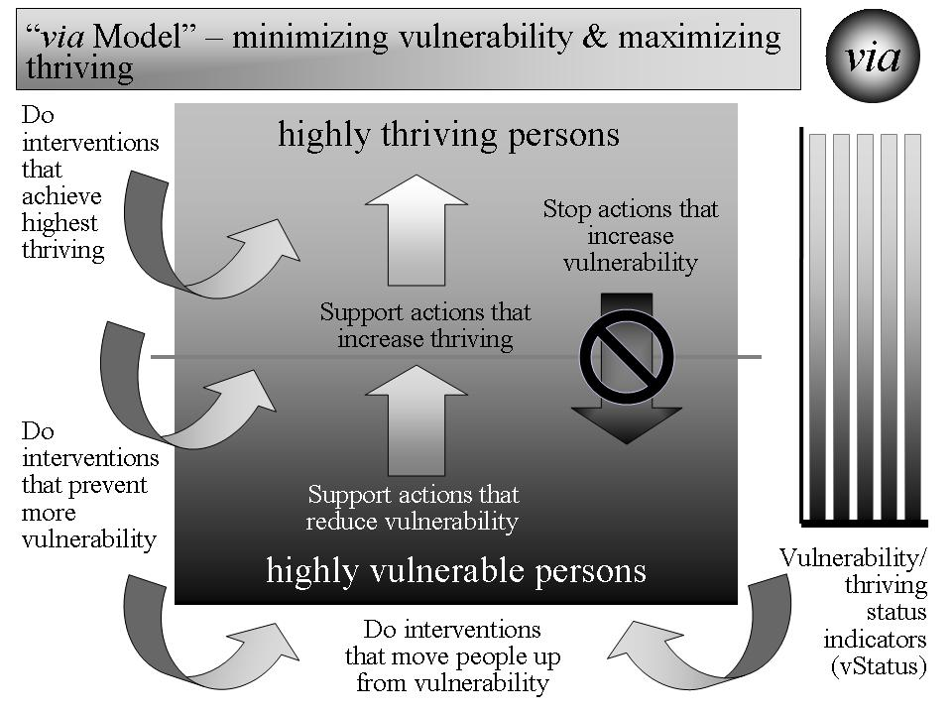
Figure 5.1. “via Model” -- Model of Vulnerability and Interventions that Positively and Negatively Impact the Minimizing of Vulnerability.

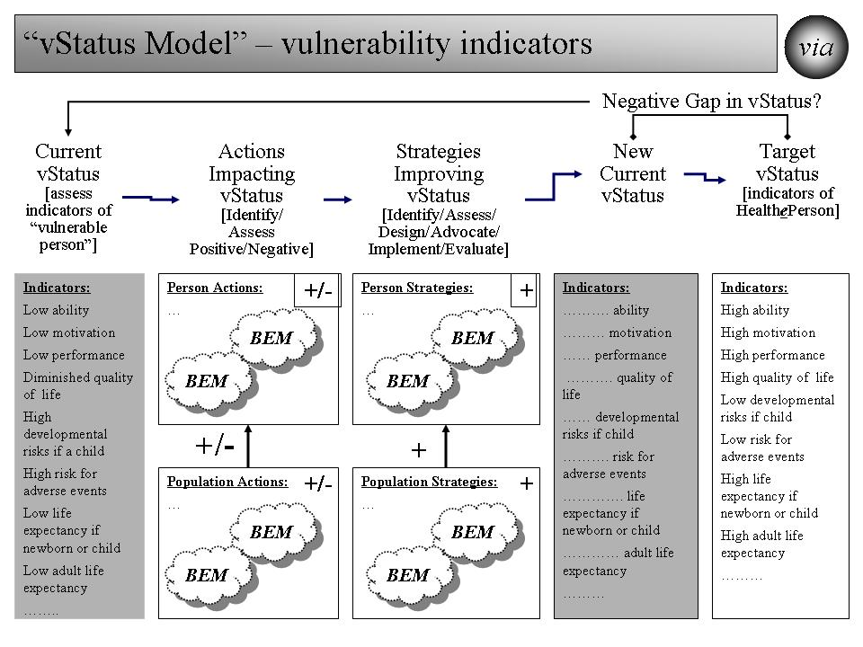
Figure 5.2. “vStatus Model” -- Model for Setting Target vStatus, Assessing current vStatus, Applying Interventions and Strategy(ies) for Reducing Vulnerability, and Moving Toward Target vStatus.

Table 5.2. Operational Strategy for Reducing Vulnerability

- Develop/track vStatus (vulnerability/thriving) indicators for individual person and for population(s); set targets and assess current status
- Oppose/stop actions that move person(s) down into vulnerability
- Support actions that move person(s) up out of vulnerability
- Develop/execute interventions that keep moving the most vulnerable person(s) (individual person, populations) up out of vulnerability
- Develop/execute interventions that keep less vulnerable person(s) and populations, especially those at the edge, from moving down into greater vulnerability
- Focus interventions/actions both on individual person and on populations
- Develop/execute ongoing strategy that ties all of the above into a coherent, sustainable program that reduces vulnerability for individual persons and for populations

As a result of this effort, a series of supportive models from viaFuture and via were used, including the following:
- via Model (reducing vulnerability)
- vStatus Model (vulnerability indicators)
- Behavioral Effectiveness Model (BEM) (personal (human) performance)
- Person Model (applying BEM over individual person’s time & life stages)
- Population Model (applying BEM over multiple persons’ time & life stages)
- System(s) Model (systems impacting vulnerability)
- Strategy Model (strategies & interventions minimizing vulnerability)

via Model. The via model in Figure 5.1 arrays overall vulnerability/thriving status from least vulnerable to most vulnerable. On the right side, a vStatus chart is depicted that represents vStatus for the global community overall or for populations or individual persons. The model recognizes that there are interventions that increase and reduce vulnerability. It lays out the overall key strategic areas – stop those interventions/actions that increase vulnerability and support those interventions/actions that reduce vulnerability. Key to long term success is to execute a strategy – a self-perpetuating “system” of actions that continuously stops actions that push people down to more vulnerable states and supports actions that lift people out of vulnerability. This “system” of actions should perpetually prevent increased vulnerability and support moving people up out of vulnerability.

As noted above, key to these strategies and to minimizing vulnerability is sustainability. In developing the strategies, both self-perpetuating and episodic approaches were considered and assessed as follows:

- Self-perpetuating approach
  - Preferred
  - Long term strategy & benefits
  - Similar to “self-sufficient, living human beings”
  - May require periodic “adjustments”
- Episodic approach
  - Less preferred than “self-perpetuating”
  - Short term strategy & benefits
  - Similar to “episodic treatment of living human being”
  - Necessary depending on “limits of human knowledge”, “uncontrollability of environment”, and “limits of human ability to create self-perpetuating systems”

Self-perpetuating approaches, to the extent they are feasible, are highly preferred but episodic approaches, to the extent they have positive impact, will be needed as well.

The via model is intended to help produce a self-perpetuating strategy for attacking vulnerability. While there will likely always be differences in levels of vulnerability for subpopulations and individual persons, the intention is to minimize those differences and to minimize both the risk and the reality of vulnerability for whole communities.

Building on the previous discussion and the above graphical depiction [Figure 5.1] of the overall strategy, Table 5.2 lays out an operational strategy for those who want to reduce vulnerability.

vStatus Model. Figure 5.2 graphically lays out the vStatus model. The starting point is the development of the vStatus indicators and the setting of a target vStatus for the whole population (global, nation, community), subpopulations and individual persons. With that starting point, the next step is to assess current vStatus and the “delta” (negative gap) from the target vStatus. The next step is to determine/project what interventions/actions are likely to occur and how they will impact vStatus. Based on that information, a strategy is developed that is designed to stop actions that will likely increase vulnerability and to support actions that will likely reduce vulnerability. The strategy is then executed. Events (supportive and not supportive of the strategy) will occur. Any resulting change (and projected change) in vStatus is then be measured against the target vStatus. This information is then used to refine future vStatus indicators and strategy. The intent is to keep cycling through the strategy until the target vStatus is achieved and then the cycling continues perpetually as “environmental” and personal factors change and/or as the target vStatus changes.

There is an important distinction with respect to individual persons. While status indicators are generally thought of as being done for the overall population and for subpopulations (groups of people with common characteristics), they are less likely to be done for “persons” (individual persons treated as unique individuals without “grouping”). In this model, an aggregate vStatus is set for individual persons. The assessment is done at the individual person level and would be of the percent and number of persons whose status is changed toward less “vulnerable” (desirable) or toward “more vulnerable” (undesirable). Today’s computers and databases, subject to appropriate privacy protection, give us greater ability to take such an individual person approach than in the past.

Behavioral Effectiveness Model (BEM). Because this is primarily about personal ability, motivation and behavior, behavioral models are being used. As indicated earlier, the Behavioral Effectiveness Model (BEM) is an example of such a behavioral model. [See Figure 5.3.] The model can be useful for many different interventions, including preventing and reducing vulnerability and increasing thriving.

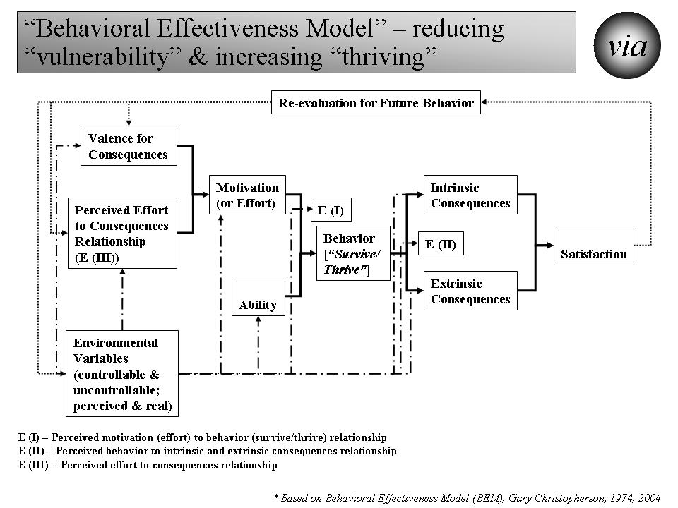

Figure 5.3. “Behavioral Effectiveness Model (BEM)” – Personal (Human) Behavior/Performance.

As shown in Figure 5.3 and in more detail in the spreadsheet in Figure 5.4, the Behavioral Effectiveness Model (BEM) has several elements that operate as inputs to or outputs from the intervention models used and help change behavior.
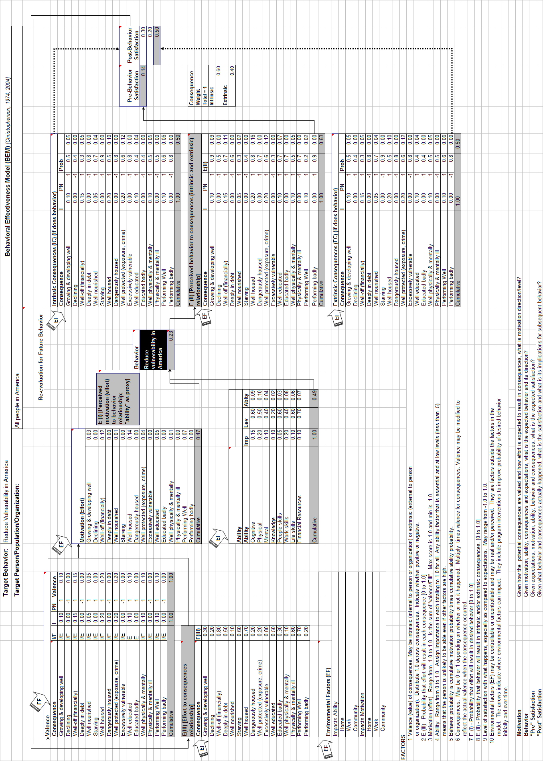

Figure 5.4. “Behavioral Effectiveness Model (BEM)” - BEM as Applied to Reducing Vulnerability in America and Beyond.
There are several outputs provided by the model that predict what will happen initially and over time, including:
- Ability -- Given the person’s own abilities and the impacting environmental factors (factors that negatively and/or positively impact a person’s ability), how able is the person to do the desired behavior?
- Motivation -- Given how the potential consequences are valued and how effort is expected to result in consequences, what is motivation direction/level?
- Behavior -- Given motivation, ability, consequences and expectations, what is the expected behavior, its likelihood, and its direction?
- "Pre" Satisfaction -- Given expectations, motivation, ability, behavior and consequences, what is the expected satisfaction?
- "Post" Satisfaction -- Given what behavior and consequences actually happened, what is the satisfaction and what is its implication for subsequent behavior?

The model can be applied and is applied here to 1) an individual, 2) populations whose characteristics are sufficiently the same, and/or 3) populations of individuals for which each individual gets a personalized/customized/tailored intervention.

To reduce vulnerability and/or increase thriving, BEM can help determine if a person/population is able to move from a more vulnerable state to a more thriving state and if a person/population is motivated to make that move. Sustainable motivation and ability are needed to move from vulnerability to sustained thriving. It helps us understand the likelihood that the person/population can and will make this move on their own. If that is unlikely or unsustainable, it helps us understand why not (insufficient ability and/or motivation) and what intervention can increase the likelihood. If likely, then no further external intervention may be needed. BEM also provides information that helps increase the likelihood of a sustained move to thriving. Very importantly, the person/population by itself or together with others can use this information to improve their likelihood of reducing vulnerability and maximizing thriving.

Person Model. To reduce vulnerability at the person level, it is essential to understand that each person goes through several life stages depending on how long they live. If vulnerability is to be reduced, it is seldom a one-time intervention and probably should be done across the life span. [See Figure 5.5.] Such efforts should recognize that reducing vulnerability prior to birth is very different than doing so for an adolescent or for a senior adult. Some factors, e.g. financial and cognitive ability, can carry across a person’s life and can help lower or increase vulnerability throughout a person’s time. Some factors, e.g. ability reduced by Alzheimer’s disease or low birth weight, always or most likely occur at a specific life stage.

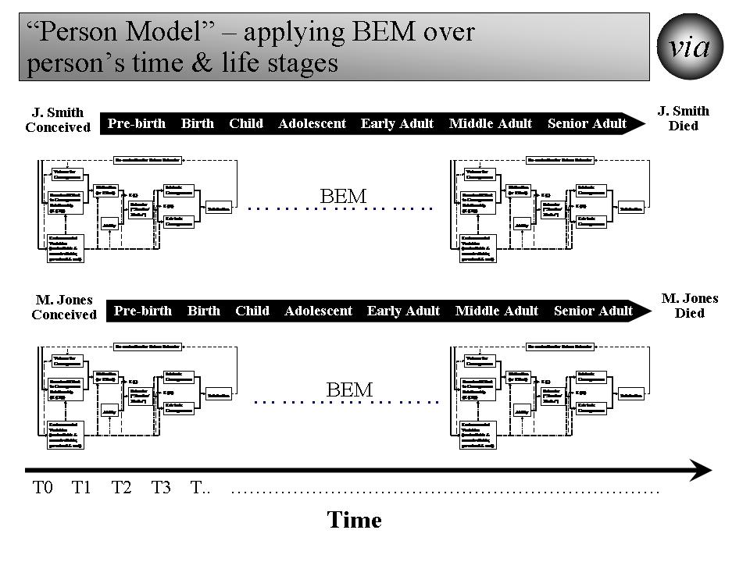
Figure 5.5. “Person Model” – Applying BEM Over Each Person’s Time and Life Stages.

The person model also recognizes that each person is different at the beginning, throughout the life stages, and near the end. For vulnerability to be reduced across the global community, the strategy needs to be both specific to each person across the life span and effective across all persons across the life span.

Population Model. The population model addresses reducing vulnerability from the perspective of what is being done at any point in time and how it might affect a diverse population. [See Figure 5.6.] Taking a time slice, the model recognizes that at any moment in time, the population at risk of being vulnerable will likely include persons from all different stages of life (pre-birth, birth, child, adolescent, early adult, middle adult and senior adult). At that moment in time, each person has different levels of vulnerability, different vulnerabilities, different factors affecting vulnerability and different responses to efforts at reducing vulnerability. This can be seen in how major disasters (e.g., tsunamis, earthquakes, disease outbreaks, crop failures, drought) affect different people differently. This can be seen in how program interventions (e.g. education, housing programs, financial assistance, health insurance programs, heating assistance, taxes) affect different people differently.

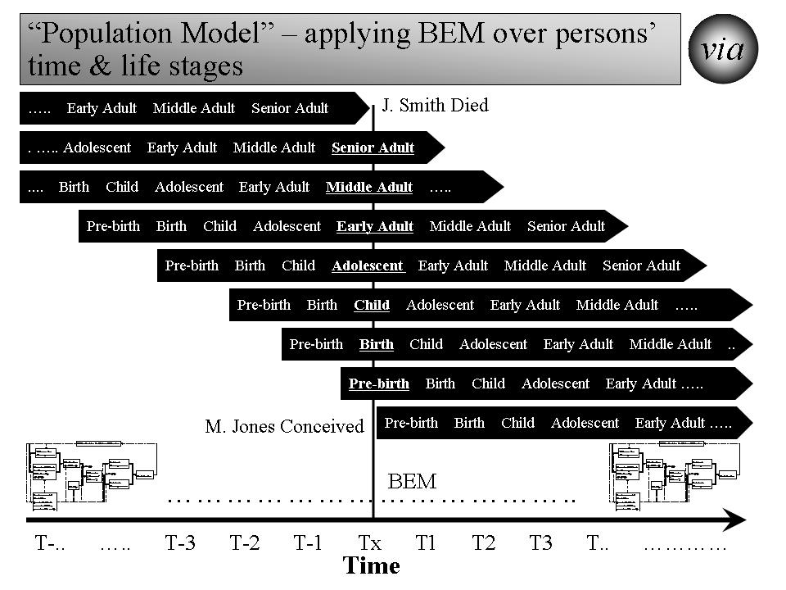

Figure 5.6. “Population Model” – Applying BEM at a Point in Time Across Persons and Their Life Stages.

Efforts to reduce vulnerability (using BEM and other models) need to understand the population model and develop strategies that work within the model. For example, applying new policies on financial assistance and/or taxes over the next twelve months will have very different effects across the population of persons. If the intent is to reduce financial vulnerability across the world’s population, then the new policy should be modeled, at a minimum, against each subpopulation and, preferably, against each “person”. The more desirable policies reduce vulnerability most for the most vulnerable and reduce vulnerability substantially for all persons. The most desirable policies do this and continue the positive effect as the population moves through time (i.e., sustained, reduced vulnerability for all people).

Systems Model. For efforts to be successful and sustainable, the strategy and its execution need to be systemic and need to effectively impact a system (the world or a nation as a whole) of systems (e.g., health, education, employment/income, housing). We need to move from the system of today where vulnerability is pervasive and substantial to a system of tomorrow where vulnerability is minimized and thriving is maximized. [See Figure 5.7.]

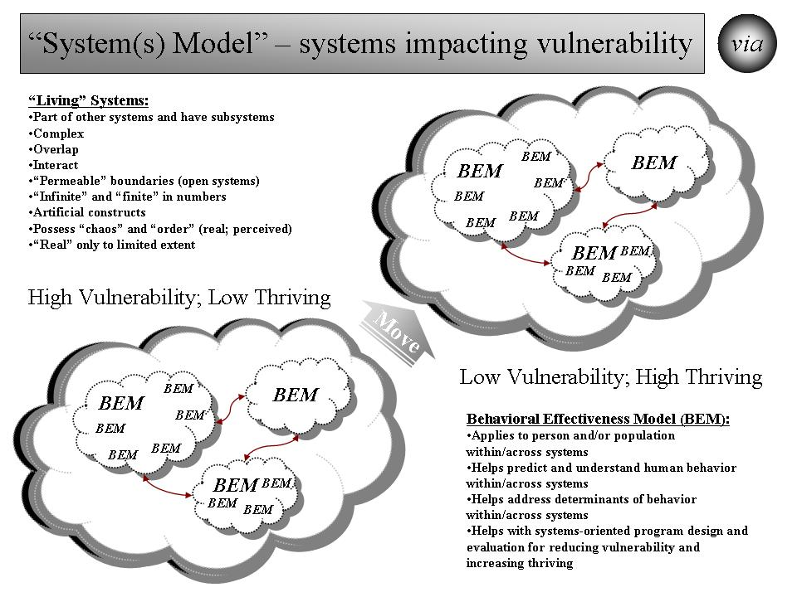

Figure 5.7. “Systems Model” -- Systems Impacting Vulnerability.

In a systems model, there is recognition that systems at this level are “living” systems that change internally, impact other systems, and are impacted by other systems. Systems are part of other systems and they have subsystems themselves. They are usually complex. They often overlap with other systems. They interact with other systems, sometimes fairly predictably and sometimes not. They often have permeable borders that are not always understood or constant. They may be nearly infinite in numbers. Often we apply an artificial construct to them to help us understand and work with them. They may be or appear to be “chaotic” or “ordered”. They may be or appear to be “real”. Also, we need to understand the impact that existing and future systems will have on each person’s vulnerability. We need to understand the impact of systems that we create, change or delete will have on other systems and, ultimately, on each person’s vulnerability/thriving.

All this needs to be kept in mind if we are to take a systemic approach to vulnerability/thriving. It especially needs to be kept in mind if we are not to take a systemic approach and are expecting specific effects on vulnerability.

Within the “human” systems are individual persons and populations of persons and organizations (made up of persons) whose behaviors collectively determine much of the system’s behavior. In the Behavioral Effectiveness Model (BEM), there is an effort to understand the behaviors and their determinants (ability, motivation, environmental factors) on an individual level and on a population of individuals level. In the systems model used here, there is recognition that moving from vulnerability to thriving requires moving individual behavior on what is often a massive scale. This movement includes the persons we want to move to less vulnerability and greater thriving, and the persons that help or hinder that movement.

Strategy Model. Building upon the above groundwork, the next step is to bring this all together to develop and execute sustainable, effective strategies for minimizing vulnerability and maximizing thriving for all people. [See Figure 5.8.] The strategy model begins with the end goal – maximizing thriving with minimal risk of becoming vulnerable. [Person’s vStatus equals “Thriving”] As defined earlier, by thriving, we mean for persons “to grow vigorously, to gain in wealth or possessions, to progress toward or realize a goal” and “to grow, develop, or be successful.” Indicators of thriving include the following:
- Performing well (life, work)
- Well-off (financially)
- Well fed
- Well housed
- Well protected (exposures, crime, etc.)
- Well educated
- Physically and mentally well (health)
  - Good physical health
  - Good mental health
  - Good ability
  - Low developmental risks
  - Low risk for adverse events
  - High life expectancy

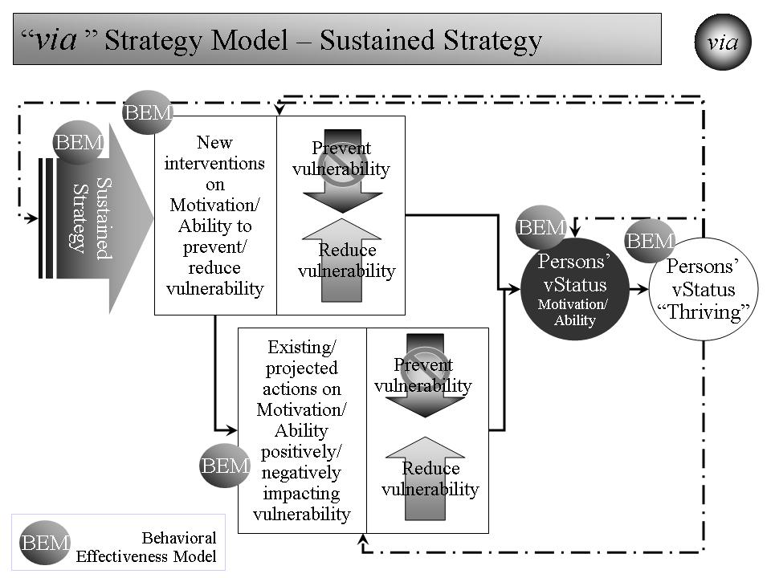

Figure 5.8. “Strategy Model” – Minimizing Vulnerability and Maximizing Thriving.

Since many, many people are not thriving today and will not be thriving in the projected future, the question is how to move from current vStatus of substantial vulnerability to the target vStatus of minimized vulnerability and maximized thriving.

For people to thrive, or even to survive, they have to have both the ability and motivation to do so. That ability and motivation is partly controlled by the person and is partly impacted by “environmental factors” (factors external to the person). The extent to which ability and motivation are problematic is the extent to which vulnerability exists. [Persons’ vStatus (Motivation/Ability)] Indicators of vStatus (vulnerability status) include:
- Personal
  - Ability to survive/thrive
    - Cognitive
    - Physical
    - Mental
    - Work skills
    - Life skills
    - Financial Resources
  - Motivation to survive/thrive
    - Generally
    - Work-related
- Environmental
  - Impacts ability (home, work, community) to survive/thrive
  - Impacts motivation (home, work, community) to survive/thrive

To reduce vulnerability is to increase persons’ ability and motivation to thrive. Each person is different in this respect. Strategies need to account for this difference.

We need to analyze how already existing and projected actions impact today’s and future ability and motivation positively and negatively. They, in turn, impact vulnerability and thriving. This gives us an indication of current vStatus and of future vStatus if we take no further action. The extent to which this is unsatisfactory, measured by the delta between current/projected vStatus and target vStatus, is the extent to which new intervention strategies are needed.

We need to analyze to what extent existing and projected actions will push people down into vulnerability (negative) or stop them from being pushed down (positive). We need to analyze to what extent existing and projected actions will push people up out of vulnerability (positive) or stop them from being pushed up and out (negative).

Assuming that analysis indicates that existing and projected actions, without any new interventions, will not minimize vulnerability and maximize thriving, the next step is new strategy development. [The “new interventions” box in the upper left corner of the strategy model.] Within the overall strategy are likely to be two sets of strategies. One set will use new interventions to change existing/projected actions (e.g. existing programs for housing, education, financial assistance, taxes) and reduce vulnerability. One set will use new interventions (e.g. new programs to cover the un-/underinsured, add housing, educate/train people, reduce health risks) to reduce vulnerability. If successfully designed and executed, the new interventions’ intended, combined and sustained effect should minimize vulnerability and maximize thriving.

Throughout the strategy model, there is the presence and use of the Behavioral Effectiveness Model (BEM). It helps us in many ways to:
- Understand the differences among persons and how to positively deal with them (one-by-one and/or in groups) in our efforts.
- Understand thriving and its determinants
- Understand vulnerability and its determinants
- Understand what impacts vulnerability and thriving and how
- Develop vStatus indicators as measures of vulnerability and of progress toward minimizing vulnerability and maximizing thriving
- Understand how already existing and projected actions increase or reduce vulnerability
- Develop and execute new interventions that positively impact existing and projected actions and reduce vulnerability
- Develop and execute new interventions that reduce vulnerability
- Develop and execute an effective overall strategy - a full complement of new, positive interventions to minimize vulnerability and maximize thriving on a sustained basis.
- Understand and address unanticipated changes that impact the overall strategy, vulnerability and thriving.

Lessons Learned, To Date.

If we want to minimize vulnerability, the above strategies and tools should be helpful. What has been learned in using the combination of viaFuture and the via strategy core set suggests that we should move forward on an overarching strategy that is likely to help minimize vulnerability and maximize thriving on a sustained basis. The combination of viaFuture and the via strategy core set can be used where we further analyze 1) the most vulnerable persons and why, 2) what forces are increasing/reducing vulnerability, and 3) what strategy would minimize vulnerability on a sustained basis. Then we proceed then to execute best strategy as an ongoing effort with ongoing evaluation and adjustment.

Path Ahead.

The path ahead offers many opportunities, as outlined above, to tackle both the overarching issue of vulnerability and specific interventions targeted at minimizing vulnerability and maximizing thriving.

There is an opportunity to tackle the overall issue of vulnerability worldwide and work on a strategy that moves beyond the limitations of “stovepipe” programs focused either on specific subpopulations or specific programmatic interventions. With the combination of viaFuture and the via strategy core set, we can bring about Vulnerable In America and World, an overarching model and an overarching strategy a) into which specific interventions can play a constructive role, b) for assessing the benefit (real or projected) such interventions have on reducing overall vulnerability and maximizing overall thriving worldwide, and, most importantly, c) for perpetually preventing/minimizing vulnerability and maximizing thriving for all persons and communities, at every level, including national and global.

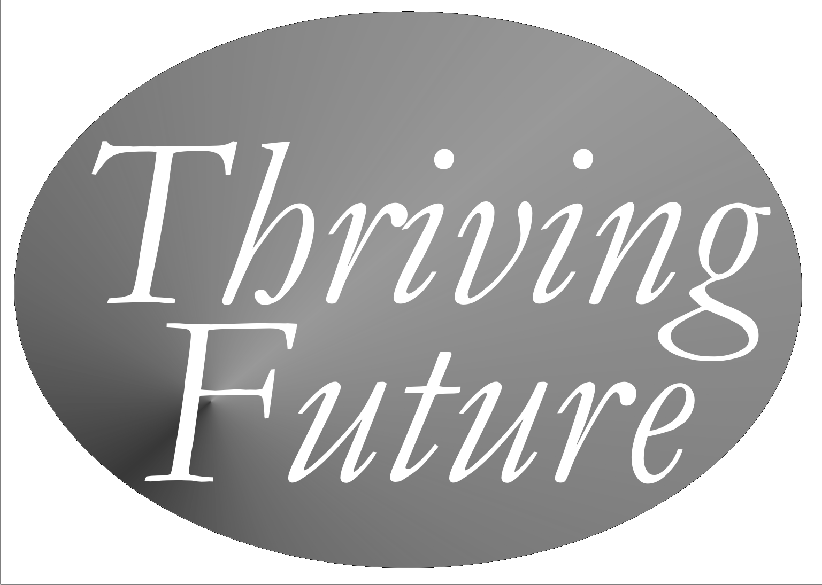

Chapter 6
Thriving Communities – Building and Sustaining Thriving Communities
via Thrive! Strategy and viaFuture Supportive Strategy

As described in previous chapters, “next generation” viaFuture strategies, models and tools are available along with examples of how they have and can be used. We are now able to turn our attention toward building a better, preferably thriving future for whole communities, including geographic communities (local, state, national, regional, global) of any size and at any level. Thrive! and viaFuture together can help us take that step and achieve that vision.

As with any major change effort, success is dependent on positive leadership from the community’s leaders and its people. How that leadership comes about is the subject of some debate. Some people argue for a leader driven approach where the leader creates the vision and motivation and the people join and/or follow. Some people argue for bottom-up or self-organizing approaches where the people lead and the traditional leaders may or may not join and/or follow. Some people argue for a collaborative approach where the traditional leaders and the people (also serving as leaders) jointly provide leadership, vision, motivation, and successful execution. In general, the latter approach probably has the greater potential to create and sustain large, positive change and a thriving community.

Another key to success is the strong desire to move the community from its current vulnerable status beyond a survival status to a thriving status. Thrive! can help provide the necessary motivation. viaFuture can help provide the necessary ability via strategies, models and tools. However, the community has to step forward and take on this responsibility.

To build the thriving community, we will again follow the steps laid out in the Overall “via” Strategy Model that we have used for the health issue and the cross-cutting, non-geographic vulnerable persons/populations. This will produce strategy and supportive operations for building and sustaining a better, preferably thriving, future for the whole community. [See Figure 6.1.]

This is not an all or nothing approach. In the past, the approach has been used both in parts and comprehensively. The likelihood of success should increase as more of the approach is used.

Before starting, we must identify and be clear on what is the community for which we are building a thriving future. This could be a neighborhood, a village, town or city, a county, a state, a nation, a region or the whole world.

Figure 6.1. Overall via Strategy Model.

Step One: Assess Community’s Current and Projected Status.

Our first step is to understand and assess the current and projected status of the whole community.

The community is a “system” and is treated as such. We use the Systems Model (including the “Ideal Systems” model) to understand the community as a system. [See Figure 6.2.] This helps us understand the elements and subsystems making up the community and how they “behave” (that is, how they interact and affect each other). This also helps us understand what is outside the community and how the outside world affects the community’s future. We can better understand the potential impact as people, time and places (physical environment) change. With this improved understanding, we are better prepared to build a thriving future with a more complete understanding of the whole community (system), the world outside the community, and how the community “behaves” currently and for the projected future.

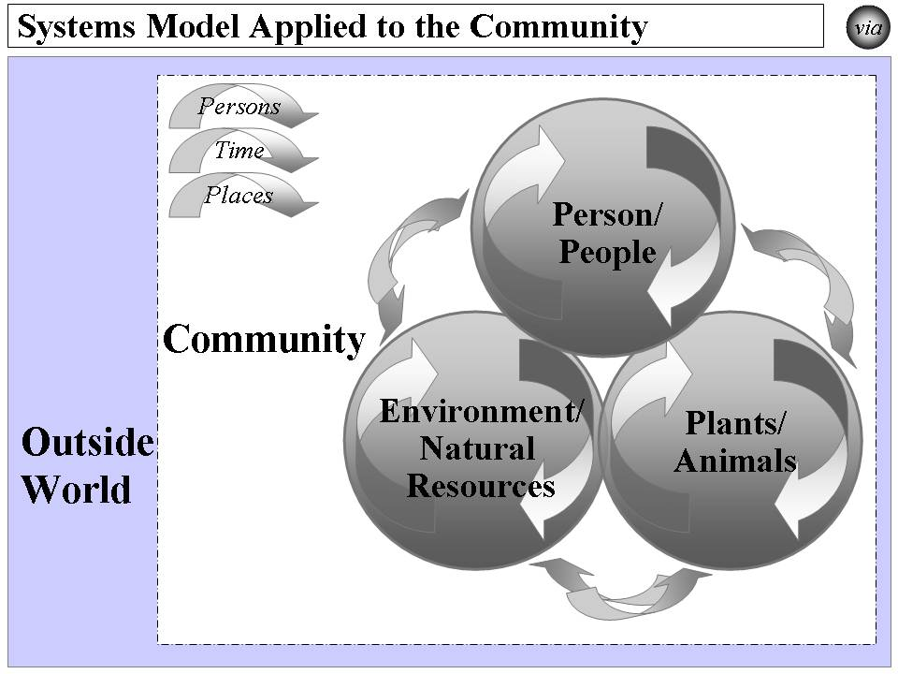

Figure 6.2. Systems Model Applied to the Community.

At a later step, the “Ideal Systems” model will be used to develop a vision of the ideal state of the community - a sustained thriving community. [See Figure 6.4.] With that vision, we can then develop 1) the recommended “thriving community” we want to create now and b) the glide path to the thriving community we ultimately want to create and sustain. In this step, we need to understand how the current community falls short of what we initially think the community should become.

To identify current and projected status of a community’s key elements, we use the Status Model as follows:
- Identify all of the status indicators.
- To the extent needed, identify more detailed measures for each indicator.
- Assess the “Current Status”, i.e., the current level of indicators for the target population.

The community’s status will be a composite measure consisting of the status of its people, plants and animals, natural resources, environment, and government (a potential enabler or inhibitor). The status measures (and their desired “thriving” state) include:
- People:
  - Performing well
  - Well-off (financially)
  - Well nourished
  - Well housed
  - Well protected (exposures, crime)
  - Well educated
  - Physically/mentally well
  - Growing/developing well
  - Sustaining
- Plants/Animals:
  - Performing well
  - Well nourished
  - Good habitat
  - Well-protected
  - Physically well
  - Growing/developing well
  - Sustaining
- Natural Resources & Environment:
  - Performing well
  - Well-protected
  - Stable, positive climate
  - Physically well
  - Sustaining
- Government:
  - Performing well
  - Stable and positive
  - Sustaining

Using these and other appropriate status measures, we assess the current status of the community. That assessment includes how the community is doing overall as measured against comparable communities and against our vision for a thriving community. It includes how the more vulnerable parts of the community are doing. It includes how the more thriving parts of the community are doing. It includes how the rest of the community is doing. This provides us with a baseline to measure our progress toward the thriving community we want to create and sustain.

We use the “via” Model to analyze the positive/negative actions currently impacting or projected to impact the community and its status measures. These include:
- Actions that lower status.
- Actions that increase status for that portion above the mean or median.
- Actions that increase status for that portion below the mean or median.
We measure the effect that the current and projected actions will have on the status indicators. This tells us what is likely to happen without a new strategy and provides us with the information to build a new strategy for a thriving community.

To identify how the community’s individual people are likely to behave without our new effort, we use the Person Model to the extent feasible. This is important because the community consists of very different people behaving in very different ways over time. We get closer to identifying and understanding individual person behavior to the extent we successfully:
- Identify the persons whose behavior is targeted.
- Determine the time frame or life stage(s) to be addressed. The preferred time frame is a person’s whole life.
- Apply the Behavioral Effectiveness Model (BEM) across time and across persons and their life stages taking into account their differing motivation, ability, behavior, and environmental variables.
- Determine the likely behavior(s) over time and through life stages.

The power to make large, positive, and timely change is greatest when we can apply our efforts to individual persons and when individual persons want to help make that positive change.

Similar to the Person Model, we use the Population Model to identify what the community’s whole population or subpopulations are likely to do. This step plays an especially important role when we lack information at the individual person level and/or when an intervention can’t be customized at the individual person level. We get closer to identifying and understanding population behavior to the extent we successfully:
- Identify the population whose behavior is targeted.
- Decide what the point(s) are in time and life stage(s) to be addressed.
- Apply the BEM model across time and across populations and their life stages taking into account their differing motivation, ability and environmental variables.
- Determine the likely behavior(s) over time and through life stages.

To help assess the community’s current and projected behaviors for the above person and populations models, we use the Behavioral Effectiveness Model (BEM) as follows:
- Identify the people whose behavior is targeted.
- Decide what the key behaviors are. Note that some behavior is one-time and some is recurring.
- Assess motivation in terms of its current and future characteristics.
- Assess ability in terms of its current and future characteristics.
- Assess environmental variables, both controllable and uncontrollable and both perceived and real.
- Assess how motivation, ability and environmental variables are likely to affect future behavior without further intervention.
- Assess what are likely to be the intrinsic (internal to the person or population) and extrinsic (external to the person or population) consequences of projected behavior and what is likely to be the person or population’s satisfaction.
- Assess how consequences and satisfaction are likely to affect future behavior
- Assess how projected behavior, without further intervention, matches to desired behavior.

Step Two: Design Strategy for Community’s Thriving Future.

Our second step is to design our strategy for achieving the community’s thriving future.

We use the Systems Model (incl. “Ideal Systems”) again, but this time to identify the desired future community as follows:
- Identify the desired status and characteristics for the future community (system) using the Ideal Systems Model.
- Identify the key behaviors in the community currently and what they need to be in the future.
- Determine what changes need to be made to move a community to the desired future.
- Assess what interventions will best make those changes and move a community to the desired future.
- Apply the interventions and assess their effect on behavior change and on status.
- Adjust the interventions as needed over time and based on result.
- Feed the interventions into the Overall Strategy and Supporting Strategies.

The systems model graphic below is updated to reflect the characteristics of the thriving community we want to create and sustain. [See Figure 6.3.]

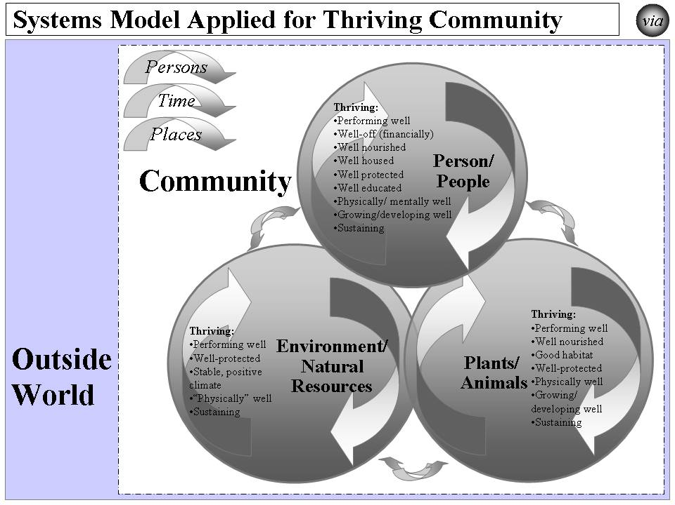

Figure 6.3. Systems Model Applied for Thriving Community.

The “Ideal Systems” model will be used to create a vision of the ideal state of the community - a sustained thriving community. [See Figure 6.4.] With that vision, we will design the recommended “thriving community” we want to create for the near future. We will also design the glide path to the thriving community we ultimately want to create and sustain.

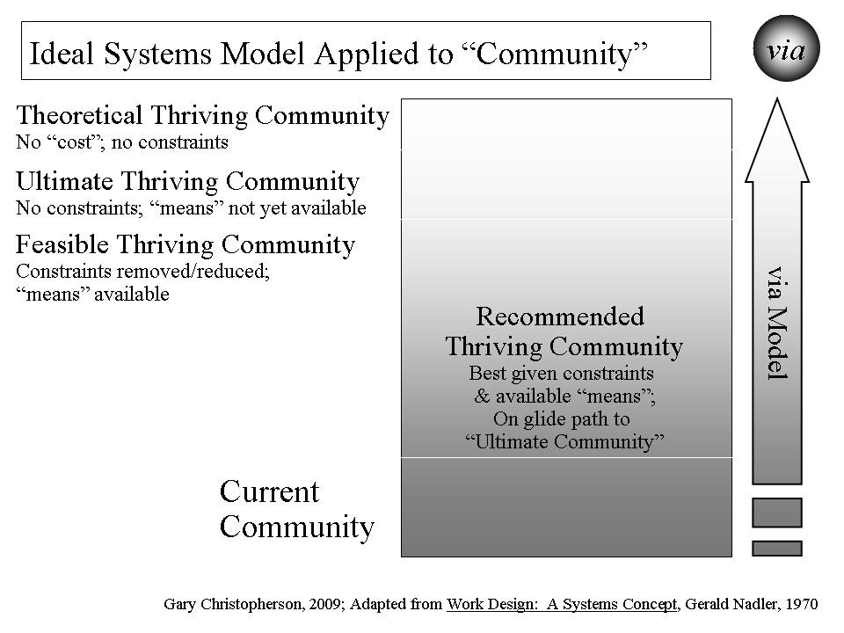
Figure 6.4. Ideal Systems Model Applied to “Community”.

We use the Status Model again, but this time to identify the community’s desired status as follows:
- Decide how high, in general, is the desired status. Is it optimal? If not, how close can we get to optimal?
- Identify all of the indicators that, as a set, indicate the desired high status. These are the “Target Status” set of indicators.
- Decide what each indicator’s level should be to match the desired high status.
- Decide what each indicator’s level is to describe low status.
- Assess the “Negative Gap” between the current status and the desired target status. This is the gap to be closed with the overall strategy.
- Execute the status model effectively and measure progress.
- Assess the effectiveness of the status indicators.
- Revise status indicators, individually and as a set, as needed to be effective.

We use the Performance Improvement Model again, but this time to identify changes needed to progress from the community’s current status to its desired status as follows: [See Figure 6.5.]
- Based on an understanding of the community, assess its current status or performance level.
- Determine what should be the desired level of status or performance.
- Assess what is the delta (difference) between those two levels.
- Determine what outcomes need to be produced in order to achieve the desired level of status or performance.
- Determine what people’s current behaviors are.
- Determine what people’s target behaviors should be.
- Assess what is the delta between those two sets of behavior and what behavior changes are desired.
- Determine what inputs/environmental changes and people behavior are outside the community (“Outside World”) and already occurring or projected. The focus is on those that will affect future peoples’ behaviors.
- “Inputs/Environment” changes are non-people factors such as climate change, natural resource change, and plant and animal change within the community.
- Determine the set of strategies and interventions needed to change people behaviors by using other models, including the Behavioral Effectiveness Model (BEM), the via model, and the Person and Population models. These strategies and interventions may be applied to any or all of the outside input/environment and people behavior already occurring or projected to occur. Some are designed to stop or minimize negative actions from happening and minimize their negative impact. Some are designed to make positive actions happen and maximize their positive impact.
- Feed the strategies and interventions into the Overall Strategy and Supporting Strategies.
- Measure the effect that the new strategies and interventions are having on positively changing people’s behavior, the outcomes and the status.
- Determine how changes in status, outcomes and behavior create a new level of “current” status, outcomes and behavior and rerun the Performance Improvement Model on an ongoing basis.

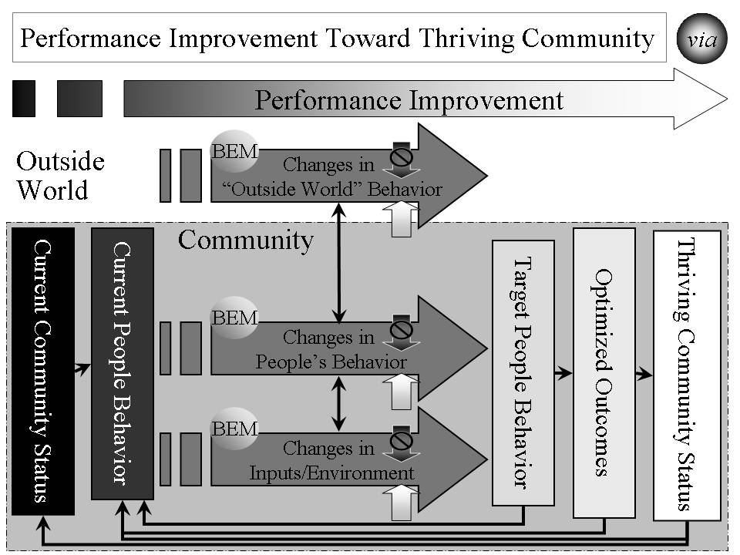

Figure 6.5. Performance Improvement Toward Thriving Community

We use the “via” Model again, but this time to identify potential interventions for the community as follows:
- Identify new interventions that positively affect status in one of the following ways:
  - Interventions that help achieve highest status, including supporting actions that further increase high or highest status.
  - Interventions that help prevent lowering of status, including stopping actions that lower status.
  - Interventions that help move up from low status, including supporting actions that increase status.
- Measure the effect that the new interventions have on current and projected actions and on the status indicators.
- Feed the interventions into Overall Strategy and Supporting Strategies.

We use the Person Model again, but this time to identify what the community’s individual people should do:
- Decide what is the desired behavior or behaviors over time and through life stages.
- Apply BEM model as a recurring model (running the model as many times as necessary) adjusting to changes in motivation, ability and environmental variables.
- Assess what interventions will best move projected behavior to desired behavior for the covered time and life stage(s).
- Apply the interventions and assess their effect on an ongoing basis.
- Adjust the interventions as needed over time and based on result.
- Feed the interventions into the Overall Strategy and Supporting Strategies.

Again as we did with the Person Model, we use the Population Model, but this time to identify what a community’s population or subpopulations should do:
- Decide what is the desired behavior or behaviors at different points in time across populations and their life stages.
- Apply the BEM model across time and across populations and their life stages taking into account their differing motivation, ability and environmental variables.
- Assess what interventions will best move projected behavior to desired behavior across time and across populations and their life stages.
- Apply the interventions and assess their effect on a population on an ongoing basis.
- Adjust the interventions as needed over time and based on result.
- Feed the interventions into the Overall Strategy and Supporting Strategies.

We use the BEM again, but this time to identify the community’s desired people behaviors and to develop supportive strategies to achieve those behaviors as follows:
- Assess what interventions will best move projected behavior to desired behavior for the near and long term.
- Apply the interventions and assess their effect.
- Adjust the interventions as needed over time and based on result.
- Feed the interventions into the Overall Strategy and Supporting Strategies.

Finally, we use the Strategy and Supportive Strategies Model to identify, organize, and assess supportive strategies (sets of interventions) for the community. [See Figure 6.6.] The Strategy Model is used to achieve desired status and incorporates previous work from the other models and input as follows:
- Load the desired status and the associated indicators.
- Load the optimized outcomes that will best produce high status.
- Load the target behaviors that will best produce the optimized outcomes.
- Use pathways to connect how the supportive strategies will best produce the target behavior. The pathways are customized to the relevant issue areas and/or the whole community.
- Identify the specific supportive strategies that, working through the pathways will best produce the target behaviors.
- Execute the strategy and its supportive strategies effectively.
- Assess the progress on improving status. Assess the effectiveness of the strategy and its supportive strategies.
- Revise strategy and supportive strategies as needed to be effective and sustained over time.

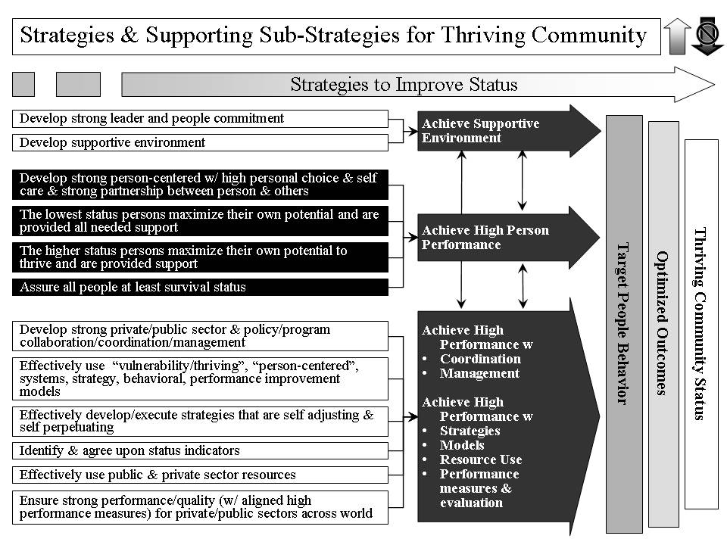

Figure 6.6. Strategies and Supporting Sub-Strategies for Thriving Community

Step Three: Develop Overall Self-perpetuating Strategy.

Our third step takes the result from applying the Strategy and Supportive Strategies Model and develops the overall, self-perpetuating strategy for creating and sustaining desired positive, large scale change across the community. This overall strategy and change effort may be entitled Building a Thriving [insert community name] for a particular community. Examples are Building a Thriving America, Building a Thriving Haiti, Building a Thriving Detroit, and Building a Thriving Louisiana. [See Figure 6.7.]

While we have the overall strategy, we must also create an operational plan that will detail all the necessary actions in terms of “who will do what, where, when, with what interdependencies, with what resources to accomplish what result with what purpose”. These specific actions, with the responsible leaders/managers identified, are then incorporated into an overall operational plan. The operational plan also details what actions interact with and/or are dependent on other actions. This operational plan will change depending on knowledge gained, changing inputs, and changing strategy. All this must be loaded into a management system that enables the management of the operational plan and provides operational feedback to leaders and managers.
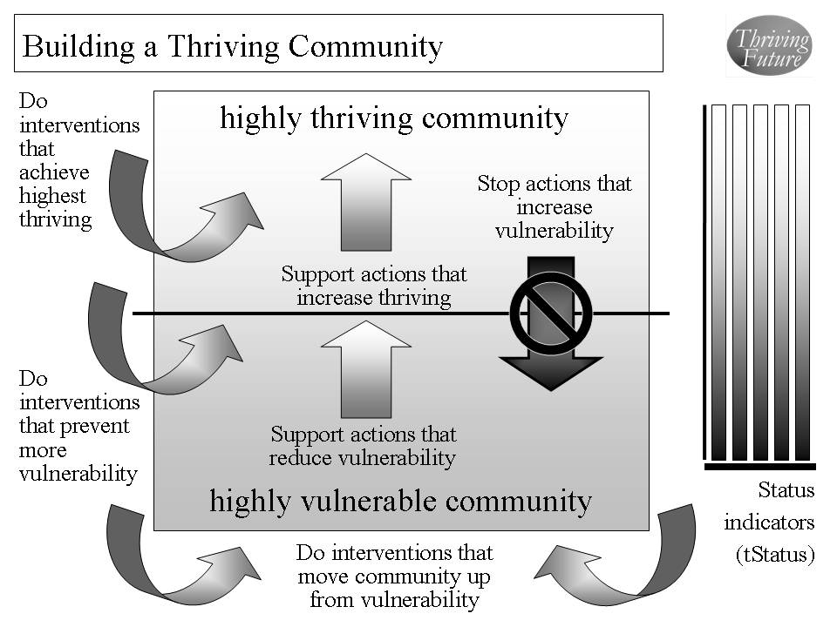

Figure 6.7. Building a Thriving Community.

Step Four: Evaluation Methodology.

Our fourth step applies an evaluation methodology to the community for assessing interventions’ and strategies’ impact on near and long term status and for implications for future interventions and strategies.

The evaluation includes to what extent the target behaviors, outcomes and status indicators are being achieved. If they are being achieved, it helps us understand why? If they are not, why not? This helps us understand how well the strategy is working and what adjustments need to be made.

Step Five: Launch and Execute Strategy.

Our fifth step launches and executes the overall strategy [for example, Building a Thriving America, Building a Thriving Haiti, Building a Thriving Detroit, Building a Thriving Louisiana] and supportive strategies to successfully build and sustain the thriving community.

Step Six: Adjust Strategy and Execution As Needed.

Our sixth and recurring step adjusts and executes our overall strategy and supportive strategies successfully to meet changing inputs, including status, outcomes, behaviors, targets, and environment that affect the community and its effort toward a thriving community.

With strong leadership by the community’s leaders and by all and each of us and with use of next generation Thrive! and viaFuture, the thriving community can be built and sustained.

Chapter 7
Thriving Future – Building and Sustaining a Thriving Future
via Thrive! Strategy and viaFuture Supportive Strategy

With the “next generation” viaFuture strategies, models and tools in hand and with examples of how they have and can be used, we are more capable of building a better, preferably thriving, future. It is now up to our leaders and us to create and sustain a better future, preferably a thriving future.

As proposed and demonstrated in previous chapters, the combination of Thrive!, viaFuture and the via strategy core set can help build a thriving future for an issue, a cross-cutting issue, a non-geographic population, or a community (local, state, national, regional, world) of any size and at any level.
- Thrive! - Motivation for action(s) that create and sustain a thriving future. ThrivingFuture.org
- viaFuture - Vision for creating and sustaining change and a thriving future coupled with the necessary enhanced ability (next generation strategy/models/tools) and the necessary strong motivation. Includes "via", the needed supportive strategies/models/tools. viaFuture.org
- HealthePeople - Building a Healthy and Thriving Future - Using viaFuture to create a strategy and change effort for an issue (or cross-cutting issue) such as building a healthy community, America and world. HealthePeople.com or BuildingaHealthyAmerica.org
- Vulnerable - Vulnerable in America and World - Using viaFuture for to create strategy and a change effort for a whole non-geographic population/community as the means to minimize vulnerability and maximize thriving. VulnerableInAmerica.org
- Building and Sustaining a Thriving Community - Using viaFuture to create a strategy and a change effort for a whole geographic community (including local, state, national, regional, global) of any size and at any level. viaFuture.org and ThrivingFuture.org

With all this available to us, we must and can create and sustain large, positive, and timely change in support of Building and Sustaining a Thriving Future across all key issues, all key cross-cutting issues, all non-geographic communities, and all geographic communities of any size and at any level. It includes individual change efforts but is much more. The Thrive! call for action includes successful action on individual issues, cross-cutting issues, non-geographic communities and geographic communities but calls for much more. viaFuture enables successful individual change efforts but can do more. The full vision is one where all individual, positive change efforts happen and are successful. But, even more important, this vision is one where all these change efforts work together to create and sustain a thriving future within and across all nations. It is a whole community effort. It is ultimately a global effort.

Thrive! will provide the motivation for the action(s) that create and sustain a thriving future and support the broader Building and Sustaining a Thriving Future. Using Chapter 1, a change effort can provide motivation as it speaks to why we must create and sustain large, positive and timely change. With the “why”, there is a call for action by our leaders, all of us together and each of us. Thrive! is that call. (Chapter 1. Website: www.ThrivingFuture.org)

viaFuture will provide the necessary vision and framework for supporting Thrive!, for creating large, positive, timely, and sustainable change, and for supporting the broader Building and Sustaining a Thriving Future. via is the core set of next generation strategies, models and tools that support change in the viaFuture framework and strategy. Using Chapter 3, a change effort can provide increased ability, i.e., how we can create and sustain large, positive and timely change. (Chapter 3. Website: www.viaFuture.org)

We will build upon past and proposed strategies and execution. Chapter 4 provides an example of a proposed health-related change effort - HealthePeople - Building a Healthy and Thriving Future - that targets a major issue and the issues that relate to it. Chapter 5 provides an example of a proposed vulnerability-related change effort - Vulnerable - Vulnerable in America and World - that targets a major subpopulation or non-geographic community and all the issues that have a substantial impact on that subpopulation or community. Chapter 6 provides an example of a proposed whole community change effort - Building and Sustaining a Thriving Community - that targets a “whole community” and all the issues that have a substantial impact on that community. Any of these examples provide guidance for any issue or cross-cutting issue, at any level, for any size population or community, and within or outside America.

As we move forward, Building and Sustaining a Thriving Future will be the launching point for future change efforts and the overall organizing strategy and bring together and use motivation (Chapter 1), the underlying philosophy (Chapter 2), ability (Chapter 3), and change effort examples (Chapters 4, 5 and 6). [See Figure 7.1.

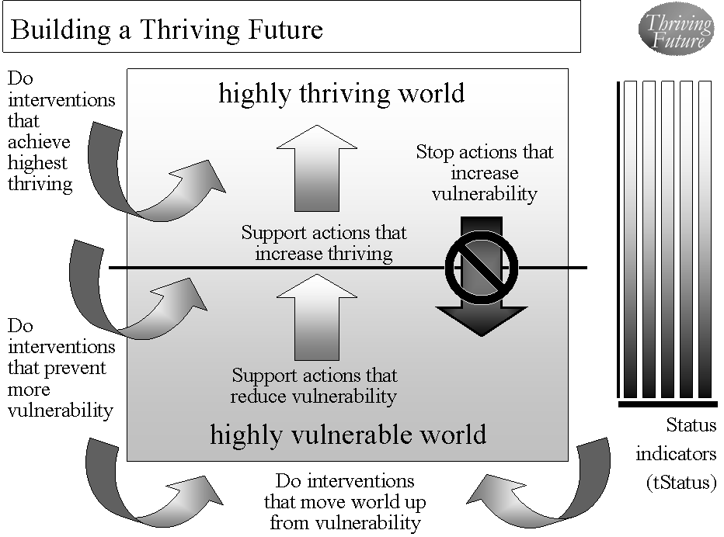

Figure 7.1. Building and Sustaining a Thriving Future.

Tipping points can be a critical element in change efforts. Throughout human history, we see moments when “tipping points” exist. We see moments when an action is taken at a tipping point and major positive or negative change occurs. We are now at such a tipping point. We are now at an historical moment when government and the private sector are broken, when our resources are becoming increasingly limited, when our environment is increasingly and negatively impacted, when our future is endangered, and when a failure to act positively dooms us to a failed, potentially non-survivable future. But, it is also a historical moment when we are the most able to change all that for the better. At this tipping point when our future is most endangered and we are most able, we must act decisively and we must not fail. We, working together, can and must create and sustain a survivable and thriving future.

Why must we act decisively, quickly and effectively? We are getting deeper and deeper into trouble. Our population is quickly exceeding our carrying capacity. Our environment is rapidly deteriorating from our impact. Our non-renewable resources are speedily being depleted by us. For many reasons, more and more people fail to survive; more and more fail to thrive. Our current ability to make large, positive and timely change using private and public mechanisms, including government, is broken. Our will to make large, positive and timely change is insufficient. Our failure to act large and positively and to create and sustain a survivable and thriving future will result in a failed future.

On the positive side, we recognize that the need is great and that successful (large, positive, timely) action can still result in a thriving future. But we must act now. We have greater ability to create and sustain large, positive, and timely change. We, working together, have greater ability to create and sustain a survivable and thriving future.

How do we do it? As we have witnessed continuing failures in politics, policymaking and program execution, we now witness the emergence of “next generation” strategies and tools to greatly improve our ability to make large, positive and timely change. This especially true in the changing context of politics, policymaking, strategy, and program execution and evaluation. As discussed earlier, one such approach is the combination of Thrive! and viaFuture. It builds on and incorporates the lessons of the past. It builds on a better understanding of people’s behavior, of non-geographic populations, of communities (local, state, national, regional, global), of how human and environmental systems function and of how to create and sustain large, positive, and timely change. Just in time, we now have the ability to build a survivable, thriving future.

We can and must apply this increased ability to politics (small and large “P”), strategy, policy, management, execution and evaluation. The approach has substantial but more limited benefit when applied to only one of these. The approach is most beneficial when applied to all of these. It helps us understand what politics are in play with regard to a change effort. It helps us understand how politics will play in terms of helping or hurting a change effort. It helps us build a strategy so that politics helps us to have a successful and sustainable change effort.

We can and must apply this increased ability to strategy. It will help us understand history without being captured by that history. It helps us to better understand what it is we are trying to change and what is the context. It helps us understand what the vision for that change effort is in the context of past visions. It helps us develop a strategic and operation plan for a successful change effort, taking into account past planning. It helps develop and execute the specific element of the strategy and its executing operations. It helps us build a flexible strategy that addresses the past and can continue to be successful as the future changes.

We can and must apply this increased ability to policy. It will help us develop policies that address historical policy and policymaking and are more likely to produce the desired results now and over time. It helps us understand the policy with respect its past state, its current state and its future state. It helps us understand what impact a policy will have on the targeted issue or community if put into place. It will help understand a policy change’s impact on other issues (e.g., a change in energy policy on the environment). It will help us create or refine a policy that will maximize positive impact and minimize negative impact for a particular issue or community as well as for other issues and other communities.

We can and must apply this increased ability to management and execution. They will benefit because the approach helps provide a clearer path to success. They benefit by better understanding the change as it applies to internal and external operations. They benefit by better understanding how people’s behavior can and will impact success and how to manage people’s behavior to substantially improve the probability of success. They benefit because a vision, strategy, an operational plan and performance measures are available and can be managed by a strong management execution system. And, management and execution benefit because the operational plan lays out all the necessary actions in terms of who, what, when, where, with what resources, with what interdependencies, with what result and for what purpose.

To what issues, cross-cutting issues, whole non-geographic populations, and whole geographic populations should Thrive! and viaFuture be applied? That depends on the leaders, change agents and people involved. In general, it is best to focus on whole geographic populations/communities, including local, states, nations, regions, and world. This allows us deal both with the “whole” while we also can deal with a particular issue, cross-cutting issue, or non-geographic population in its full context. For example, this might be a nation where we work to create and sustain a better future for the whole nation and for a particular high priority issue (for example, health, energy, jobs, housing, the economy, or the environment).

So, what else does it take for us to successfully act to survive and preferably thrive? As a species and a people, we already have the will to survive. We already have the strong desire to thrive. We just need our leadership and all of us to act together. At past tipping points, leaders and people have acted by taking their rightful place on a bus, in a school or in a restaurant, by creating highly valued social support programs during times of duress, by discovering new knowledge, by protecting and serving people in need, by opposing international threats and bringing peace, by bringing a nation and a people back together, and by obtaining independence from those who deny freedom.

Now is our time to act responsibly and effectively. We are at a key and very large tipping point. We know failure is unacceptable. We know success is highly desirable and absolutely necessary. We have the necessary strategies. With all of this, now is the time for current and future leaders and all of us to step forward, and take large, positive and timely action. Now is the time that we must and can join together and jointly create and sustain a survivable and thriving future for all. Now is the time to activate and effectuate Thrive! and Building and Sustaining a Thriving Future.

Appendix
Behavioral Effectiveness Model (BEM)

The Behavioral Effectiveness Model (BEM) is built upon several related models from expectancy theory, instrumentality theory, theory of reasoned action, contingency theory, system theory, social cognitive theory, behavioral theory, etc. These have been in use and refined over 30-40 years. [See Figure A.1.]

Figure A.1. “Behavioral Effectiveness Model (BEM) - Improving Personal (Human) Behavior/Performance

BEM’s value lies in 1) being relatively parsimonious, 2) incorporating key aspects of other behavioral models, 3) being “computable” (i.e., it can use databases (personal and environmental characteristics, desired behaviors and tailored interventions)), 4) tailoring applicability to more than one person simultaneously by using individual characteristics and desired behavior(s) and 5) using evidence-based interventions that can be tailored to those characteristics and the desired behavior.

As shown in Figure A.1 and in more detail in the spreadsheet in Figure A.2, the Behavioral Effectiveness Model (BEM) has several elements that operate as inputs to or outputs from the intervention models used and help change behavior. The elements include the following:
- Valence (value) of consequences is how a person values the consequences that he/she may or will face. They may be intrinsic (internal to person or organization) or extrinsic (external to person or organization).
- Expectancy III (E (III)) is the person’s perception (or the actual projected) probability that the person’s effort will result in each consequence.
- Motivation (effort) is what the person is expected to try to do (that is, try to do the behavior) and is calculated using the “valence of consequences” and E (III) above.
- Ability is the person’s capability to do the behavior. Any ability that is essential to the behavior and is at low levels means that the person is unlikely to be able to do the behavior even if other less essential ability factors are high.
- Behavior is the desired behavior to achieve the desired vulnerability/thriving outcome. Behavior probability is calculated using motivation and ability probabilities.
- Consequences are the expected results of effort to do the behavior or the behavior itself. Valence is modified to reflect the actual valence when the consequence occurred.
- Expectancy I (E (I)) is the person’s perception (or the actual projected) probability that the person’s effort will result in desired behavior.
- Expectancy II (E (II)) is the person’s perception (or the actual projected) probability that the person’s behavior will result in intrinsic and/or extrinsic consequences.
- Satisfaction is the person’s level and direction (positive/negative) of satisfaction with what happens, especially as compared to expectations. It is especially key when the behavior is recurring or when a future behavior is related.
- Environmental factors (EF) are those outside influences affecting motivation and ability and may be current or projected. They include program interventions to improve probability of desired behavior initially and over time. They may be controllable or uncontrollable and may be real and/or perceived. They are factors outside the factors in the model. Environmental factors can impact the model at several points as noted by the “EF” arrows depicted in the model figure above.

Figure A.2. “Behavioral Effectiveness Model (BEM)” - BEM as Applied to Reducing Vulnerability in America and Beyond.
There are several outputs provided by the model that predict what will happen initially and over time, including:
- Ability -- Given the person’s own abilities and the impacting environmental factors (factors that negatively and/or positively impact a person’s ability), how able is the person to do the desired behavior?
- Motivation -- Given how the potential consequences are valued and how effort is expected to result in consequences, what is motivation direction/level?
- Behavior -- Given motivation, ability, consequences and expectations, what is the expected behavior, its likelihood, and its direction?
- "Pre" Satisfaction -- Given expectations, motivation, ability, behavior and consequences, what is the expected satisfaction?
- "Post" Satisfaction -- Given what behavior and consequences actually happened, what is the satisfaction and what is its implication for subsequent behavior?

The BEM model, as noted below, is designed and used here to 1) apply interventions that help achieve the desired target behavior, 2) learn more about the person involved, 3) learn more about the intervention itself and 4) learn more about the “system” in which the intervention is used. Examples of the potential uses include:
- Impact behavior
  - Analyze current behavior and the factors that impact that behavior
  - Predict future behavior and the factors that impact that behavior
  - Support interventions that impact behavior and incorporate the factor that impact behavior
- Learn more about the person.
  - Information on ability and motivation.
  - Information that was initially incomplete or inaccurate.
  - Information that changes over time due to changes from the intervention, from the environment independently, and/or from the person independently.
- Learn more about the intervention.
  - On what individual person(s) does the intervention work and not work and what degrees in between (works X% of the time; produces Y% of the desired result)?
  - How can the intervention best be targeted for use by/with different individual persons?
  - How does the intervention need to be changed to match changes in individual persons?
  - How can the intervention be improved generally and for individual persons based on lessons learned?
- Learn more about the system in which the model is being used and the environment in which it and its persons operate.

The BEM model can be and is used here used for prediction, analysis and program development, including:
- It can be used and is used here as a predictive model for motivation/effort, behavior and satisfaction.
  - The person's characteristics (valence or value of potential consequences; expectations that effort will lead to specific consequences; cognitive and physical ability) are entered into the model and predicted results (expected level of motivation/effort, expected behavior and expected level of satisfaction) are processed through the model.
  - The model also can utilize environmental factors that influence any the person's characteristics. The model also can then use the predicted results and environmental factors to predict subsequent effort, behavior and satisfaction.
- It can be used and is used here as an analytic model to better understand what is working and not working, why, and what changes are needed.
  - If there is a lack of motivation, the model can help work through the perceived consequences, the perceived linkages of effort to those consequences and provide options for what needs to be changed.
  - If the desired behavior is not occurring, the model helps work through what factors (e.g., persons' ability, their expectations about consequences, their general motivation, their satisfaction with previous efforts with an intervention, the effects of environmental factors) need to be changed.
  - If the desired satisfaction is not achieved, the model can help work through why not and provide options for what needs to be changed..
- It can be used and is used here for program development to develop or modify a program intervention for particular individuals and/or generally.
  - Based on the person(s) characteristics and the desired behavior, the program intervention can be designed or modified to improve likelihood of successfully achieving the desired behavior. For some persons, the focus might be on ability, motivation or both..

The model can be applied and is applied here to 1) an individual, 2) populations whose characteristics are sufficiently the same, and/or 3) populations of individuals for which each individual gets a personalized/customized/tailored intervention.

The model can be linked to a database so that it can produce information and support personalized/customized/tailored interventions:
- For any number of individuals and over any period of time
- For one-time behaviors and behavior over time
- For change in a single behavior and multiple behaviors.

Figure A.2 provides an example of how BEM works when applied to an issue such as reducing vulnerability and increasing thriving. The example is a relatively simple one that is applicable to either an individual or a population with very similar characteristics. It shows how the basic calculations would be done and what the results would be on a first run of the model. To fully use the model, it should be run multiple times to see what changes occur and need to be incorporated into the model. For some uses, this basic model or even a simpler version may be adequate. For some uses, the model may need many more factors. It may need to be run separately for other individuals or populations. If the target behavior is a recurring behavior, then the model should be rerun consistent with the recurring behavior and over the relevant time.

As is true for almost any model and as has been true over the past decades, the Behavioral Effectiveness Model (BEM) will improve with more use and the knowledge gained from that use.

The websites for the key elements cited are www.ThrivingFuture.org (includes Thrive!), www.viaFuture.org, www.HealthePeople.com, www.VulnerableInAmerica.org.
A “people” is a group of persons such as a family, community, state.
This striving and increasing ability is evident in overall human development to date. It can be argued that a people will achieve that high level of ability over time.
“Not Being” is the absence of (for example, not yet born), the ending of (for example, death), or the conscious rejection of current being. It can be the beginning of “becoming”.
“Inputs” include the “senses” (sight, hearing, smell, taste, touch, pain, balance, motion/acceleration, time, temperature, direction) as well information from and experiences with other persons and the surrounding world.
This striving and increasing ability is evident in overall human development to date. It can be argued that a people will achieve that high level of ability over time.
“Nonlinear” means not going in a straight line or not continuously progressing or regressing.
The risk is that in the progression toward the ideal, a regression (for example, loss of natural resources, death of a people and/or the world) may be so severe as to end the progression.
To some extent, the exceptions are very young children and older persons with very limited cognitive ability.
This argues for relying on renewable and reusable resources to the extent feasible. Non-renewable resources by definition will not last forever and require careful use or no use.
The via name is used because its definition is “by way of, through the medium or agency of, or by means of.”
via has two meanings. The first, as mentioned earlier, relates to a supportive set of strategies, models and tools and to a path, ways or means supporting a change effort. The second, as used here, serves as an abbreviation of “Vulnerable in America and World”.
“thrive” means: to grow vigorously *, to gain in wealth or possessions *, to progress toward or realize a goal *, and to grow, develop, or be successful ** “survive” means: to remain alive or in existence *, to continue to function or prosper *, and to continue to live ** * Merriam-Webster Dictionary definitions ** Cambridge Dictionary definitions
Taking advantage of tipping points can be very helpful in building a thriving future. However, change efforts can also occur without an existing tipping point or without any tipping point. It is just more difficult. Where feasible, we should take advantage of current, future and creatable tipping points: - We should take advantage of current tipping points. - We should build off “communities” that are broken and/or with endangered futures (e.g., Detroit, California, Africa, America, the world). - We should build off “communities” that are positioned to move up from surviving to thriving. - We should build off issue areas and cross-cutting issue areas that are broken and/or with endangered futures. - We should take advantage of breakthroughs in knowledge and technology. - We should take advantage as new, more capable and motivated leaders emerge. - We should utilize social networking. - We should utilize grassroots and self-organizing movements. - We should watch for and make use of new tipping points as they emerge. - When necessary, appropriate and doable, we should create new tipping points that are opportunities to build a thriving future.

